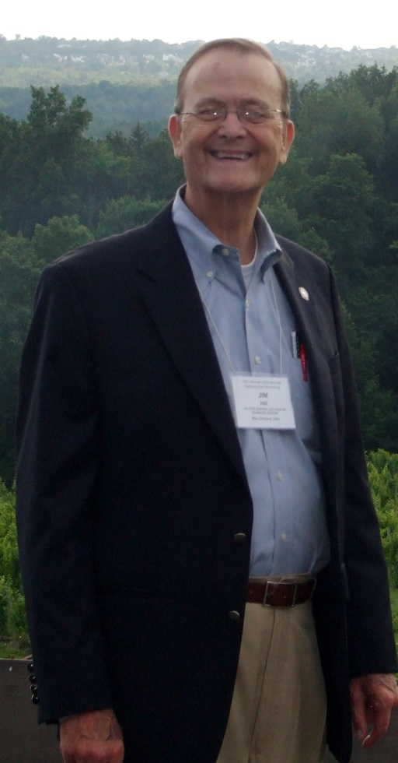
Dr. James Milton Hill (Jim) of New Orleans, LA passed away at 8:32 pm on Wednesday, October 9, 2013. Jim was born on February 20, 1942 in Moss Point, MS to Milton and Virginia Hill. Jim grew up in Moss Point, graduated from Moss Point High School in 1960 and attended Spring Hill College in Mobile, AL. It was at Spring Hill where he met his sweetheart, Barbara Lynn McLeod. Jim graduated from Spring Hill in 1964 and continued his education at the University of Mississippi Medical School in Jackson, MS and the Baylor College of Medicine in Houston, TX. Jim and Barbara were married on June 8, 1968 at Little Flower Church in Mobile. Dr. Hill completed his post-doctorate at Harvard Medical School in Boston, MA and held positions at the Medical College of Georgia in Augusta and the LSU Eye Center in New Orleans. Dr. Hill was a renowned research scientist and professor in his field. He and Barbara travelled the world, as he was a sought after speaker year after year. Jim had a passion for education, scientific research, theatre, sports, family, and LIFE! He believed that indeed you could have it all and do it all. He strived for excellence in every endeavor. Jim was a survivor of colon cancer in 1992 and a liver transplant in August 1994. Jim’s family was his #1 priority, always making time to participate in family events and create special memories with his wife, children, grandchildren, and his large extended family. Everyone who knew Jim knew his favorite things: Barq’s root beer, Hubig pies, New Orleans Saints, Notre Dame Fighting Irish, Boston Celtics, Broadway Theatre, tennis (both playing and watching), and eating a delicious meal in great company. For Jim, the conversation was as important as the cuisine. Jim’s favorite song was “If I were a Rich Man,” from the musical Fiddler on the Roof. It was the last song he requested to hear at 4:00 pm on the afternoon of his death. Jim lived a rich life right up until he drew his last breath with his family by his side. All of us are richer by virtue of knowing him.
Dr. Hill was preceded in death by his father, Milton Hill, his sister, Janis Hill, and his wife’s parents, Lamar and Eloise McLeod, of Mobile, AL. He is survived by his wife, Barbara Hill, of New Orleans; son, Chris Hill, daughter-in-law, Genevieve, and grandsons, Zachary and Nicholas, of Rockport, TX; daughter, Kim Putman, son-in-law, Skylar, and grandson, Shai of Austin, TX; mother, Virginia Hill, of Pascagoula, MS; brother-in-law and sister-in-law Tom and Rebecca Dollman of Athens, AL; brother and sister-in-law, Burt and Judy Hill of Pascagoula, MS; sister and brother-in-law, Mary and Walter Hallberg of Vicksburg, MS; sister and brother-in-law Georgine and Ray East of Austin, TX; brother and sister-in-law Donald and Penny Hill, of Ocean Springs, MS; brother and sister in law, Walter and Melanie Hill, of Dothan, AL; along with many nieces, nephews, and extended family and friends around the world. The family of Dr. Hill very much appreciates the care he has received at Tulane Medical Center in New Orleans and the Transplant Center in Omaha, NE where he received his liver transplant in 1994. The family requests that in lieu of flowers, donations be made in Jim’s honor payable to the UNMC Patient Assistance Fund. Donations can be sent to the University of Nebraska Medical Center, 983285 Nebraska Medical Center, Omaha, NE, 68198-3285, in care of: Laurie Williams.
Family and friends are invited to a celebration of life to honor Dr. Hill on Sunday, October 13 from 2:00 - 5:00PM at the home of Toby and Marion Ramsey, 2123 Palmer Avenue, New Orleans, 70118.

