Anatomy

Cerebrospinal Fluid
- Osm 295, Na same as plasma, Cl/Mg higher than plasma, K/Cl/uric acid/glucose lower than plasma (glucose 2/3 plasma level, usu 45-80; protein nl<45)
- 70% made by choroid plexus, 18% from capillaries, 12% from metabolic water production
- volume is 150 cc (25 cc in ventricles); make 450 cc/day
- arachnoid granulations absorb if pressure is 3-6 cmH2O above venous pressure
- normal pressure is 10-15 cmH2O; 3-6 cmH2O in children; 20-30 cmH2O when sitting
- secretion increased by CO2 and volatile anesthetics; secretion decreased by NE and carbonic anhydrase inhibitors
- 150 ml at any given time
- Produce 450 ml/day (turnover CSF volume 3 times/day)
- Active secretion requiring NA/K pump
- Composition
  - Has similar Na⁺ to serum
  - Increased Cl⁻ and Mg⁺⁺
  - Decreased K⁺ and glucose
- Blood Brain Barrier
  - Formed by capillary endothelial tight junctions
  - Permeable to H₂O, CO₂, O₂, and lipid-soluble molecules
  - Not permeable to glucose and protein-bound molecules
- Circumventricular Organs
  - Pineal – secretes melanin for circadian rhythm
  - Subforniceal organ – between intraventricular foramen; connected to choroid plexus; involved with body fluid regulation
  - Subcommisural organ – unknown function; only one with intact BBB
  - Organum vasculosum of the lamina terminalis – outflow of hypothalamic peptides; monitors peptides, amino acids, and proteins in blood
  - Median eminance of hypothalamus – site of secretion of hypothalamic releasing factors
  - Neurohypophysis (post pit)
  - Area postrema – only paired structure; in inferior fourth ventricle; involved with emesis

Meninges
- Dura consists of two layers
  - Outer layer – continuous with periosteum
  - Inner layer – extends from brain to spinal cord, ends at S2 (spinal cord ends at L1/L2)
- Arachnoid
- Pia – 2 layers
  - Intimal layer
  - Epipia – absent over convexities; filum is epipia
- Somatic innervation
  - CN V for anterior/middle fossa
  - CN IX and X for posterior fossa

Anatomy of Cerebral Cortex
- Area of 2.5 square feet
- About 14 billion neurons
- Development
  - from telencephalic vesicle
  - neurons originate in germinal zone, migrate peripherally to form cortical mantle
  - at 6 months fetal age neurons begin to form 6 layers of neopallium (neocortex)
  - paleopallium (olfactory cortex) and archipallium (hippocampal formation and dentate gyrus) consist of 3 layers
- Cell Types
  - granular cells (stellate) – short axons, intracortical, glutamate/GABA, more common in sensory/association areas
  - fusiform cells – for output
  - pyramidal cells (like Betz) – for output to spinal cord and subcortical association fibers; large cells with large axons
- Cell Layers – 1-3 intracortical association fibers, 4=input, 5=output to brainstem/spinal cord, 6=output to thalamus
  - I – molecular layer; cells with horizontal axons, Golgi type II cells; receive input from cells of Marinotti
  - II – external granular layer – ipsilateral cortico-cortical association fibers
  - III – external pyramidal layer – commissural fibers (to contralateral hemisphere); some ipsilateral cortico-cortical association fibers. Pyramidal cells (acetylcholine, cells of Betz)
  - IV – internal granular layer – myelinated fibers of external band of Baillanger – receive thalamocortical fibers
  - V – internal pyramidal layer – project to subcortical structures – mostly corticostriate, corticospinal, corticotectal; cells of Betz here (pyramidal)
  - VI – multiform layer – project to subcortical structures – mostly corticothalamic
- Summary of Cell Layers
  - Layers II and III – output to different cortical areas (SI, SII, motor cortex)
  - Layers V and VI – output to subcortical areas, thalamus
  - Layer IV – receives input from thalamus
- Cytochemistry
  - Glutamate and Aspartate – excitatory; most projection neurons
  - GABA – inhibitory; nonpyramidal cortical neurons that inhibit pyramidal
  - Peptides – include CCK, VIP (a vasodilator), and Neuropeptide Y (a vasoconstrictor)
  - Acetylcholine – include neurons from substantia inominata (in subcommisural region ventral to corpus striatum, includes basal nucleus of Meynert)
  - Norepinephrine – from locus ceruleus
  - Serotonin – from median and dorsal raphe nuclei of raphe
- Cortical Areas (Brodmann)
  - Broca’s – area 44
  - Wernicke’s – area 22
  - Auditory (Heschl) – areas 41-42
  - Gustatory – area 43
  - Angular gyrus – areas 39-40
  - Visual (calcarine) cortex – area 17
  - Secondary visual areas – areas 18-19
  - Sensory areas – areas 3, 1, 2
- Sensory Cortical Areas
  - Thick layer 4
  - Area 3a (most anterior) – Muscle stretch
  - Area 3 – slow and fast cutaneous
  - Area 1 – fast cutaneous
  - Area 2 (most posterior)
  - Primary Sensory Area (SI) – areas 1-3
    - Area 3a – info from deep stimuli, muscle spindle (muscle stretch, group Ia)
    - Area 3b – from skin; slow and rapid
    - Area 1 – from skin; rapid
    - Area 2 – from deep stimulation; pressure and joint position
  - Secondary Sensory Area (SII) – lies along superior bank of lateral sulcus; extends laterally into parietal lobe, has bilateral body representation
    - Afferents from thalamus (VPLc and VPM) and ipsilateral and contralateral SI
    - Efferents to SI and motor cortex
  - Primary Visual Area (striate cortex)
    - Area 17; on walls and floor of calcarine sulcus
    - Lesion of left visual cortex causes right homonymous hemianopsia
    - Retinal cells have circular receptive rields with either “on” or “off” center
    - In the cortex, receptive fields tend to be oriented in discrete columns
      - Simple cells respond best to light in one axis of orientation with basic “on” or “off” response
        - Located in layer IV
        - Receive impulses directly from lateral geniculate nucleus
        - Receive monocular input
      - Complex cells get input from multiple simple cells; respond to motion of light slits in sustained manner depending on orientation and direction of movement
        - Located in layers above or below IV
        - Receive binocular input
    - Two regions of striate cortex are monocular and do not contain ocular dominance columns:
      - (1) region representing blind spot of retina – area of optic disc (in nasal half of each retina) transmits no visual impulses to contralateral striate cortex; this region of straite cortex receives sole input from temporal half of ipsilateral retina
      - (2) region representing monocular temporal crescent –optic disc in each retina extends farther nasally than temporally, so extreme nasal part of each retina has no corresponding temporal part in the contralateral eye
  - Secondary Visual Area (area 18) and Tertiary Visual Area (area 19)
    - Input from pulvinar
  - Primary Auditory Area (areas 41-42)
    - On two transverse gyri (of Heschl) on dorsomedial surface of superior temporal convolution and in floor of lateral sulcus
    - Input from medial geniculate body
    - Unilateral cortical lesions produce partial deafness greatest contralaterally
  - Gustatory Area (area 43)
    - Parietal operculum
    - Receives information from nucleus of solitary tract
    - Projects to VPM
- Motor Cortical Areas
  - Premotor area (area 6)
    - Contains the supplementary motor cortex and the premotor cortex
    - Supplementary motor cortex is superior/medial
    - Premotor cortex is on the lateral surface of the hemisphere
  - Architecture
    - No layer 4 (little input from thalamus)
    - Giant pyramidal cells of Betz in layer 5
  - Primary Motor Area (MI, area 4)
    - Precentral gyrus
    - Contain giant pyramidal cells of Betz (in layers III and V); otherwise cortex is agranular (minimal layer IV; most thalamocortical fibers go to layer III)
    - Corticospinal fibers – Betz cells give rise to 3% of these
      - 90% between 1-4 µm
      - 40% poorly myelinated
      - Origin
        - 31% from area 4
        - 29% from area 6
        - 40% from parietal lobe
    - Organization
      - Pharynx (swallowing functions) – most inferior opercular portion of precentral gyrus, tongue, jaw, lips, larynx, eyelid, fingers, hand, wrist, elbow, shoulder, hip, knee, ankle, toes (extending into paracentral lobule), anal sphincter
  - Premotor Area (area 6aα on lateral convexity of hemisphere)
    - Voluntary motor function dependent on sensory inputs
    - Activated in response to visual, auditory, somatosensory stimuli
    - Higher threshold for activation than MI; no giant cells of Betz
    - Lesions do not cause paresis, pathologic reflexes (e.g., grasp reflex), or hypotonia (as MI lesions)
  - Supplementary Motor Area (MII, area 6aα on medial convexity of hemisphere)
    - Programming and planning of motor activities
    - Higher threshold for activation than MI
    - Unilateral ablations produce no permanent deficit in maintenance of posture or movement
    - Reciprocal connections to areas 4, 6, 5, 7, and contralateral MII
    - 5% of neurons project to spinal cord (bilaterally)
    - Subcortical projections to caudate, putamen, VA, VLo, and MD thalamus
    - Bilateral influences on both proximal and distal musculatures
    - Lesions associated with:
      - reduction of voluntary motor activity (akinesis)
      - poverty of spontaneous speech
  - Input to motor cortical areas
    - VA and VLo (mostly VLo)
      - From GP and SNpr
      - To premotor and MII
    - VLc and VPLo
      - From deep cerebellar nuclei
      - To motor MI (minor premotor/MII)
- Cortical Eye Fields
  - Frontal Eye Fields – caudal middle frontal gyrus (area 8)
    - Stimulation produces conjugate deviation to opposite side
  - Occipital Eye Center – subserve eye movements induced by visual stimuli, also involuntary smooth pursuit
    - Stimulation produces conjugate deviation to opposite side
    - Compared to frontal eye field: threshold for excitation higher, latency of response longer, eye movements smoother
- Corticothalamic Projections
  - Frontal cortex to/from MD thalamus
  - Area 6 to/from VA, VLc, VPLo, PF (parafascicular) nucleus
  - Area 4 to/from CM (centromedian) nucleus

Tracts
- Medial forebrain bundle
  - From: basal olfactory regions, septal nuclei, periamygdaloid region and subiculum (mainly formed by septal region fibers)
  - To: through hypothalamus to:
    - Ventral tegmentum to supercentral nucleus
    - Nuclei of diagonal band and medial septal nuclei to hippocampus via fornix
- Amygdalo-Hypothalamic Fibers – Mostly via stria terminalis to:
  - Medial preoptic nuclei
  - Anterior hypothalamic nuclei
  - Ventromedial and arcuate nuclei
- Brainstem afferents
  - Median raphe nuclei – serotonergic via MFB
  - Nucleus of the Solitary Tract – to medial (general visceral) and lateral (special visceral=taste) parabrachial nuclei
- Retinohypothalamic fibers
  - From retina through chiasm to suprachiasmatic nuclei (circadian rhythms
- Dorsal longitudinal fasciculus – Descending fibers
  - From: medial and periventricular hypothalamus
  - To: periaqueductal gray and tectum
- Mammillary Efferents – from fasciculus mammilary princeps to:
  - Mamillary-tegmental tract – to midbrain
  - Mamillary-thalamic tract – to cingulate cortex, then to entorhinal cortex, then back to hippocampus
- Tuberhypophyseal (tuberoinfundibular) tract
  - Formed by axons of cells of arcuate nucleus situated in uppermost part of infundibulum (median eminance)
  - End on sinusoids of hypophyseal portal system, carrying releasing hormones for anterior lobe of pituitary via hypophyseal portal vessels
  - Superior and inferior hypophyseal artery supply pituitary from internal carotid
  - Releasing hormones:
    - GHRF – growth hormone
    - CRF – ACTH (acts on adrenal cortex to make corticosteroids)
    - FRH, LRH – LSH, FSH
    - TRF – TSH (acts on thyroid gland to make thyroxine); also potentiates release of prolactin
    - PIF – inhibits dopamine secretion
    - Somatostatin RF – inhibits growth hormone
    - MSH – from intermediate lobes
- Anterior Commissure – mainly connects middle temporal gyrus (some inferior temporal gyrus)
  - In front of fornix, behind septal nuclei
- Corpus Callosum – gives rise to tapetum

Paleocortex, Archicortex, Limbic System
- Olfaction – paleopallium
  - Rhinencephalon – olfactory bulb, tract, tubercle and striae, anterior olfactory nucleus, parts of amygdala, and parts of pyriform cortex
  - Olfactory nerve – first order neuron, bipolar with cell body in nasal mucosa
    - axon is unmyelinated, synapses with mitral cells and tufted cells in olfactory bulb (second order neurons, glu and asp) to form olfactory tract
  - Olfactory tract – to lateral olfactory striae to primary olfactory cortex
  - Primary olfactory cortex – pyriform cortex and periamygdaloid area; output to secondary olfactory cortex
  - Secondary olfactory cortex – entorhinal cortex (area 28); output via uncinate fasciculus to hippocampus, anterior insulae, and frontal cortex
  - Medial Forebrain Bundle – carries olfactory information to the hypothalamus and to habenula via stria medullaris; also via stria terminalis (from amygdala) to hypothalamus, finally to brainstem salivatory nucleus and dorsal nucleus of X (nausea, increased peristalsis, and gastric secretions)
- Septal nuclei
  - Rostral to anterior commissure and preoptic area near base of septum pellucidum
    - From: hippocampus via fornix and MFB
    - To:
      - Stria medullaris to habenula
      - MFB to lateral hypothalamus and midbrain tegmentum
      - Fornix to hippocampus
  - Stria terminalis does not end in septal nuclei but in nuclei of stria terminalis lateral to fornix and dorsal to anterior commissure; some do end in anterior hypothalamic nucleus and medial preoptic nucleus
- Hippocampus – archipallium – 3 layers (molecular, granule, polymorphic)
  - Dentate gyrus and Subiculum
  - Indusium griseum – end of hippocampus above corpus callosum; has white matter tracts within it – form medial and lateral longitudinal striae
  - Indirect olfactory afferents from entorhinal cortex (area 28)
  - Fornix – gives fibers to lateral septal nuclei (precommissural fibers) and anterior/lateral dorsal thalamic nuclei (postcommissural fibers)
  - Subiculum is major source of efferents in fornix and sole source of direct cortical projections
  - Korsakoff’s syndrome (amnestic confabulatory syndrome) – severe impairment of memory without clouding of consciousness, confusion and confabulation; lesion in mammillary bodies
  - Memory impairment with lesions of dorsomedial nucleus of thalamus and hippocampus, not with isolated lesions of amygdala or mamillary bodies
- Amygdaloid complex
  - Afferents from olfactory fibers from lateral olfactory tract to corticomedial (NOT basolateral) group
  - Klüver-Bucy syndrome
    - Lesions in animals produce psychic blindness; compulsion to examine objects visually, tactually, and orally; and bizarre sexual behavior
- Substantia innomonata = nucleus basalis – cholinergic to widespread cortex
- Limbic system
  - Encompasses limbic lobe – subcallosal, cingulate, and parahippocampal gyrus (NOT amygdala)
  - Limbic system – limbic lobe + subcortical nuclei (amygdaloid, septal nuclei, hypothalamus, epithalamus, thalamus, and medial tegmentum of midbrain) – NOT fornix
  - Arrest reaction with stimulation – immediate cessation of other activities expression of surprise, movement of head/eyes to opposite side
- 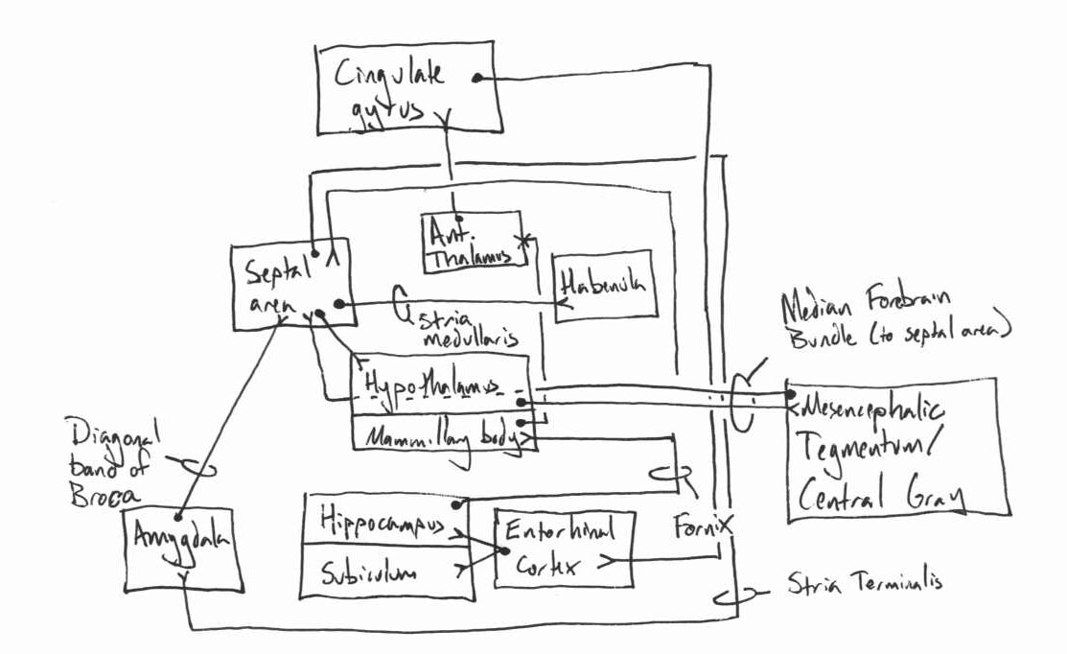
- 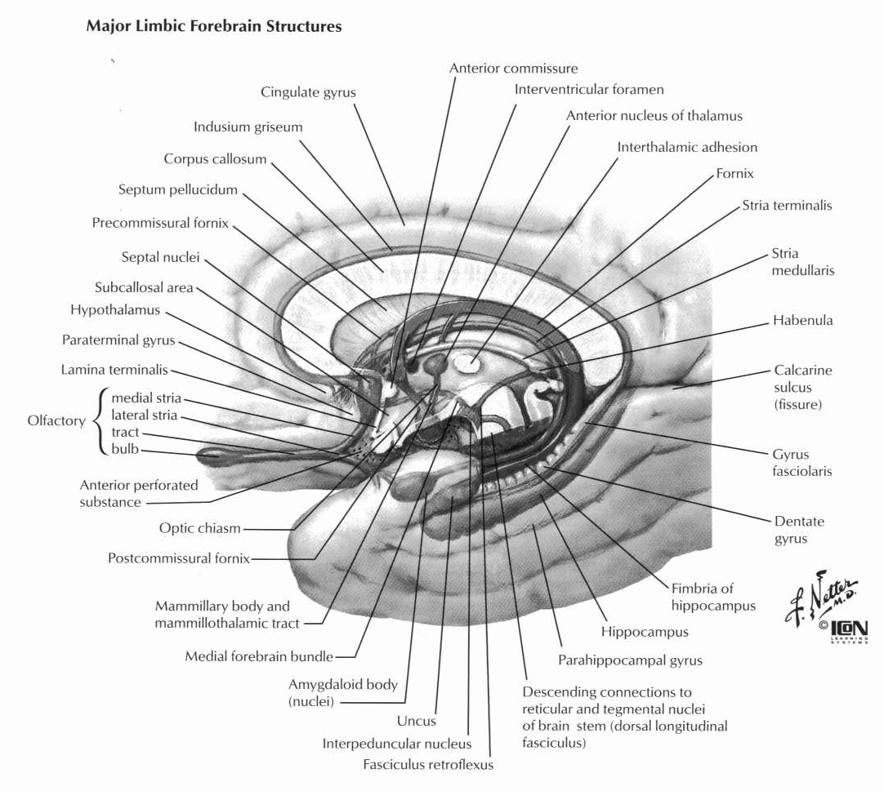

Higher Cortical Function
- anatomy of language
  - Wernicke’s (area 22) – posterior superior temporal in dominant side, behind primary auditory cortex, language comprehension area, important for higher intellectual function, stimulation elicits complex thought/memory/visual and auditory hallucinations
  - Angular gyrus (visual association area) – between Wernicke’s and occipital lobe – visual processing of words, damage leads to alexia
  - Auditory association area – damage produces word deafness
  - Lateral temporal-occipital junction – word naming
  - Broca’s (area 44, posterior inferior frontal gyrus) – word formation/execution, coordinates simulateous stimulation of respiratory/pharyngeal/laryngeal; straddles premotor and prefrontal
- function of association cortex
  - parieto-occipital-temporal association cortex – integrates somatosensory, visual, auditory to determine spatial coordinates of body and surroundings
  - prefrontal association cortex – works with motor cortex to plan complex patterns/sequences; also involved with thought elaboration

Cerebellum
- Archicerebellum
  - Oldest part – related to the vestibular system
  - Consists of the nodulus and the flocculus
  - Defined by the posteriolateral fissure
- Paleocerebellum (anterior lobe)
  - Receives impulses from stretch receptors via spinocerebellar tracts
  - Helps regulate muscle tone
- Neocerebellum
  - Coordinates somatic motor function
  - Inputs from contralateral cerebral cortex via pontine relays
- 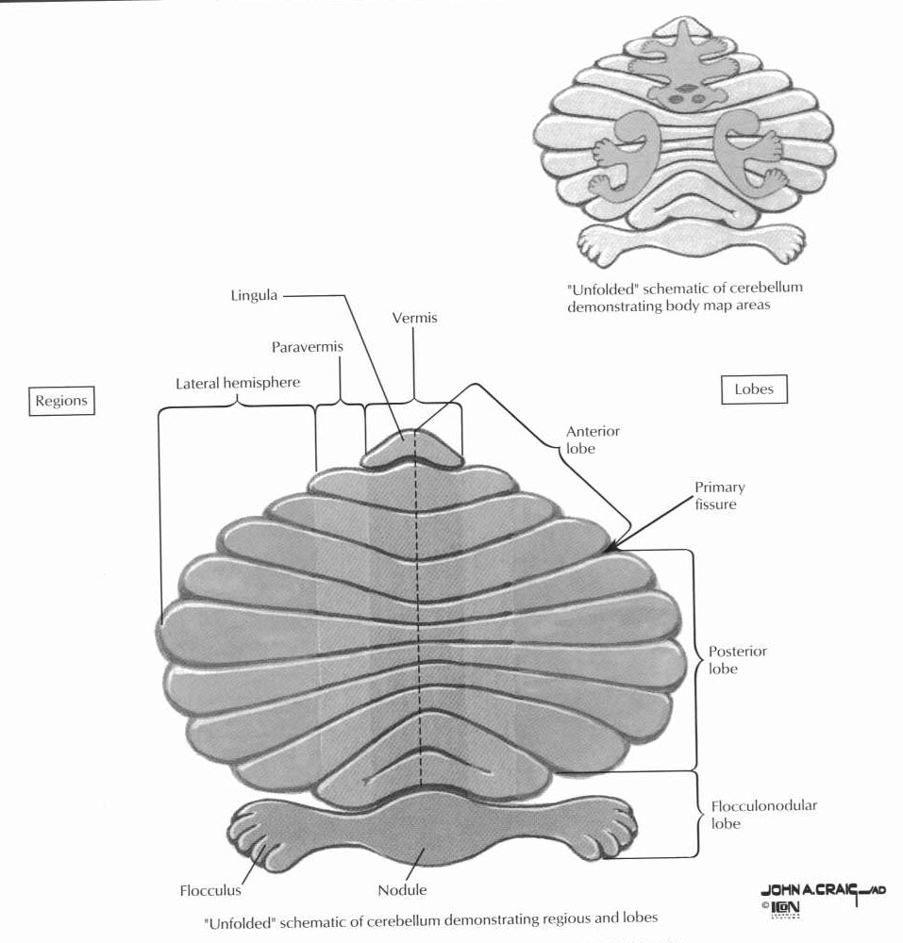
- Inferior cerebellar peduncle (restiform body)
- Middle cerebellar peduncle (brachium pontis)
- Superior cerebellar peduncle (brachium conjunctivum)
- Midline lesions
  - Rostral – stance and gait affected
  - Caudal – Axial and tuncal posture and equilibrium
  - Lateral lesions – impair limb movement
- Deep nuclei
  - Fastigial – axial muscles
    - Some fibers cross within the cerebellum
    - Crossed fibers exit as uncinate fasciculus (of Russel)
    - Uncrossed fibers project to brain stem via juxtarestiform body
    - Projects to bilateral VL, VPL
  - Globose/Emboliform – distal limb muscles
    - Project to caudal red nucleus
  - Dentate – aids in planning voluntary movements
- Cell Types
  - Granule cells – excitatory cells in the granular layer
    - Input from mossy fibers (from spinocerebellar tracts and brain stem nuclei)
  - Basket cells – in the molecular layer
    - Inhibit Purkinje cell bodies and granule cell axons
- Fiber Types
  - Parallel fibers – in the molecular layer (from granule cells)
    - Intersect dendrites of a row of Purkinje cells
    - Each Purkinje cells receives converging input from 200,000 parallel fibers
  - Climbing fibers – excitatory input from the inferior olivary nucleus
    - Each climbing fiber synapses on just one Perjunke cell body
- Layers
  - Molecular layer – contains axons of granule cells (parallel fibers)
    - Contains basket and stellate cells
  - Purkinje cell layer – sole output of cerebellum (only myelinated axons in the cerebellum)
    - Inhibitory cells (use GABA)
- 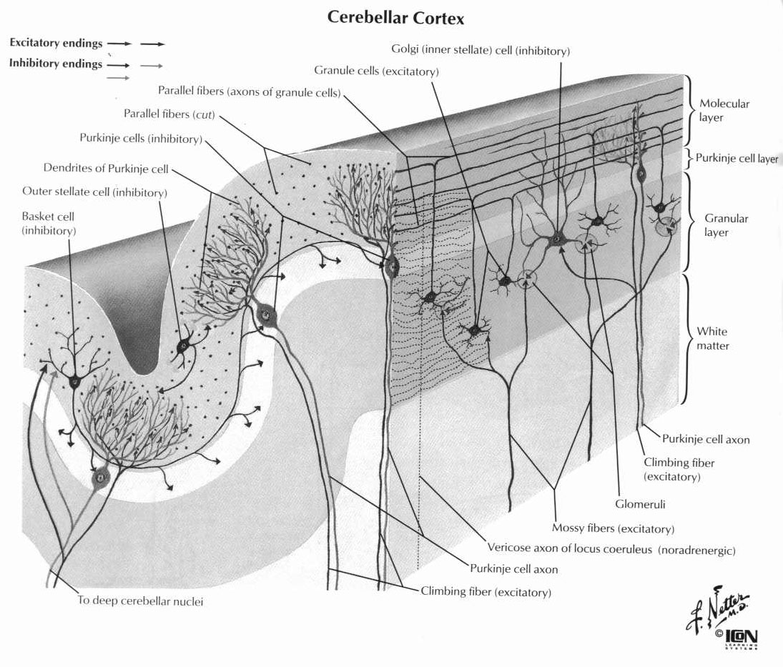
- Connections
  - Inferior Peduncle
    - Afferents
      - Dorsal spinocerebellar tract
      - Rostral spinocerebellar tract
      - Cuneospinocerebellar tract
      - Juxtarestiform body
        - Primary and secondary vestibulocerebellar fibers
      - Cerebellospinal tract
      - Olivocerebellar fibers (decussate)
      - Trigeminocerebellar fibers
    - Efferents
      - Cerebellovestibular nuclei (inhibitory fibers – lesion can unmask extensor tone)
  - Middle Peducnle
    - Afferents
      - Pontocerebellar fibers from motor and premotor cortex (decussate)
      - Fibers from pontine reticular formation
    - Efferents – none
  - Superior Peduncle
    - Afferents
      - Ventral spinocerebellar tract (via brachium conjunctivum)
      - Tectocerebellar fibers
      - Monoaminergic fibers
    - Efferents
      - Cerebellotegmental fibers
      - Dentatothalamic fibers
      - Dentatoruberal fibers
- Function
  - Vestibulocerebellum (archicerebellum)
    - Connect with vestibular nuclei in the cerebellum
    - Helps to regulate body equilibrium and eye movements
    - Inhibits extensor posturing
  - Spinocerebellum – involved in movement feedback
    - Vermis (fastigial nucleus)
      - Connects with reticular formation and lateral vestibular nuclei
      - Regulates axial and proximal muscles
    - Intermediate zone (globose and emboliform nuclei)
      - Connects to red nucleus (magnocellular portion)
      - Regulates distal muscles
  - Cerebrocerebellum (dentate nucleus) – involved in movement planning
    - Connects to VPL of the thalamus
    - Output to motor and premotor cortex via the red nucleus (parvicellular portion)
- Circuits
  - Vestibularcerebellar circuit
  - Spinocerebellar circuit
  - Cerebrocerebellar circuit
  - Olivocerebellar circuit
- Lesions
  - Floculonodular lobe – ataxic gait, wide-based gait, nystagmus
  - Spinocerebellum – tremor, hypotonia (pendular reflexes, flaccid posture)
    - Vermis – disturbances in axial and truncal control
      - Titubation or tremor in trunk
      - Dysarthria, scanning speech
    - Interposed nuclei – limb ataxia, action tremor, hypotonia
  - Cerebrocerebellum
    - Delay in initiating and terminating movements
    - Terminal tremor at the end of a movement
    - Disorders in temporal coordination involving multiple joints
    - Disorders in spatial coordination
    - Terminal tremor
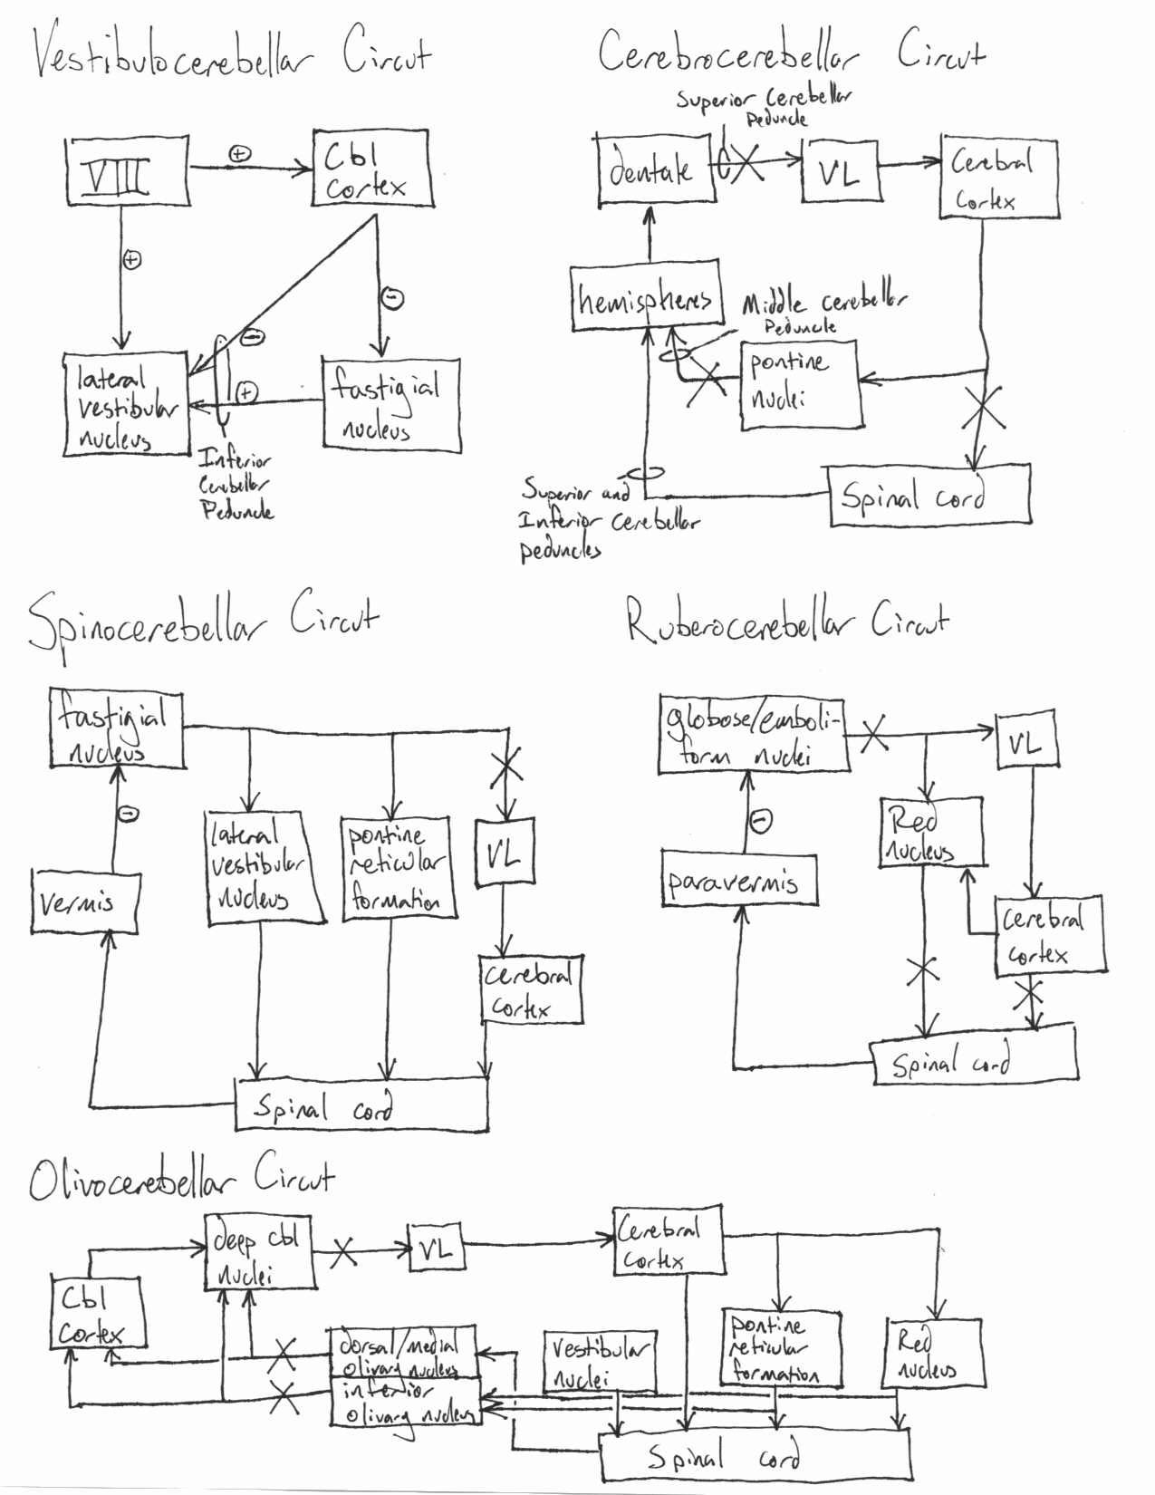

Basal Ganglia
- Circuits
  - Striatum (caudate and putamen) receive input from motor, premotor, limbic, and association cortex
  - Dorsolateral striatum has input from sensorimotor system
  - Middle striatum has input from assiciation cortex
  - Ventromedial striatum has input from limbic system
  - Striatum and SN have reciprocal projections (DA from SN)
  - Striatum projects to GPe and GPi
  - GPe projects to STN which projects to GPi
  - GPi projects to VA and VL of the thalamus (thalamic fasciculus aka Fields of Forel) and the habenula
  - VA projects to frontal cortex (limbic system)
  - VL projects to premotor and motor cortex
- 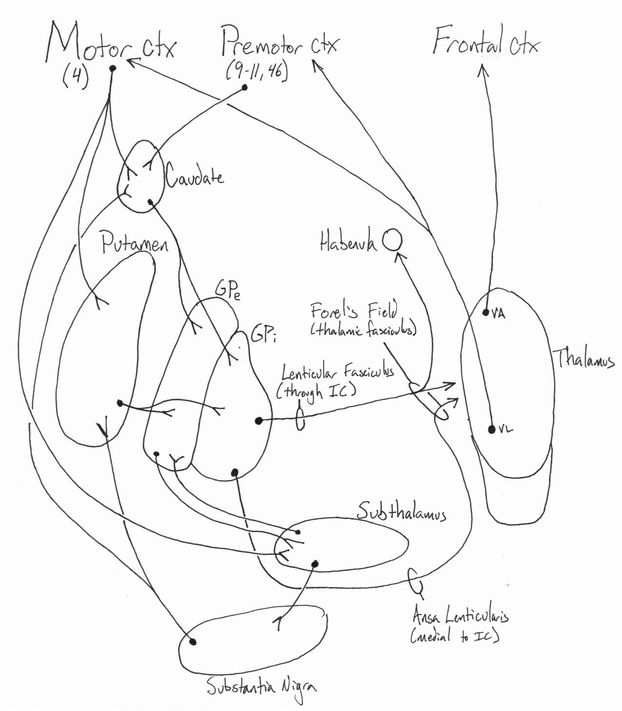
- Neurotransmitters
  - Cortex and thalamus use glutamate
  - BG circuitry uses GABA, an inhibitory neurotransmitter
  - DA from pars reticulata of the SN and the ventral tegmental area (limbic striatum)
  - Enkephalin from type II spiny neurons
  - Substance P from type I spiny neurons
  - Aspiny neurons – interneurons that modulate spiny neurons
    - Type I – GABA, neuropeptide Y, and somatostatin
    - Type II – giant cholinergic neurons
- 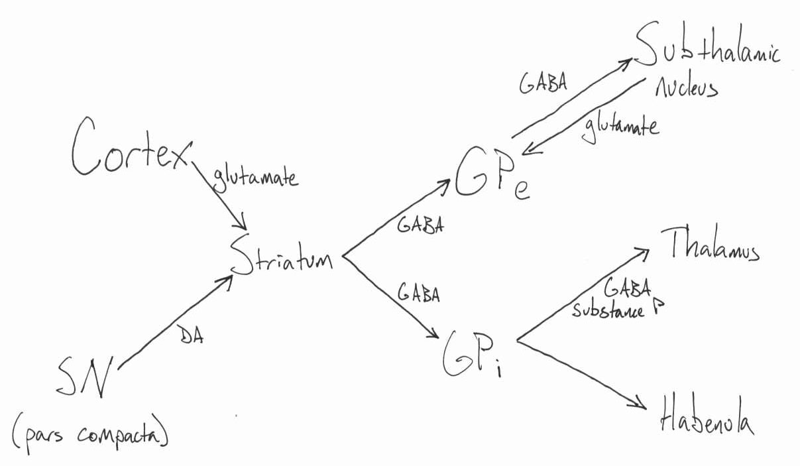
- Diseases
  - Huntington’s disease
    - Type I spiny neurons affected first
  - Parkinson’s Disease
    - Depletion of DA-production cells of the SN
    - Increased STN activity (inhibits thalamic nuclei)
    - VL/VIN DBS for treatment of tremor
    - GPi or STN DBS for treatment of rigidity

Diencephalon
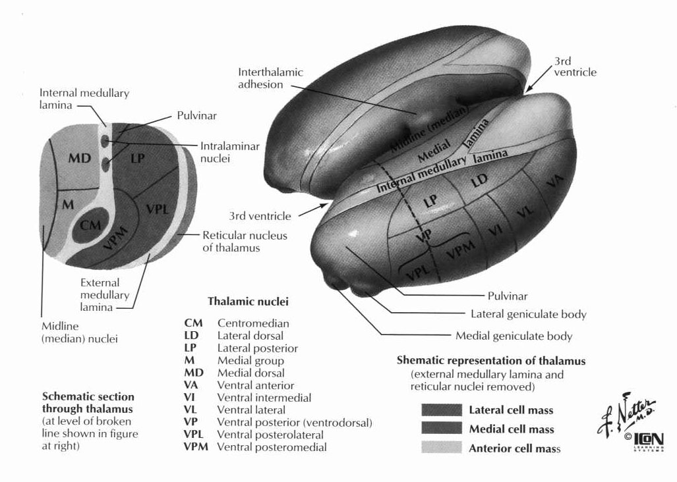

Nucleus | Category | Input | Output | Misc
Anterior (A) | Limbic | Hippocampus, mammillary bodies, Raphe nuclei, cholinergic nuclei | Cingulate gyrus | Part of Papez circuit, modulates alertness
DM | Association | Amygdala, basal forbrain, frontal, temporal and olfactory cortex, substantia nigra | Nuc basalis of Maynert, frontal cortex, frontal eye fields (portion that gets input from SN) | Lesions decrease emotional responsiveness, change reaction to pain
 | Nonspecific | Hypothalamus | Amygdala, striatum, cingulate gyrus | Involved with visceral activities
LD | Specific limbic | ? | Cingulate gyrus
LP | Association | Sup. colliculus, pretectum, sup. and inf. parietal lobules | Reciprocal fibers to areas 5 and 7 | Integrates information from visual cortex and secondary somatosensory cortex
Pulvinar | Association | Sup. colliculus, visual cortex (primary and secondary), inf. parietal lobule | Visual cortex (areas 17-19), areas 5 and 7 | Receives some direct fibers from the retina
VA | Motor | GP and premotor cortex
VL | Motor | GP, deep cerebellar nuclei, motor cortex | Motor and premotor cortex | Lesions decrease tremors
VPL | Sensory | Medial lemniscus, spinothalamic tract, deep cerebellar nuclei (rostral portion) | Primary somatosensory cortex
VPM | Sensory | Trigeminothalamic tract, solitariothalamic tract | Lateral primary somatosensory cortex, parietal operculum
MGN | Sensory | Inferior colliculus, auditory cortex | Auditory cortex(transverse gyrus of Heschel, areas 41 and 42)
LGN | Sensory | Optic nerve | Primary visual cortex (area 17)
CM | Nonspecific | Reticular formation, frontal cortex, GP, CBL | Striatum, diffuse cortex | Thalamic pacemaker, involved in pain processing and sleep
- Neurotransmitters
  - ACh from nucleus basalis of Maynert (substantia inominata)
  - GABA – most prominent neurotransmitter in the thalamus
  - Glutamate from cortex and cerebellum

Claustrum
- Input from sensory connection, hypothalamus, CM thalamus, and locus coeruleus
- Reciprocal fibers with layer VI of cortex
- No subcortical efferents

Hypothalamus
- Functional centers
  - Suprachiasmatic nucleus – biological rhythms
  - Ventromedial nucleus – satiety center
    - With lesion, can’t stop eating
  - Lateral nucleus – feeding center
    - With lesion, don’t eat
  - Anterior and medial regions – parasympathetic control
  - Posterior and lateral regions – sympathetic control
  - Anterior nucleus – dissipates heat
  - Posterior nucleus – retains heat
  - Sunstantia inominata – nucleus basalis of Maynert
- Endocrine function
  - Supraoptic Nucleus – lateral to SCN
    - Magnocellular cells produce VP and OT
  - Paraventricular nucleus
    - Magnocellular cells produce VP and OT
    - Parvocellular cells make release factors (released into median eminence)
  - Arcuate nucleus – near entrance to infundibulum
    - Cells contain DA, ACTH, β-endorphin, β-LPH
    - Regulates anterior pituitary
    - Projects to brainstem, involved in cardiopulmonary function

Limbic System
- Structures
  - Amygdala, hippocampus, septal nuclei, cingulated gyrus, prefrontal cortex
- Papez circrcut
  - Hippocampus to fornix to mammillary bodies to mammillothalamic tract to ant. thalamic nucleus to cingulated gryus to entorhinal cortex to hippocampus
- Connections
  - Median Forbrain bundle
    - Arises from basal olfactory regions, septal nuclei, periamygdaloid region and subiculum
    - Projects to the hypothalamus
  - Diagonal band of Broca
    - From the hypothalamus to the hippocampus
  - Hypothalamus projects to ventral tegmentum
  - Stria terminalis – separates thalamus from the caudate
    - Connects the hippocampus and septal area
  - Stria medullaris – runs in the midline
    - Connects the septal nuclei, ant. thalamic nucleus, and lateral preoptic region to the habenular nuclei
  - Brainstem afferents
    - From median nuclei of Raphe – serotonin
    - From nucleus solitarius – visceral and taste sensation
  - Retrohypothalamic fibers from the retina to the suprachiasmatic nucleus
  - Dorsal longitudianal fasciculus
    - Descending fibers from medial and periventricular hypothalamus
    - Project to periaquaductal gray and tectum
  - Mammillothalamic and mammilotegmental tracts

Ascending tracts of the spine
- Posterior columns
  - Carry light touch/vibtation sensation
  - Ascend in fasciculus gracilis (lower body) and fasciculus cuneatus (upper body)
  - Synapse on secondary nuclei in the medulla
  - Fibers decussate as the internal arcuate fibers, become medial lemniscus
  - Medial lemniscus projects to VPL of the thalamus
- Anterior spinothalamic tract
  - Carry pain and light touch sensation
  - Fibers from contralateral laminae I, IV, and V
  - Crosses anterior white commisure over several levels and ascends
  - Projects to VPL
- Lateral spinothalamic tract
  - Carry pain and temperature sensation
  - Fibers may ascend or descend 1 level before entering spinal cord
  - Fibers cross in the anterior white commisure
  - Tract ventral to the dentate ligament
  - Projects to VPL
- Spinotectal tract
  - Ascends with anterior spinothalamic tract
  - Terminated in deep contralateral superior colliculus
  - Conveys nociceptive impulses
- Dorsal spinocerebellar tract
  - Uncrossed tract
  - Carries muscle spindle information from below T6
  - Synapses in the dorsal nucleus of Clark
  - Enters the cerebellum through the inferior cerebellar peduncle
- Ventral spinocerebellar tract
  - Carries Golgi tendon organ information from below T6
  - Crosses twice
    - Anterior white commisure in the spinal cord
    - Brachium conjunctivum
  - Enters the cerebellum through the superior cerebellar peduncle
- Cuneocerebellar tract
  - Uncrossed tract
  - Carries muscle spindle information from above T6
  - Synapses in the accessory cuneate nucleus
  - Enters the cerebellum through the inferior cerebellar peduncle
- Rostrocerebellar tract
  - Uncrossed tract
  - Carries Golgi tendon organ information above T6
  - Enters the cerebellum through the inferior cerebellar peduncle

Descending tracts of the spine
- Corticospinal tracts
  - Arise from layer V of cortex
  - Largest fibers from giant pyramidal cells of Betz
  - 30% from premotor, 30% from motor, 30% from primary sensory cortex
  - 3 separate tracts
    - 90% crossed lateral corticospinal tract (dorsal to dentate ligament)
    - 8% uncrossed anterior corticospinal tract
    - 2% uncrossed lateral corticospinal tract
  - Terminate mostly in laminae VII
- Tectospinal tract
  - From superior colliculus
  - Terminates in the upper cervical cord
  - Mediates reflexive movements in response to visual stimuli
- Rubrospinal tract
  - From the magnocellular portion of the red nucleus
    - Receives information from contralateral cerebellum and ipsilateral motor cortex
  - Fibers cross in the ventral tegmental decussation
  - Flexor bias of the upper extremities – cortical lesion causes decorticate posturing
- Interstitiospinal tract
  - Uncrossed descending MLF
- Vestibulospinal tracts
  - Lateral vistibulospinal tract – from Deiter’s bucleus
    - Extensors to all extremities
    - Lesion above Deiter’s nucleus causes decerebrate posturing (no red nucleus flexor bias)
  - Medial vestibulospinal tract
    - Descends in the MLF
- Reticulospinal tracts
  - Pontine reticulospinal tract
    - From the nuclei pontis caudalis and opalis
    - Descends in the medial portion of the anterior funiculus
    - Extensor bias, especially in response to pain
  - Medullary reticulospinal tract
    - From the nucleus reticularis gigantocellularis
    - Projects bilaterally
    - Flexor bias
  - Functions:
    - Facilitate/inhibit voluntary movement
    - Influence muscle tone
    - Affect phasic activities associated with respiration
    - Pressor/depressor effects on the circulatory system
    - Facilitate/inhibit central transmission of sensory impulses

Descending autonomic pathways
- From hypothalamus to dorsal motor nucleus of X, intermediolateral cell column of thoracic and upper lumbar spine
- Nucleus tractus solitarius to contralateral phrenic nerve nucleus (C3-5)
- Locus coeruleus and group A5 cells (lateral to CN VII)
  - Major noradrenergic input to intermediolateral cell column

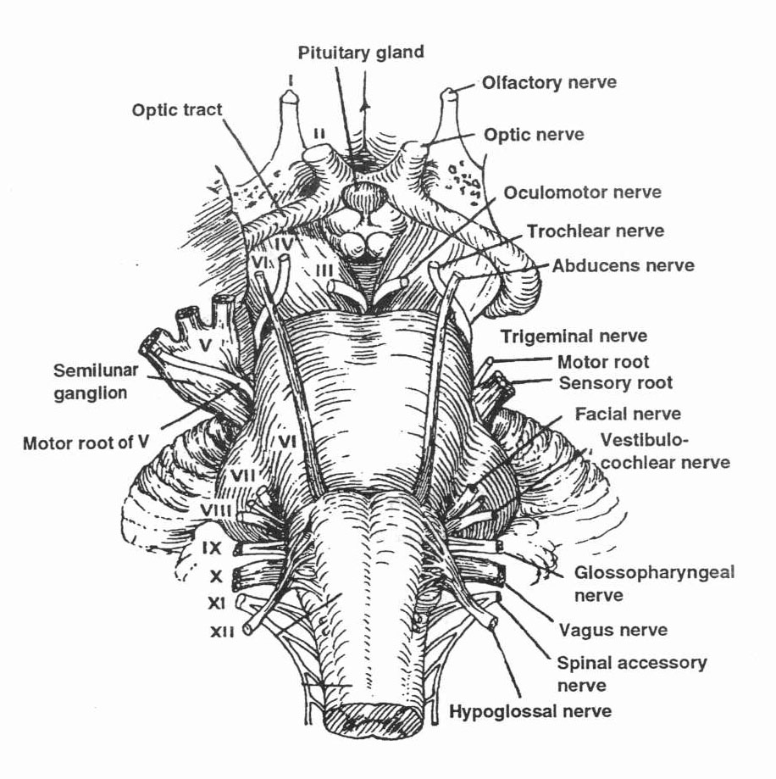

Medulla
- 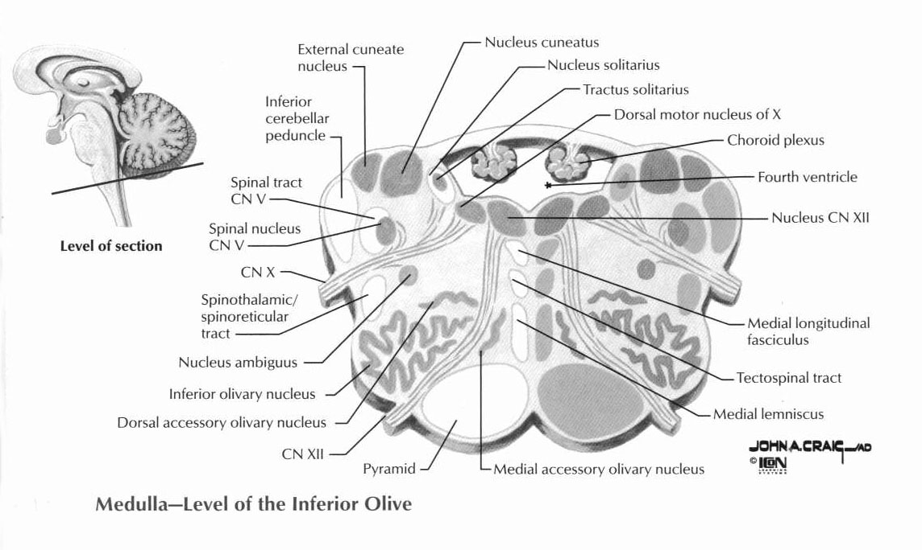
- Nuclei cuneatus and gracils (medial)
- Accessory cuneate nucleus
- Spinal trigeminal nucleus
  - Runs along spinothalamic tract
  - Merges with substantia gelatinosa of the spinal cord (slow pain relays)
  - Pain and temperature sentation from the face
  - V3 dorsal, V1 ventral
  - Medial face represented anteriorly in the nucleus
  - Lateral face represented posteriorly in the nucleus
- Inferior olivary complex
  - Output crosses median raphr, enters the inferior cerebellar peduncle
  - Climbing fibers to the Perkinje layer of the cerebellum
- Raphe nuclei
  - Make seretonin (5-HT)
  - Involved in analgesia
  - Bilateral spinal projections in the dorsolateral funiculus terminate mostly in laminae I and II
- CN XII – hypoglossal
  - Tongue deviates toward side of lesion
- CN XI
  - Cranial portion – arises from caudal nucleus ambiguous
    - join CN X fibers to form inferior (recurrent) laryngeal nerve
  - Spinal portion – anterior horn from C1-C5 up to foramen magnum
    - project to the trapezius and sternocleidomastoid muscles
  - Lesions:
    - weakness turning head to the opposite side and downward and outward
    - rotation of the scapula
    - moderate sagging of the shoulder
- CN X
  - Sensation
    - Superior ganglion – cutaneous back of ear and external auditory meatus
      - Projects to spinal trigeminal nucleus
    - Inferior (Nodose) ganglion – visceral and somatic sensation
      - Larynx, pharynx, trachea, epiglottis, thoracic and abdominal viscera
      - Projects to the nucleus tractus solitarius
      - Some fibers descend to the obex where the solitary nuclei of both sides merge to form the commissural nucleus of vagus
  - Fasciculus solitarius
    - Formed by visceral afferents from VII, IX, X
    - Taste information projected to VPM thalamus
  - Dorsal motor nucleus of X – afferents from hypothalamus
    - Parasympathetic preganglionics
    - “secretomotor” center and vasomotor center
  - Nucleus ambiguous
    - Projects to IX, X, and XI
    - Somatic motor efferents to muscles of the larynx and pharynx
  - 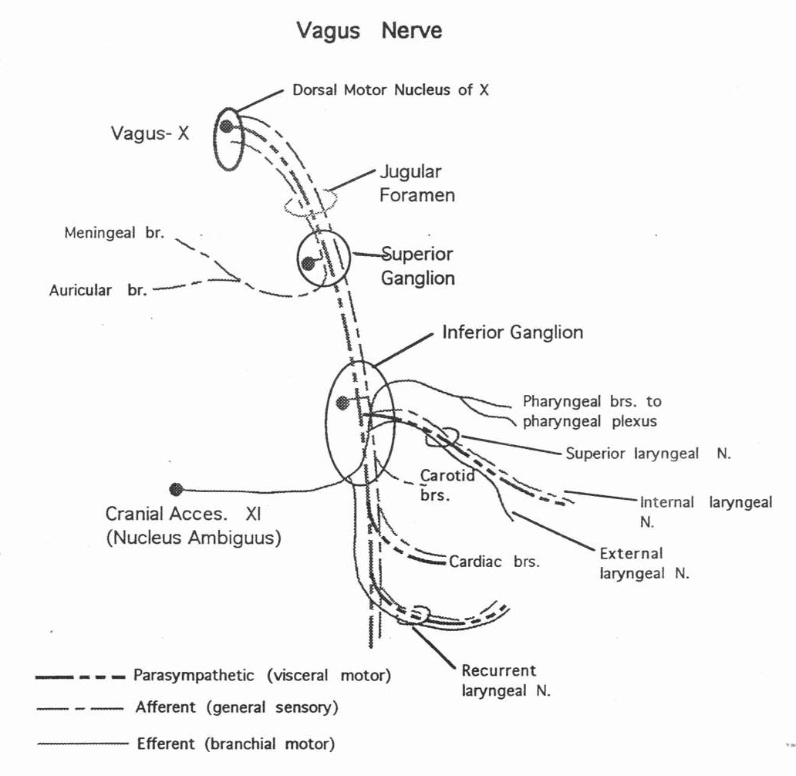
- CN IX
  - Sensation
    - Superior ganglion – cutaneous back of ear
      - Projects to trigeminal nucleus
    - Inferior ganglion – somatic and visceral sensation
      - Pharynx, posterior third of tongue, Eustachian tube, carotid sinus and body
    - Carotid sinus nerve – detects increases in BP (baroreceptor)
      - Projects to the nucleus tractus solitarius
      - Results in increased parasympathetic output
    - Carotid body receptor – detects changes in O₂ tension (chemoreceptor)
  - Visceral efferent
    - Inferior salivatory nucleus projects through IX (becomes lesser petrosal nerve) to the otic ganglion
  - Somatic efferent
    - Nucleus ambiguus projects to the sytlopharyngeus muscle
  - 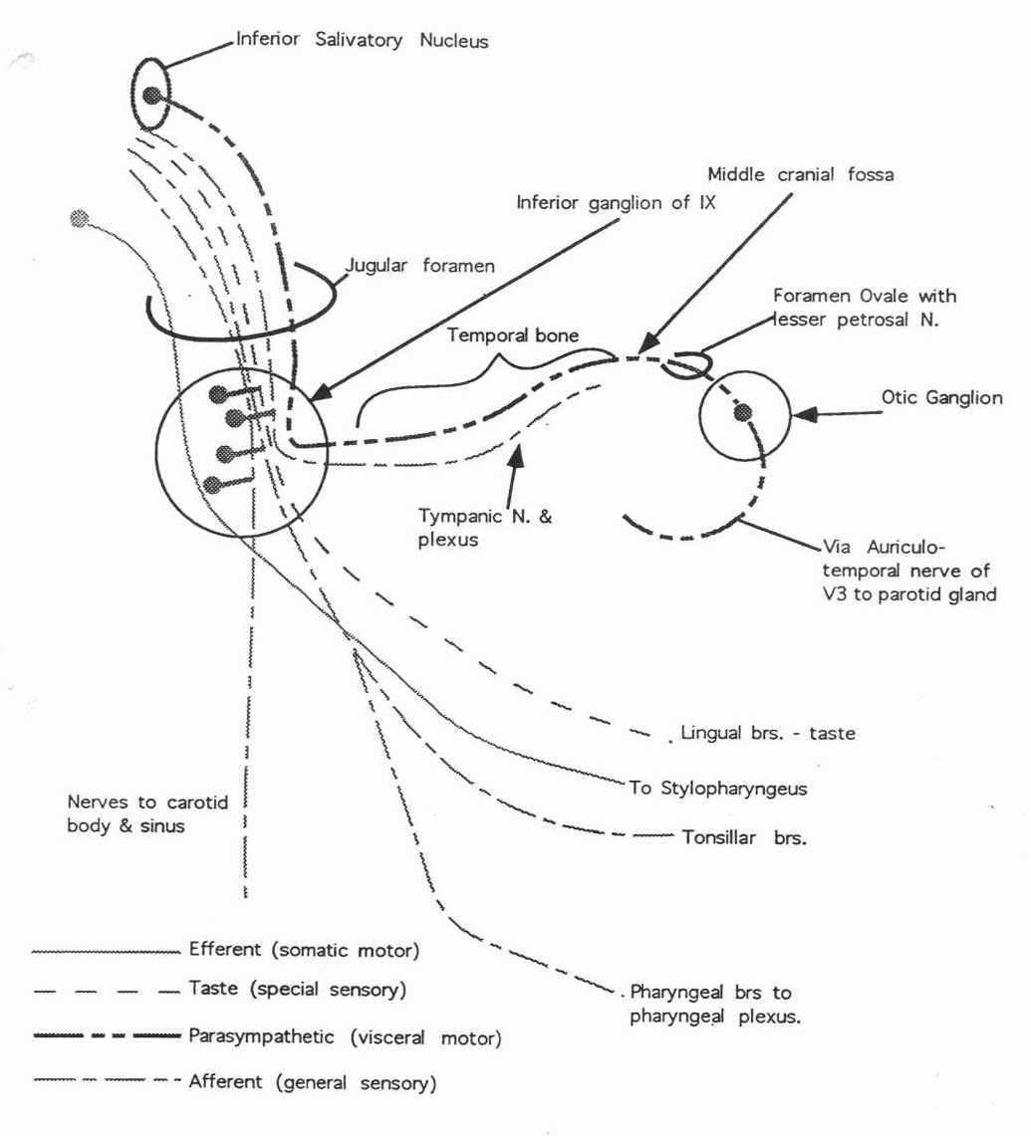
  - 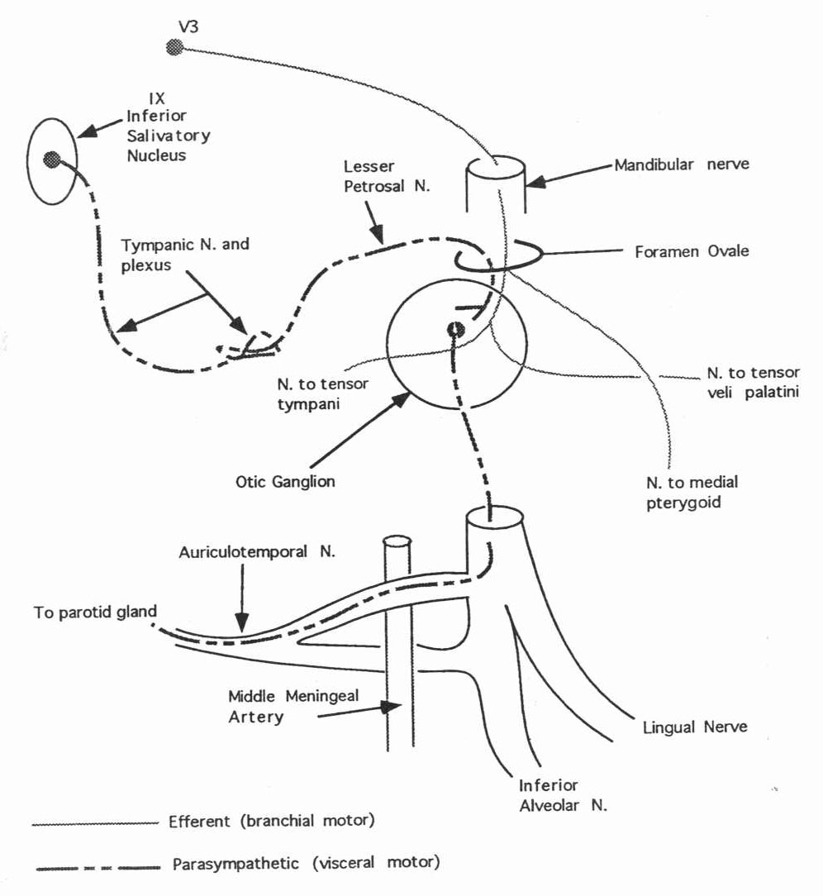

Pons
- 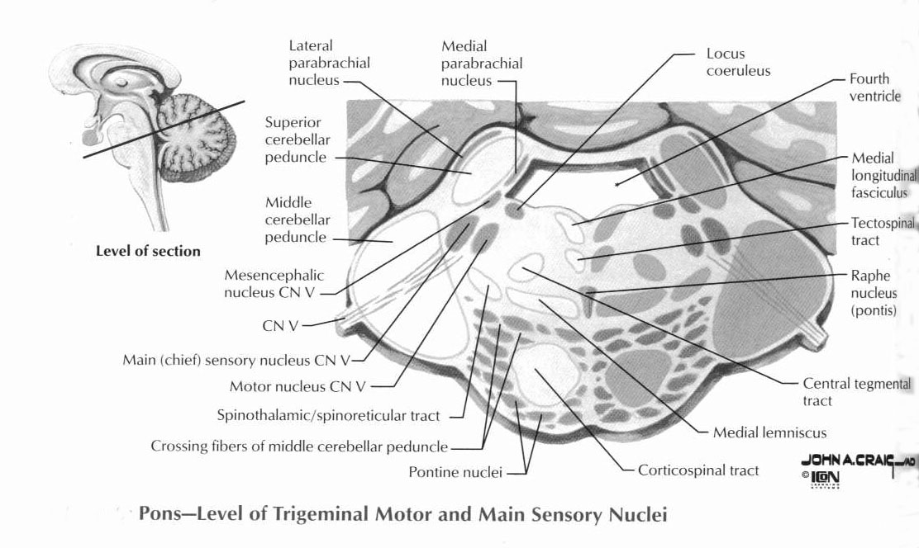
- Contains CN’s V, VI, VII, and VIII
- Pontine nuclei – synapse with fibers from all areas of cortex
  - Project through the contralateral middle cerebellar peduncle to the cerebellum
- CN VIII
- CN VII
  - Somatic motor fibers from facial nucleus
  - Visceral motor fibers from the superior salivatory nucleus
    - Travel in the intermediate nerve
    - Greater petrosal nerve carries parasympathetics to the pterygopalatine ganglion through the vidian canal
    - Chorda tympani carries parasympathetics to the submandibular ganglion
      - Taste fibers (anterior 2/3 of tongue) return to geniculate ganglion
  - Lesions – can determine location by symptoms
    - Greater petrosal nerve is the first to split off
    - Nerve to the stapedius muscle is the second to spit off
    - Chorda tympani is the third to split off
    - Motor fibers to face remain
    - “crocodile tears” – aberrant regeneration of the nerve to the greater petrosal nerve instead of the submandibular ganglion
      - cry when salivation impulse is sent
  - Transverse crest – separates cochlear and inferior vestibular nerves from facial and superior vestibular nerves
  - 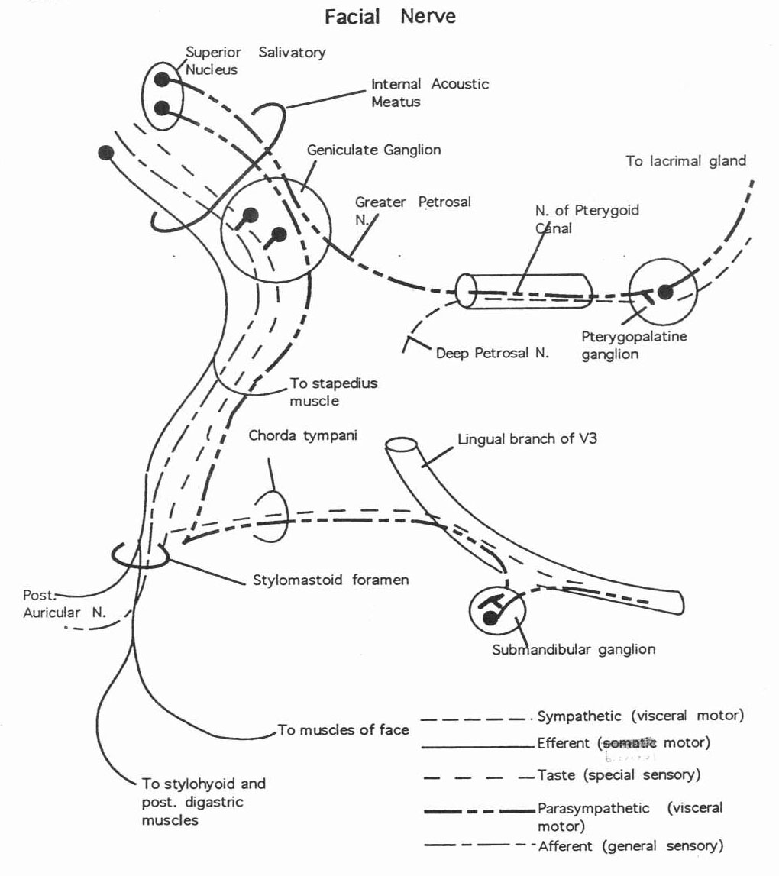
  - 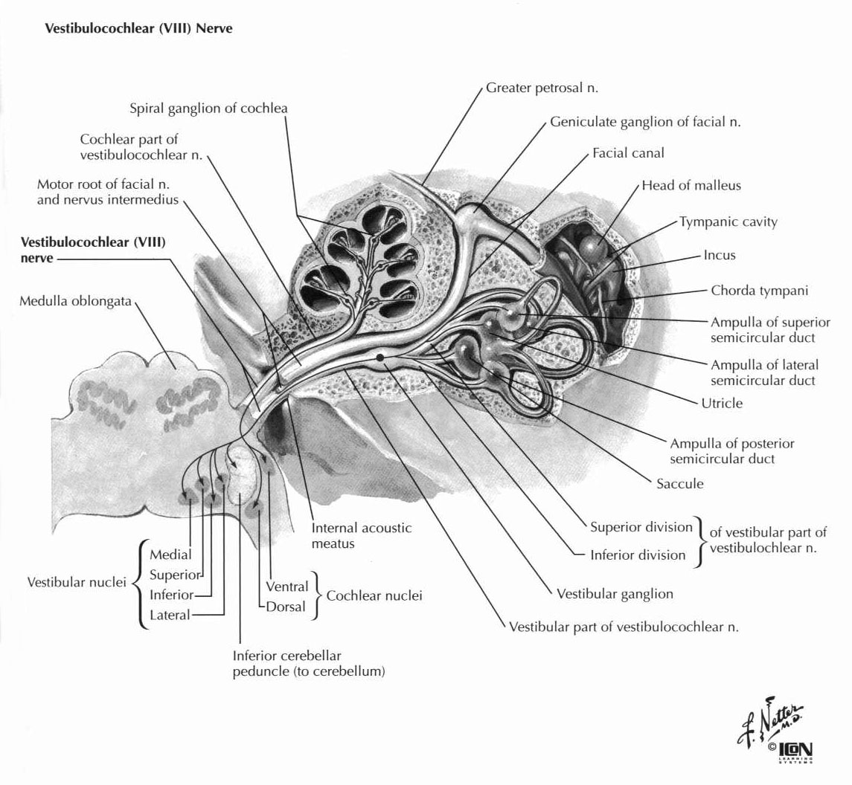
- CN VI
  - Horizontal gaze center in the caudal paramedian pontine reticular formation
  - Abducens nerve projects to the ipsilateral lateral rectus
- CN V
  - Somatic motor – muscles of mastication, tensor veli palatini, tensor tympani
  - Somatic sensation – face, mouth, anterior and middle fossa dura
    - Main sensory nucleus of V
    - V3 dorsal, V1 ventral
    - Tactile and pressure sense – little adaptation
    - Ventral trigeminothalamic tract (crossed)
      - Contains fibers from the spinal and main sensory nuclei of V
    - Dorsal trigeminothalamic tract (uncrossed)
      - Smaller tract from only the main sensory nucleus of V
    - Projects to VPM thalamus
- V1
  - 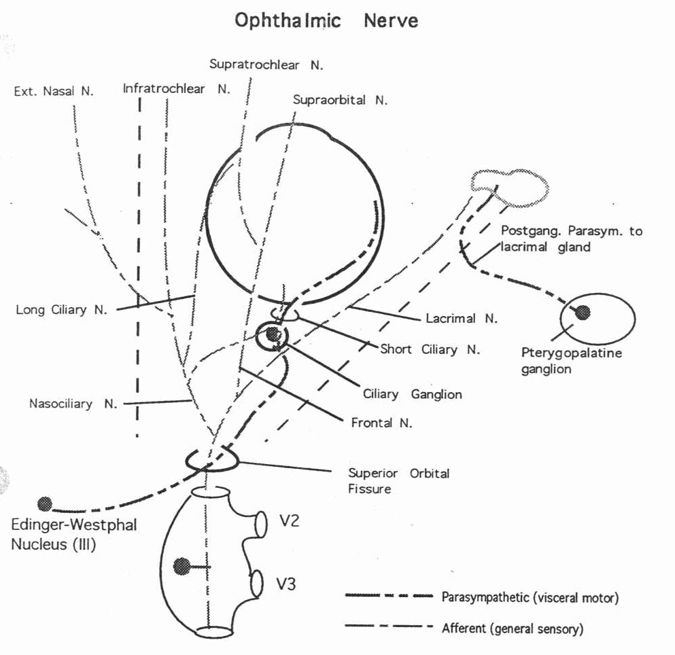
- V2
  - 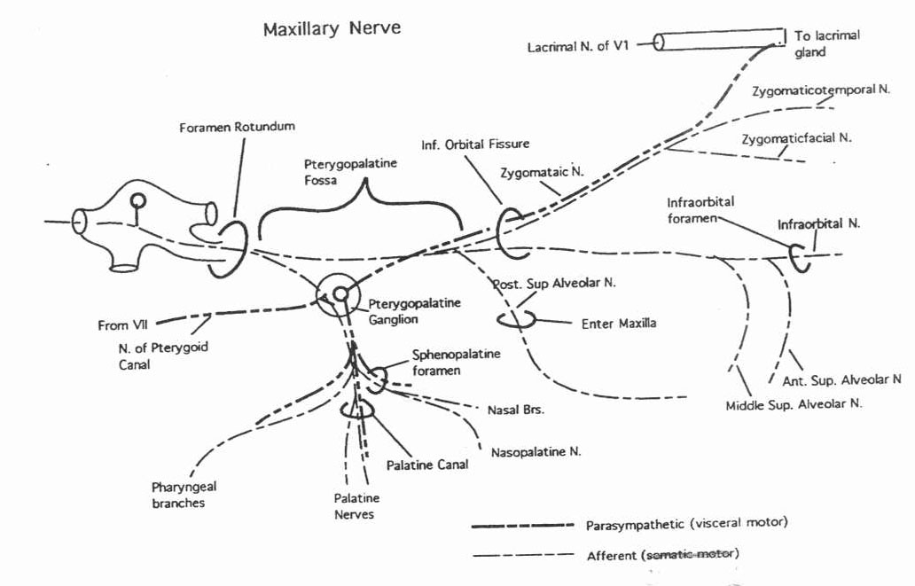
- V3
  - 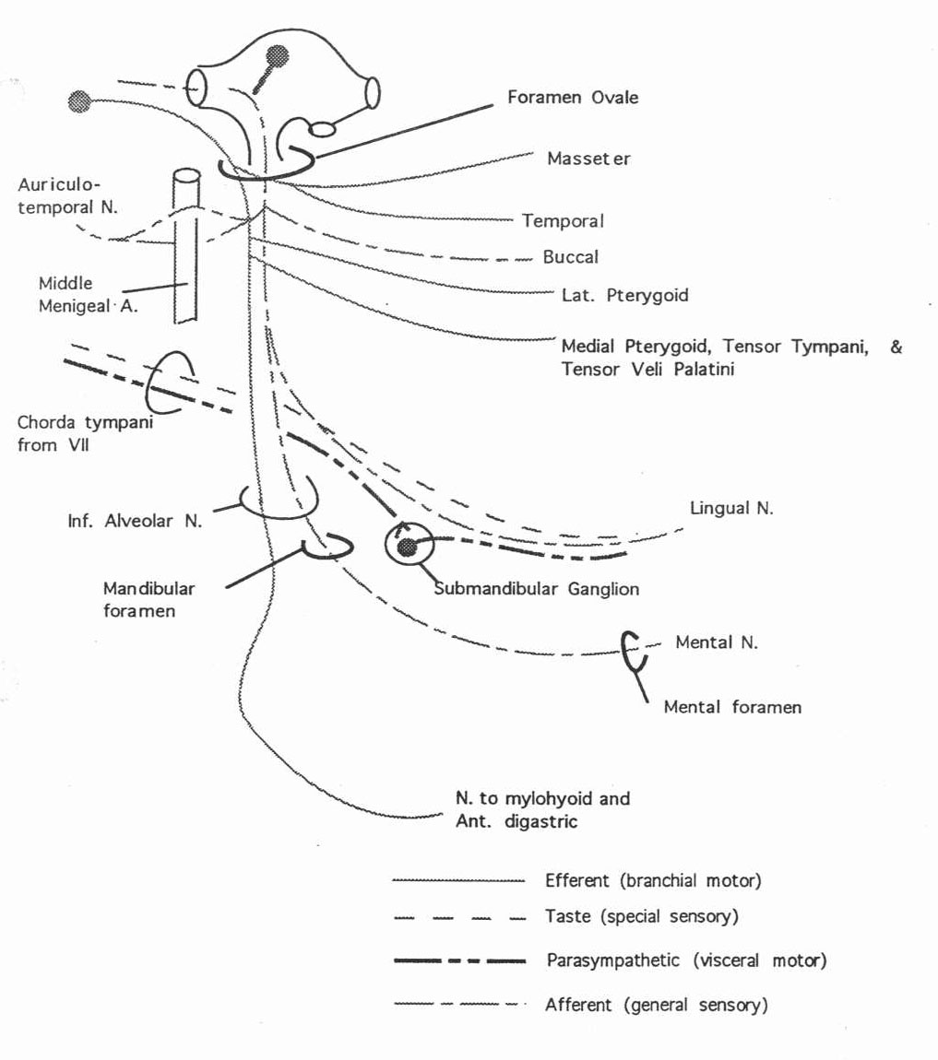
  - 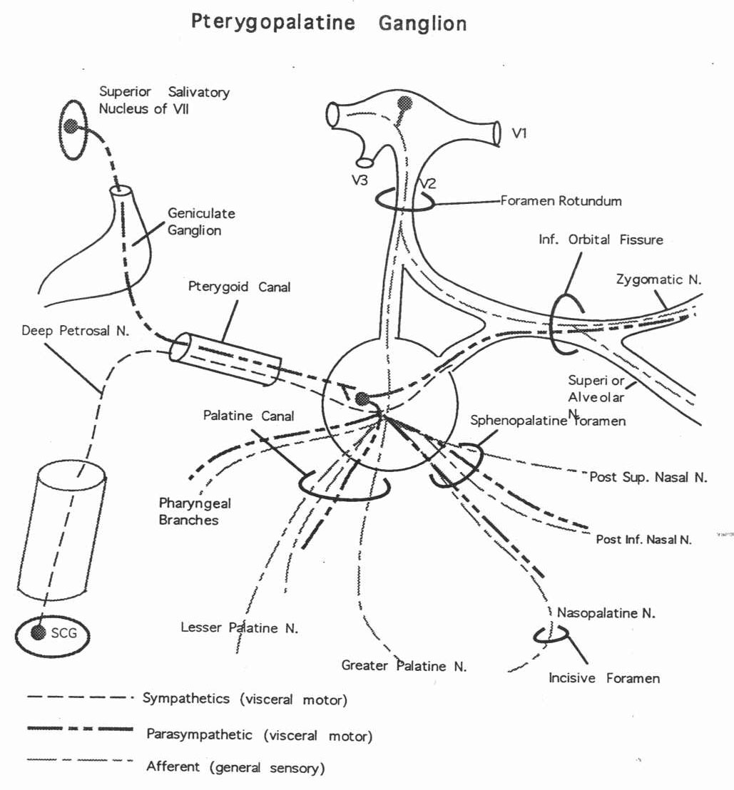

Midbrain
- Superior colliculi
  - Input from retina and cortex (contralateral visual field), spine
  - Afferents from contralateral eye are dominant
  - Projections
    - Tectothalamic tract to ipsilateral pulvinar
    - Tectospinal tract
  - Unilateral lesions
    - Neglect of contralateral visual field
    - Deficits in tracking
    - Heightened responses to stimuli in ispilateral field
    - No impairment of eye movements
  - Stimulation causes contralateral conjugate deviation of the eyes
- Inferior colliculi – auditory relay nuclei
- CN V
  - Mesencephalic nucleus of V consists of the cell bodies of muscle spindle fibers
  - Projects to motor nucleus of V (monosynaptic reflex)
- CN IV
  - Fibers decussate in the superior medullary velum
  - Emerge from the dorsal surface of the brain caudal to the inferior colliculi
  - Pass between the SCA and PCA lateral to CN III
  - Innervates the superior oblique muscles
  - Lesions
    - Causes vertical diplopia maximal on attempted downgaze to the contralateral side
    - Patient tilts head laterally to opposite side
- CN III
  - Projects to superior, inferior and medial rectus and inferior oblique muscles
  - Innervates the levator palpebrae muscle
  - Parasympathetics from Edinger-Westphal nucleus to ciliary ganglion
  - 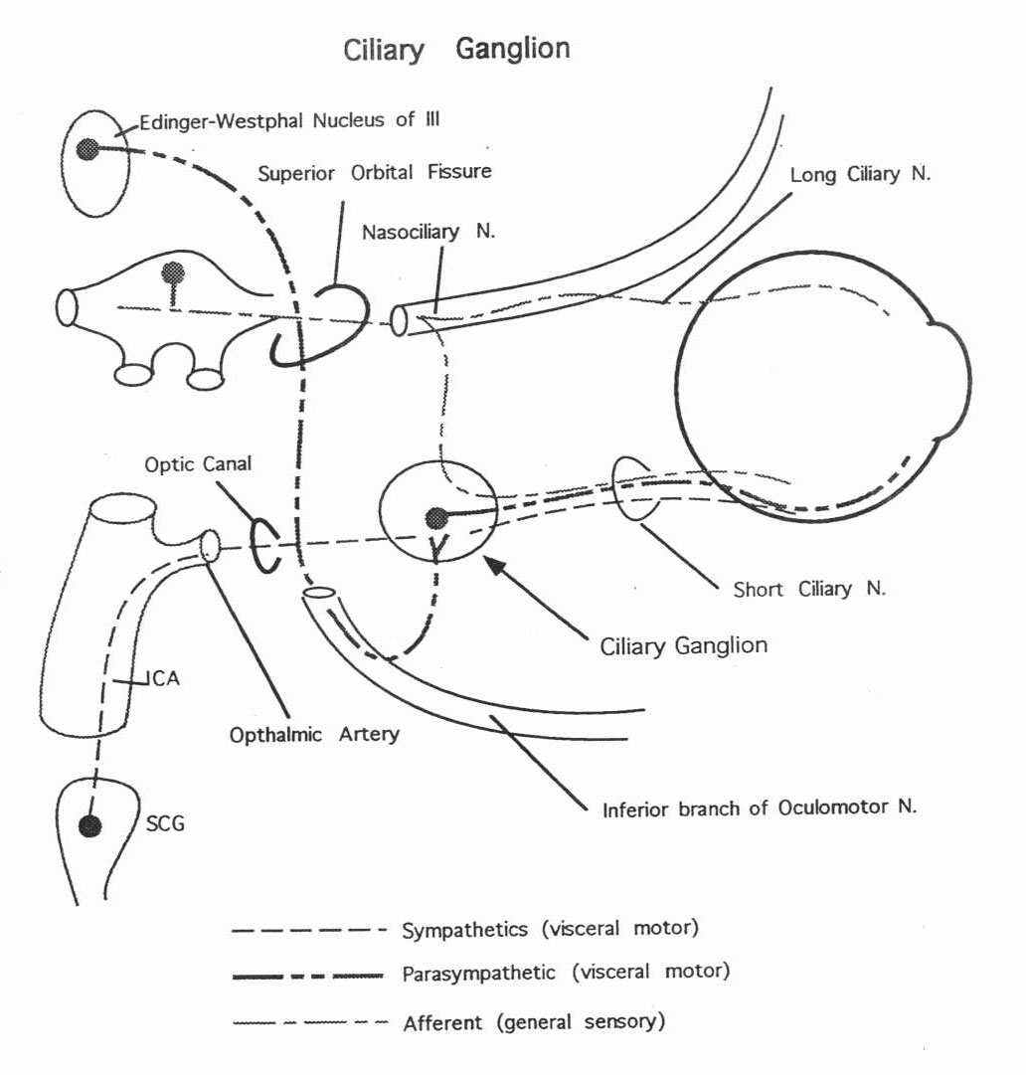
- Accessory nuclei to the oculomotor nucleus (near the pineal gland)
  - Intersitital nucleus of Cajal
    - Involved with smooth persuit, slow rotatory and vertical eye movements
  - Nucleus of Darkschewitsch
  - Nuscleus of the posterior commisure
  - Lesions cause bilateral lid retration, impaired vertical eye movements (Perinaud’s Syndrome)
- Rostral Interstitial nucleus of the MLF (RiMLF)
  - Vertical gaze center (rostral paramedian pontine reticular formation)
- Posterior commisure
  - Connects accessory nuclei
  - Fibers allow conjugate papillary light reflex
  - Contains the subcommisural organ
    - Only periventricular organ with a blood-brain barrier
- Substantia nigra
  - Pars compacta (pigmented)
    - Principal source of striatal dopamine
  - Pars reticulata (not pigmented)
    - GABAergic
    - Also contains CCK, substance P
  - Afferents are diffuse but mostly from striatum
  - Efferents to striatum (traverse GP but don’t synapse)
    - Nigrothalamic fibers to VA, DM thalamus
    - Nigrocollicular fibers to superior colliculi
      - Initiates REM
    - Nigrotegmental fibers to pedunculopontine fibers (GABAergic)
- Lesions
  - Weber’s Syndrome
    - Ventral midbrain where CN III exits by the cerebral peduncle
    - CN III palsy with contralateral hemiplegia
  - Benedikt’s Syndrome
    - Weber’s with contralateral tremor, ataxia, and chorea
    - Involves the red nucleus

Lesions of Cerebral Cortex
- Frontal Lobe
  - Nondominant:
    - Contralateral spastic hemiplegia
    - Slight elevation of mood, difficulty in adaptation, loss of initiative
    - If entirely prefrontal – no hemiplegia but will see grasp/suck reflexes or instinctive grasping
    - Anosmia with involvement of orbital part
  - Dominant – see all nondominant frontal abnormalities plus:
    - Motor speech disorder with agraphia, with or without apraxia of lips and tongue
    - Sympathetic apraxia of left hand
    - Loss of verbal associative fluency, perseveration
  - Bilateral:
    - Bilateral hemiplegia
    - Spastic bulbar (pseudobulbar) palsy
    - If prefrontal – abulia or akinetic mutism; lack of ability to sustain attention or solve complex problems; rigidity of thinking; bland affect; social ineptitude; behavioral disinhibition; inability to anticipate; labile mood, grasping, sucking, decomposition of gait, and sphincter incontinence
- Temporal Lobe
  - Nondominant
    - Inability to judge spatial relationships in some cases
    - Impairment in tests of visually presented nonverbal material
    - Agnosia for sounds and some qualities of music
  - Dominant
    - Wernicke’s aphasia
    - Amnesia
    - Dysnomia or amnestic aphasia
    - Visual agnosia
  - Either Lobe
    - Homonymous upper quadrantanopsia
    - Auditory, visual, olfactory, and gustatory hallucinations
    - Dreamy states with uncinate seizures
    - Emotional and behavioral changes
    - Delirium (usually nondominant)
  - Bilateral:
    - Korsakoff amnestic deficit (hippocampal formation)
    - Klüver-Bucy Synrdome
      - Apathy and placidity
      - Increased sexual activity
      - Sham rage
- Parietal Lobe
  - Unilateral
    - Cortical sensory syndrome with sensory extinction (or total hemianesthesia with large acute lesions of white matter)
    - Mild hemiparesis, unilateral muscular atrophy in children, hypotonia, poverty of movement, hemiataxia
    - Homonymous hemianopsia or visual attention; sometimes anosognosia, neglect of one-half of body and of extrapersonal space (observed more frequently with right than with left parietal lesions)
    - Abolition of optokinetic nystagmus with target moving toward side of lesion
  - Dominant
    - Disorders of language (esp. alexia)
    - Gersmann;s syndrome:
      - Finger agnosia
      - Left-right confusion
      - Acalculia
      - Agraphia
    - Tactile agnosia (bilateral astereognosis)
    - Bilateral ideomotor and ideational apraxia (cannot use comb or tool)
  - Nondominant
    - Visual/spatial disorder
    - Topographic memory loss (“constructional apraxia”)
    - Anosognosia and dressing apraxia (also may occur in dominant lesions), neglect, blunted emotion
    - Confusion
    - Tendency to keep eyes closed, resist opening, blepharospasm
  - Bilateral
    - Visual spatial imperception, optic ataxia, spatial disorientation, severe constructional apraxia
    - Topognosia (inability to localize touch/pain stimuli)
- Occipital Lobe
  - Unilateral
    - Contralateral congruent homonymous hemianopsia; also homonymous hemiachromatopsia
    - Elementary (unformed) hallucinations – due to irritative lesions
  - Left
    - In deep white matter or splenium – alexia and color-naming deficit, without agraphia (can see with right visual cortex but cannot transmit to left association area for interpretation)
  - Right
    - Loss of topographic memory and visual orientation
  - Bilateral
    - Cortical blindness (with reactive pupils)
    - Anton syndrome (claim sight although blind)
    - Achromatopsia (loss of perception of color)
    - Prosopagnosia
    - Simultanognosia
    - Balint syndrome:
      - Inability to look voluntarily into and scan peripheral field (psychic paresis of fixation of gaze)
      - Optic apraxia – failure to touch or grasp object under visual guidance, as though hand and eye were not coordinated
      - Visual inattention (disorientation) involving mainly peripheral field
- Disconnection syndromes
  - Alexia without agraphia
    - alexia in left visual field
    - Lesion of corpus callosum – information from right visual field cannot get to language centers
    - Always associated with right homonymous hemianopsia
  - Ideomotor apraxia
    - In Broca’s aphasia
    - Destroy origin of fibers that connect left and right motor association cortices (anterior corpus callosum or white matter under Broca’s area)
    - Apraxia of commanded movements of left hand
  - Pure word deafness
    - Subcortical lesion of left temporal lobe or bilateral lesion of auditory cortex interrupts connection between auditory and speech areas
- Top of the Basilar Syndome – occlusion of rostral basilar artery – infarct in midbrain, thalamus, portions of temporal and occipital lobes
  - Impaired ocular movements – gaze palsies, skew deviation, convergence spasms, convergence-retraction nystagmus
  - Abnormalities of pupils – small minimally reactive (diencephalic dysfunction), large or mid-position and fixed (midbrain), ectopic or oval pupils
  - Alterations of consciousness and behavior – stupor, apathy, somnolence, memory deficits
  - Deficits in vision – homonymous hemianopsia, cortical blindness, Balint’s syndrome (impaired visual form discrimination and color dysnomia), abnormal color vision
  - Motor weakness, sensory deficits, reflex abnormalities – subtle and variable
- “One-and-a-half Syndrome” – lesion of PPRF or CN VI nucleus involving MLF fibers crossing to that side from contralateral CN VI
  - Horizontal gaze palsy when looking to side of lesion (“one”)
  - INO when looking away from side of lesion (“half”)
  - Ipsilateral eye has no horizontal movement and contralateral eye has only abduction and nystagmus
  - Convergence usually unimpaired
- Pseudobulbar palsy
  - Cortical lesion (bulbar palsy involves brainstem, with dysphasia, dysarthria, and tongue paresis with fasciculation)
  - Brisk jaw jerk
  - Frontal release signs
  - Emotional incontinence (frontal efferents?)
- Aphemia (mutism) – cannot speak but repetition, reading, writing, understanding unaffected
  - Lesion near Broca’s area
  - Also called “pure motor aphasia”
- Transcortical aphasias – due to watershed infarcts
  - Repetition remarkably unaffected
  - Sensory transcortical aphasia – like Wenicke’s; fluent, alexia, agraphia, comprehension impaired
  - Motor transcortical aphasia – like Broca’s, nonfluent, comprehension unaffected
  - Pure word deafness – impaired comprehension but normal formulated speech, intact reading
  - Writing disturbed in all forms of aphasia except alexia without agraphia and mutism
- Localization of Brainstem Dysfunction
  - Subcortical lesion – cheyne-stokes breathing, pupils small and reactive
  - Midbrain lesion – central hyperventilation, pupils midposition to large and fixed
  - Pontine lesion – apneustic then cluster, pupils pinpoint
  - Medullary lesion – ataxic breathing, midposition fixed pupils, often irregular

Physiology

Basic Biology of Nerves
- Synthesis and Movement of Proteins in the Nerve
  - proteins made in cell body and transported down axon
  - slow transport = 1 mm/day; fast = 20-40 mm/day
  - retrograde transport is always slow and uses dynein (GTP); anterograde uses kinin
  - Fast – 200-400mm/day
    - Carries organelles/vesicles
    - ATP-dependent
    - Kinesin – motor for anterograde fast transport
    - Dynein – motor for retrograde fast transport
  - Slow – 1-2mm/day
    - Carries cytosolic proteins and cytoskeletal elements
    - Only moves in anterograde direction
- Endocytosis – uses dynamin (GTP is energy source)
- Membrane Potential and Membrane Properties
  - Nernst equation – membrane potential = +/- 61 log ( [Ci] / [Co] ) – where [Ci] and [Co] are concentrations of that ion in and outside of the cell
  - Goldman equation – membrane potential = -61 log ( [Na_{in} x K_{in} x Cl_{in}] / [Na_{out} x K_{out} x Cl_{out}]
  - Resting membrane potential:
    - –90 for large nerves and skeletal muscle
    - –65 for nerve soma
    - –55 for small nerves and smooth muscle
- ion channels
  - tetrodotoxin blocks Na channels, TEA blocks K channels
- generation and conduction of an action potential
  - opening of Na → potential becomes +35 for large nerves, +0 for small
  - lasts 1/10,000 sec
  - positive afterpotential to –100 mV
  - threshold –61 mV
  - axon hillock has 7x as many Na channels – need 40 to 80 EPSPs
  - IPSPs open Cl (to –86) or K (to –94) channels
  - rhythmic AP – fire when K conductance at lowest
  - Velocity of AP increases with increasing transmembrane resistance (myelin), decreasing membrane capacitance (myelin), or decreasing internal resistance
    - Myelin – 1/3 of PNS, all postganglionic ANS; salutatory conduction between nodes of Ranvier (each is 3 um, 1-3 mm apart); repolarization occurs when Na gates inactivate (so fast that K not involved)
  - Refractory period – when Na (and Ca) gates are closed but K gates are open – lasts 1/2500 (absolute), 1/10000 (relative)
  - Membrane stability decreased by lower Ca, higher K, alkalosis, caffeine, strychnine; stabilized by opposite of these (anesthetics also stabilize)
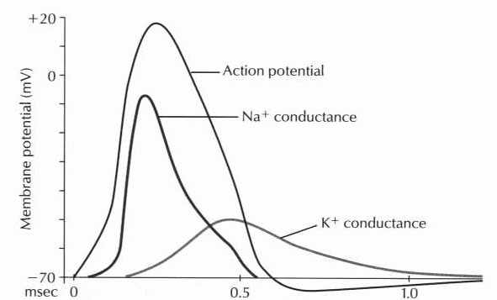

Membrane Potentials
- Membrane transport can occur via simple diffusion, ion channels (selectively permeable, voltage-gated, or ligand-gated) or active transport
- Simple diffusion: through a lipid bilayer
  - Small or lipid-soluble molecules
- Voltage-gated: Na+ and K+ channels
- Ligand-gated: neurotransmitters
- Voltage- and ligand-gated: NMDA receptor
  - Ligand is glutamate
  - Cell must be depolarized to remove blocking Mg++ before channel can be opened
- Active transport: Requires energy
  - Na+/K+ pump – One ATP moves 3 Na+ out and 2 K+ ions into the cell
- Action potentials
- Nernst equation yields the transmembrane potential for individual ions
  - Dependent on the concentrations of an ion inside and outside the cell
- Goldman equation calculates the overall transmembrane potential
  - Factors in all contributing ions
- At equilibrium there is no net movement of ions across the membrane
- Equilibrium potential for Na+ is +61 mV
- Equilibrium potential for K+ is -94 mV
- Equilibrium potential for Cl- is -86 mV
- The resting potential for large peripheral nerves is -90 mV
- The resting potential for neurons (at the soma) is -65 mV
- The resting potential for small nerves is -55 mV
  - These are the summatin of the equilibrium potentials of Na+, K+, and Cl-. K+ contributes more to the overall membrane potential because the membrane is more permeable to K+
- Tracing of an action potential: [picture]
  - If enough excitatory postsynaptic potentials (EPSPs) arrive at the axon hillock to depolarize the membrane to greater than –60 mV, voltage-gated Na+ channels are opened, starting the action potential. Once the potential reaches +35 mV, K+ and Cl- channels open. This causes hyperpolarization of the cell at that point, preventing retrograde transmission. In myelinated fibers, the myelin acts as an insulator, allowing the potential to jump rapidly from one exposed region of membrane (Node of Ranvier) to the next. This is called saltatory conduction.

Synaptic Transmission and Neurotransmitters
- Electrical synapses: pore connecting adjoining cells (gap junction)
  - Bidirectional flow
  - Cardiac and smooth muscle
- Chemical synapses: unidirectional flow
- 80% of axons synapse with dendrites, 20% with the soma
- Synaptic cleft: 20-30 nm wide
- Action potential opens Ca++ channels in the presynaptic terminal
  - Ca++ triggers neurotransmitter release
- 1 vessicle contains 10,000 molecules (1 quanta), enough to cause 1 miniature end-plate potential (MEPP)
- Multiple MEPPs are needed to trigger another action potential
  - Spatial summation: MEPPs from different regions can add up
  - Temporal summation: MEPPs can build up from repetitive firing
- Excitatory neurotransmitters: ACh, NE, glutamate open Na+ channels
- Inhibitory neurotransmitters: GABA, glycine, DA, seretonin (5-HT) open K+ or Cl- channels
- types of synaptic transmission
  - Small molecule neurotransmitters – most have receptors linked to ion channel
    - Class I – acetylcholine
      - excitatory, found in motor cortex, skeletal muscle, all presynaptic ANS, postsynaptic parasympathetic, and postsynaptic sympathetic to sweat glands
      - Receptor: (1) nicotinic (alpha₂beta₂delta) – at neuromuscular junction, blocked by hexamethonium; (2) muscarinic (G-protein, cAMP) – postsynaptic ANS
    - Class II – amines tyr→DOPA→DA→NE→epi
      - NE (excitatory) from locus ceruleus and postganglionic sympathetic (alpha > beta; epi affects alpha = beta)
      - DA (inhibitory) uses cAMP
    - Class III – amino acids
      - Glycine (inhibitory) – spinal cord renshaw cells, open Cl channels
      - GABA (inhibitory) – in cortex, basal ganglia, cerebellum (Purkinje), spinal cord
        - type A (alpha₂beta₂(gamma or delta)) open Cl channels (alpha binds benzo/barbiturates, beta binds baclofen)
        - type B – bind G protein, blocked by picrotoxin (which causes seizures)
      - glutamate (excitatory) – in cortex, dentate gyrus, striatum, cerebellum (granular); involved in death/plasticity
        - ligand gated – metabotropic
        - ligand/voltage gated – NMDA, AMPA, kainite (Na/K channels); blocked by Mg
  - Neuropeptide – large, slower acting, more potent than above; made in ER/Golgi and must be transported along axon; include hypothalamic releasing hormones, CCK, bradykinin
- Neurotransmitters and Receptors
  - Acetylcholine (ACh): found in the motor cortex, skeletal muscle, preganglionic autonomic nerves, postganglionic parasympathetics (EXCEPTION: also supplies postganglionic sympathetics to sweat glands
  - Nicotinic ACh receptors
    - Preganglionic autonomic synapses
      - 5 subunits – α₂βγδ (α binds ACh – 2 molecules must bind)
      - 4 transmembrane proteins
      - stimulation produces a fast EPSP
      - Hexamethonium causes an irreversible, depolarizing blockade
    - NMJ synapses
      - Receptor has two subunits
      - Produces a slow EPSP and a slow IPSP
  - Muscarinic ACh receptors
    - Found in parasympathetic postganglionic cells and in sweat glands (sympathetic)
    - Action mediated by G-proteins
    - Pertussin toxin blocks G-protein
    - 5 types of M receptors – M2 is cardiac, M4 is glandular
- Drugs that affect the cholinergic system
  - Direct agonists
    - ACh – stimulates both nicotinic and muscarinic receptors
    - Carbachol – stimulates both nicotinic and muscarinic receptors, miotic
    - Bethanechol and Methacholine – stimulate muscarinic receptors, evacuate bladder
    - Arecholine – stimulates both nicotinic and muscarinic receptors, alkaloid
    - Pilocarpine – stimulates muscarininc receptors, miotic
  - Indirect agonists (inhibit AChE)
    - Physostigmine – glaucoma
    - Neostigmine – myasthenia gravis
    - Pyridostigmine (Mestinon) – MG
    - Parathion, Mlalthion – pesticides
    - Edrophonium (Tensilon) – tests for MG (competaive inhibitor)
  - Muscarinic antagonists
    - Atropine
    - Scopolamine
    - Trihexylphenidyl (Artane) – Parkinsons
    - Benztropine (Cogentin) – Parkinsons
  - Neuromuscular blockade (NMJ nicotinic antagonists)
    - Depolarizing – succinylcholine
    - Non-depolarizing – curare, vecuronium
- Drugs that affect the adrenergic system
  - Norepinepherine (NE)
    - Excitatory neurotransmitter
    - Found at the postsynaptic sympathetic synapse and throughout the brain
    - Made from phenylalanine
    - Rate-limiting step is conversion of tyrosine to DOPA by tyrosine hydroxylase
  - NE receptors
    - α1 – constriction (vasoconstriction, radial muscle of the iris)
    - α2 – presynaptic inhibition (decreases sympathetic outflow form the CNS)
    - β1 – increase heart rate, inotrope
    - β2 – muscle relaxation (bronchioles, skeletal muscle)
  - Catecholamines (agonists)
    - Epinephrine – α1>β2, used for anaphylaxis
    - Norepinephrine – α>β1>>β2, used to increase SVR
    - Isoproterenol – β agonist
    - Dobutaime – β1 agonist, increase HR, contractility
    - Dopamine – D>β>α
  - Non-catecholamine agonists
    - Phenylepherine – α1, increases SVR (reflex bradycardia)
    - Metaproterenol – β2 agnist, bronchiodilation
  - Indirect NE agonist
    - Amphetamine – releases NE from presynaptic terminals
    - Cocaine – prevents reuptake
  - α2 agoinists (decrease sympathetic outflow, decrease BP)
    - Clonidine, Guanabenz, Aldomet
  - α antagonists
    - Phenoxybenzamine – irreversible, noncompetitive
    - Phentolamine – reversible, competitive
  - Non-specific NE antagonists
    - Guanethidine – decreases NE release
    - Bretylium – decreases NE release
    - Reserpine – depletes presynaptic vesibles
  - Specific NE receptor subtype antagonists
    - Anti-α1 – Prozasin, Terazosin
    - Anti-β – Propranolol, nadolol, timolol, pindolol
    - Anti-β1 – Metoprolol, Atenolol, Esmolol
    - Anti-α,β – Labetolol
- GABAergic System
  - GABA-
    - Inhibitory action by increasing Cl – permeability
    - Receptor has 5 subunits (α2β2 and γ or δ), blocked by picrotoxin (causes seizures)
  - GABA receptors
    - GABA-A receptor
      - α binds GABA, benzodiazepines, and barbitautes (agonists)
      - β binds GABA
    - GABA-B receptor
      - α binds GABA and baclofen (agonists)
- Glycine
  - Cl – channel, binds to strychnine (causes rigidity)
- Glutamatergic System
  - Most common excitatory neurotransmitter in the CNS
  - Receptors
    - All are ion channels with 4 transmembrane domains
    - NMDA – associated with cell death
      - Voltage – and ligand-gated
      - Depolarization removed Mg⁺⁺ blockade, allowing further activation to open the channel when glutamate is present
      - Permits Na⁺ and Ca⁺⁺ movement
      - Requires glycine co-activation
    - AMPA/quisqualate, kainite receptors permeable to monovalent cations
    - Metabotropic receptors linked to second messenger systems
- Dopaminergic System
  - Many different subtyes of receptors
  - D1 – activates adenylate cyclase (cAMP) through a G-protein
  - D2 – inhibits adenylate cyclase through a G-protein, inhibits IP₃ turnover
- transmitter release
  - for acetylcholine, synapse is 20-30 nm, lasts 0.5 msec
  - 90% synapses axon-to-dendrite, most of the rest are axon-to-soma (others rare)
  - Presynaptic – Ca release causes fusion of vesicle (each contains 10,000 Ach) – produces MEPP; can inhibit this by blocking Ca release (causes slow, long-acting inhibition)
  - Postsynaptic – Ach opens Na, K, Cl channels, activates cAMP enzymes; need 20 mV for AP
  - Fatigue: (1) run out of neurotransmitter, (2) inactivate postsynaptic receptor, (3) increased [Ca] opens [Ca]-activated K channels
  - Post-tetanic facilitation – synapses more responsive because of higher concentration of Ca
- nerve-muscle transmission
  - nerve contacts muscle at motor endplate; skeletal muscle RMP is –90; binding of Ach causes Ca channels to open
  - neuromuscular synapse is 20-30 nm
- chemical messengers
  - include most neuropeptides as well as neuroendocrine molecules
- direct gated receptors
  - gated ion channel – include acetylcholine receptor as well as glycine, glutamate, and GABA; causes opening of ion channel
  - stop by diffusion, enzymatic destruction, and reabsorption
- second messenger linked receptors
  - enzyme-linked receptor – receptor tyrosine kinase (EGF, PDGF, insulin) – phosphorylation of tyrosine activates
  - cytokine receptor (interleukin, interferon) – no intrinsic enzyme activity – single transmembrane (N-terminus extracellular) – binding of hormone causes activation of intracellular tyrosine kinase
  - G-protein: neurotransmitters such as GABA, dopamine, most neuropeptides, hormones, local effectors; receptor binds ligand, causes cytosolic G-protein to exchange GDP for GTP, subsequently hydrolyzes when G-protein binds effector (such as adenyl cyclase (cAMP), phospholipase (PLC→ IP3 + DAG), ion channels, cyclic nucleotide phosphodiesterases (cGMP PDE – for vision))

Nerve Transmission
- Velocity – 0.5-120 meters/sec
Number | Function | Fiber Type | Diameter (μm) | Velocity (m/sec)
IA | Somatic motor, afferent from muscle spindle (annulospiral ending), causes monosynaptic increase in firing in motor neurons | Aα | 12-20 | 70-120
IB | Golgi tendon organ | Aα | 12-20 | 70-120
II | Muscle spindle (flower spraw ending), Pacinian, Meissner, Merkel, Ruffini | Aβ | 5-12 | 30-70
II | Efferent to muscle spindle | Aγ | 3-6 | 15-30
III | Pain/temperature, some crude touch | Aδ | 2-5 | 12-30
 | Preganglionic autonomic | A | <3 | 3-15
IV | Postganglionic sympathetics, unmyelinated pain/temperature | C | 0.3-1.3 | 0.5-2

Physiology of sensory systems
- sensory receptor physiology
  - sensory nerves are 0.2-20 um, fall into four categories:
    - A-alpha –consist of class IA (to primary annulospiral spindle fibers, largest and fastest (120 m/sec) in the body) and class IB (to Golgi)
    - A-beta and A-gamma (class II) – to secondary flower spindle fibers and cutaneous tactile
    - A-delta (class III) – temperature, crude touch, prickling pain
    - C (class IV) – burning pain, itch, temperature
  - Receptors:
    - Free nerve – pain/touch/pressure
    - Meissner corpuscle – touch, in dermal papillae – project to large A-beta myelinated – fast adapting
    - Merkel disc (expanded tip tactile) – touch/pressure, in dermal papillae – slowly adapting, superficial, small receptive field
    - Pacinian – vibration, fast adapting, deep
    - Ruffini – heavy touch/pressure, slowly adapting, deep, large receptive field
    - Hair – fast adapting
- sensory receptors
  - Pacinian – rapidly-adapting, in deep tissue
    - Senses vibration
  - Meissner – rapidly-adapting, superficial (small receptive fields)
    - Senses light touch
  - Merkel – slowly-adapting, superficial (small receptive fields)
    - In dermal papillae
    - Senses pressure
  - Ruffini – slowly-adapting, in deep tissue (large receptive fields)
    - Senses heavy touch and pressure
  - Memory Key:
    - SMERF – Slow: Merkel and Ruffini
    - M’s are superficial
  - Free nerve endings
    - Fast pain by Aδ fibers, slow pain by C fibers
    - Chemicals can excite pain receptors – histamine, acids, ACh, K⁺, bradykinin
  - Analgesia
    - Periacqueductal gray and periventricular hypothalamus
    - Enkephalins, β-endorphins cause presynaptic inhibition of pain fibers
- anatomy of somatic sensory system
  - slow (2-40 m/sec): anterolateral to VPL thalamus (face to VPM), spinoreticular to interlaminal thalamic nuclei
  - fast (30-120 m/sec): DCML to VPL – somatotopic, only 25% of these ascend all the way (rest are reflexes)
  - fastest – spinocerebellar – upper extremity from accessory cuneate nucleus travels in DCML, lower extremity from Clarke’s nucleus travels in posterior spinocerebellar tract
- coding of modality specific sensory information
  - neospinal – fast, A-delta, from lamina 1 (marginalis), 10 um, 0.1 sec, 6-30 m/sec, to thalamus → on to cortex
  - paleospinal – slow, C, from lamina 2-3 (substantia gelatinosa) and lamina 5, 1 sec, 0.5-2 m/sec, to reticular formation/tectum/periaqueductal gray; reticular formation projects to thalamic interlaminar nuclei, hypothalamus, and basal brain
- pain and analgesia
  - central analgesia pathway: periaqueductal/periventricular gray (enkephalin) → raphe nuclei (serotonin) → lamina 1,2,5 of spinal cord (block Ca channels)
    - Tricyclic – increase serotonin/norepinephrine
    - deep brain stimulation of PAG: diplopia, oscillopia, fear, anxiety
  - gate control theory: large-diameter fibers inhibit pain (more negative potential prevents positive potential of C fibers in dorsal horn)
  - Dejourine-Roussy – infarction of posterior-ventral-lateral thalamus → ataxia, contralateral hemianesthesia, develops into increased pain/affective unpleasant feelings; facilitation of medial thalamic nucleus with increased reticular formation pain transmission
  - Referred pain – visceral pain fibers and cutaneous pain fibers both synapse in lamina 5 – mixing occurs
  - Phantom limb – lamina 5/thalamus needs input
  - RSD – injured nerves sprout axons sensitive to catecholamines
- cortical integration of sensory perception
  - SS1 – all sensory modalities except pain
    - Area 1 – rapid skin
    - Area 2 – deep pressure/joint
    - Area 3a – muscle/tendon/joint
    - Area 3b – slow/rapid skin
  - SS2 (secondary sensory cortex) – shape discrimination – both sides have bilateral projections
  - SSA (supplemental sensory area) – behind SS1 and above SS2 – complex feelings, lesion causes astereognosis
- Visual System
  - Eye anatomy
    - Iris separates the anterior and posterior chambers of the eye
    - Vitreous humor – gelatinous material between the lends and retina (doesn’t flow)
    - Aqueous humor – free-flowing liquid in the anterior chamber
      - Made by the ciliary body by active Na⁺ secretion
      - Reabsorbed into the venous system through the canal of Schlemm
      - Buildup causes glaucoma
    - Retina
      - Has 10 layers
      - Photoreceptors (rods and cones) are in the outer layer
      - Light must pass through all layers to get to the photoreceptors
      - Optic disc – where the optic nerve leaves the retina
      - Macula – pigmented spot that marks the fovea
      - Fovea – spot where visual acuity is highest (contains only cones)
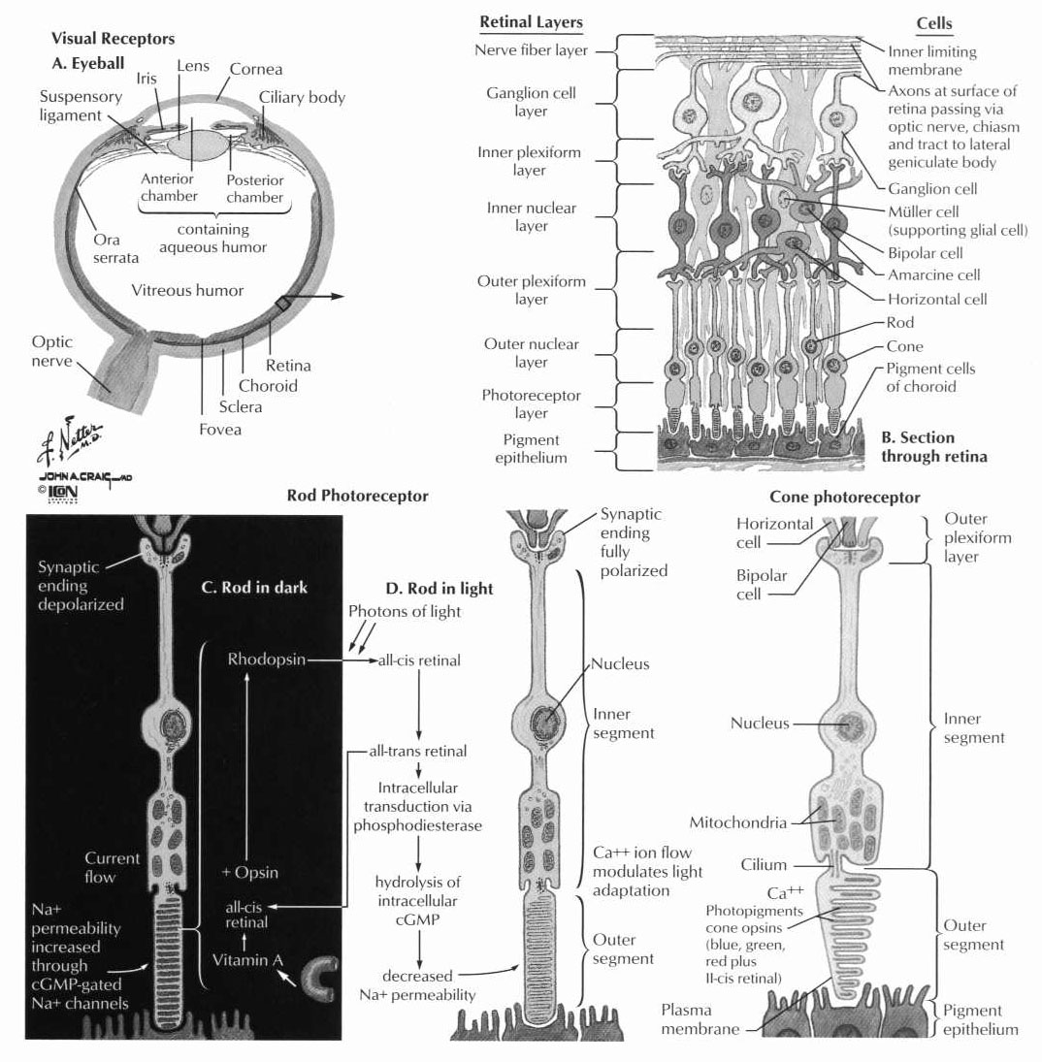
  - processing of information in the retina
    - lens is a sphere pulled by 70 zonules (attached to ciliary body) into lens shape
      - parasympathetic → relaxation of ciliary body accommodation (rounder for closer vision); presbyopia is inability to accommodate (14D in children, 2D by 40, 0D by 70)
      - aquaeous humor secreted by ciliary processes, through pupil, trebeculae at iris-cornea jct, absorbed by Schlemm’s canal into venous system
    - retina supplied by central retinal artery (through optic nerve); outer layers adherent to choroids, fed by diffusion from choroids to outer segments of rods/cones
    - layers of retina
      - outer pigment layer (deepest layer so nearest to back surface of globe); albino lack this so poor vision
      - inner limiting membrane
      - outer nuclear layer (cell bodies, rods/cones)
      - outer plexiform layer
      - inner nuclear layer
      - inner plexiform layer
      - ganglion layer
      - optic nerve fiber layer
      - inner limiting membrane
    - rods (100 million) – outer segment contain light-sensitive photochemical rhodopsin with transmembrane proteins – causes hyperpolarization with light
      - rhodopsin = scotopsin + 11-cis retinal; light causes trans so dissociate (bathorhodopsin → lumirhodopsin → metarhodopsin 1 → metarhodopsin 2 → scotopsin + trans retinal); this causes G-protein to activate phosphodiesterase, decreasing cGMP, closing Na channels, hyperpolarizing the cell
      - rods normally hyperpolarized (-40 mV); receptor potential proportional to light intensity (one photon causes movement of millions of sodium ions); 100 nanosecond of light causes receptor potential that lasts longer than 1 second; rhodopsin kinase inactivates rhodopsin in fraction of second
      - severe vitamin A deficiency causes night blindness due to loss of rhodopsin
    - cones (3 million) – newer/faster/larger cells and fibers but 300 times less sensitive than rods
      - macula (1 mm) – only cones; at fovea (0.4 mm), cones are more slender so higher acuity
    - horizontal cells – in outer and inner plexiform layers, lateral inhibition to increase contrast
    - bipolar cells – from rods/cones/horizontal to inner layer amacrine/ganglion
    - ganglion cells (1.6 million) – to optic nerve – 3 types:
      - W – 40%, small, slow (8 m/sec), rods, large fields, directional/dark vision
      - X – 55%, medium, 14 m/sec, small fields, cones, color vision
      - Y – 5%, large, fast (50 m/sec), large fields, changes in black and white vision
    - adaptation – bright light causes reduction of photochemicals to retinal and opsins, retinal converted to vitamin A to decrease sensitivity
      - cones 100x less sens (10 min); rods 25,000x (40 min); additional adaptation through pupil size (30x) and neural adaptation
    - retinal cells conduct signals by electrical conduction not action potential
  - phototransduction
    - Light activates rhodopsin (form cis form to all-trans retinal)
    - G-protein is activated that decreased cGMP levels
    - Na⁺ conductance is decreased
    - Cell hyperpolarizes to –90mV
    - Glutamate
    - Scotopic vision – night vision
      - Rods are more sensitive in dim light but adapt more slowly than cones
      - Night blindness – Vitamin A deficiency depletes rhodopsin
    - Photopic vision – bright light vision
      - Cones use red, green, or blue photopsins
      - Red or green color blindness is X-linked
  - neural elements of vision
    - Transmission from rods/cones through horizontal cells, bipolar cells, amacrine cells to ganglion cells
    - Optic nerve projects to LGN, pretectal area, suprachiasmatic nucleus, superior colliculi
    - LGN – uranium 235 (uncrossed are 2, 3, and 5)
      - Layers 1 and 2 are magnocellular (from Y ganglion cells)
      - Layers 3-6 are parvocellular – receive color information (from X ganglion cells)
      - Layers 2,3, and 5 receive ipsilateral input
      - Layers 1, 4, and 6 receive contralateral input
    - Cortical organization
      - Center of the visual field is represented at the occipital pole
      - Upper VF is below the calcarine sulcus
      - Lower VF is above the calcarine sulcus
  - processing of vision in the central visual pathways
    - suprachiasmatic (hypothalamus) – circadian rhythm
    - pretectal nuclei – eye/pupil reflex (project to Edinger-Westphal nucleus, through CN III to ciliary ganglion through short ciliary nerves to ciliary muscle (accommodation) and iris sphincter (miosis)
      - counteracted by sympathetics from T1 through sympathetic chain to superior cervical ganglion, long and short ciliary nerves, to radial iris muscle fibers (mydriasis), Muller’s muscle (eyelid), and ciliary muscle
      - pretectal also has input from areas 18 and 19
    - superior colliculi – conjugate eye movements in response to head movements
    - ventral LGB – to basal brain for behavior
    - dorsal LGB (newest) – for vision
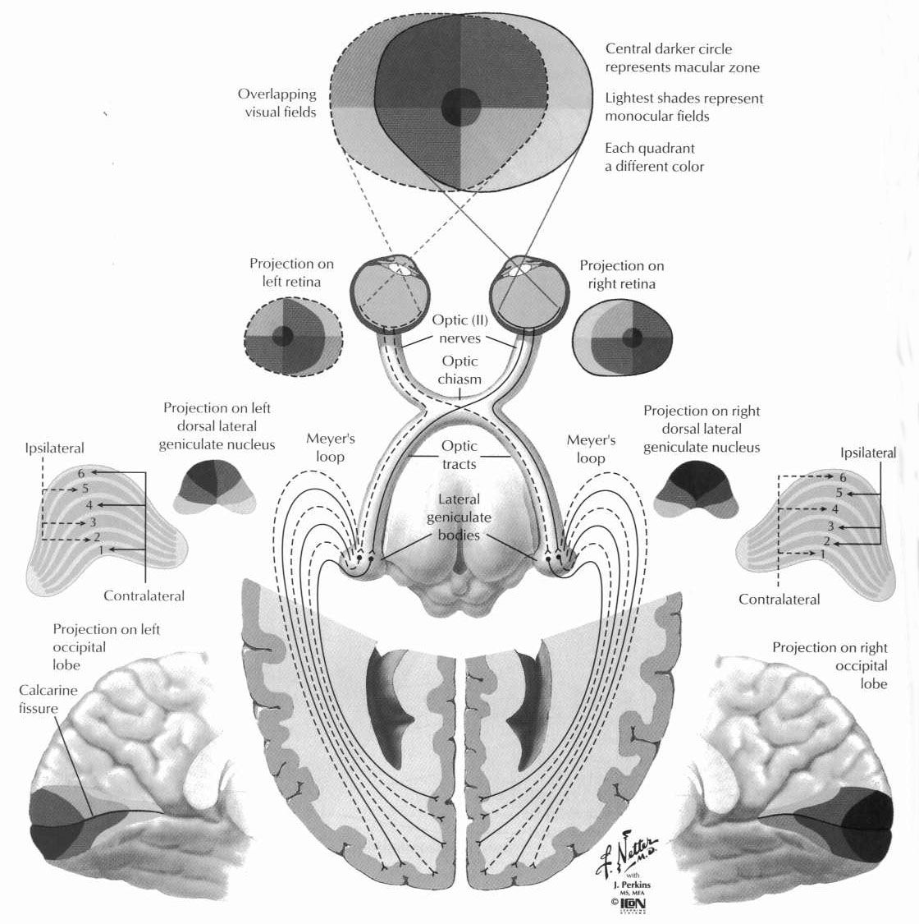
  - columnar units of visual cortex
    - area 17 – ocular dominance columns (40 um wide, 1000 neurons each) – LGB projects to layer 4 forming thin stripes from alternating eyes (lines of Gennari)
    - simple cells have rectangular field
    - complex cells – orientation not position
    - color blobs – interspersed among primary visual columns for color determination
  - visual perception of motion and form.
    - Position/form/motion from Y cells (black/white) – project to middle posterior temporal and occipitoparietal cortex
    - Detail/color project to inferior ventromedial occipitotemporal cortex
    - Fixation:
      - Voluntary – premotor cortex and middle frontal gyrus
      - Involuntary – keep object in field – tertiary visual area (area 19) to superior colliculus to reticular formation to EOMs
  - Accomodation
    - Flat lens allows distance vision
    - Rounded lens allows near vision
    - Ciliary muscle contraction takes tension off the lens, allowing it to round up
    - Edinger-Westphal nucleus and pretectal area supply parasympathetics
  - Pupillary reaction
    - Mediated by the iris
    - Radial muscle innervated by sympathetics from superior cervical ganglion
      - Run in the short and long ciliary nerves
      - Causes mydriasis
    - Sphincter muscle innervated by parasympathetics
      - From E-W nucleus
      - Run in the short ciliary nerve
      - Causes miosis
    - Horner’s Syndrome – impaired sympathetics
      - Miosis, ptosis, anhydrosis
      - Preganglionic – dilates with amphetaime
      - Postganglionic – no reaction to amphetamine
    - Marcus-Gunn pupil – poor contriction to direct light
      - Indicates damage to the retina or optic nerve
    - Argyll-Robertson pupil – small, irregular pupils that accommodate only
      - Poor reaction to light
      - Seen with syphilis
    - Adie’s tonic pupil – Large, non-reactive pupil
      - degeneration of the ciliary ganglion
      - Some response to accommodation
      - Denervation sensitivity – responds to pilocarpine
      - More common in women in their 30s
      - Constricts to pilocarpine
  - Hyperopia – far-sightedness (flattened lens, can see far)
  - Myopia – near-sightedness )rounded lense, can see close)
  - Presbyopia – non-accomidating eye that focuses at a certain distance (need bifocals)
  - Astigmatism – oblong cornea causing a refractive error
  - Eye drugs
    - Testing sympathetics (mydriasis)
      - Amphetamine – releases NE
      - Cocaine – prevents NE uptake
      - Epinephrine – direct stimulation of NR receptors
    - Testing parasympathetics (miosis)
      - Pilocarpine – direct stimulation fo AChM receptors
- Auditory System
  - Tympanic membrane → malleus → incus → stapes → oval window – no change in amplitude but force increased 1.3x, also oval window 17x smaller surface area than TM so total 22x pressure increase
    - Local attenuation – from superior olive; tensor tympani (V3) pulls malleus inward, nerve to stapedius (VII) pulls stapes outward – net effect is to dampen system to mask low frequency and sound of own speech
  - Cochlea – 3 coiled tubes (scalae) make 2.5 turns
    - Scala media – endolymph secreted by stria vascularis; ion concentration like intracellular (high K low Na) so +80 mV potential with other “scalae”
    - Scala tympani, Scala vestibuli – perilymph in communication with CSF and vestibular organs
    - Reissner’s membrane – flexible, separates media from vestibule
    - Basilar membrane – rigid, separates media from tympani
    - Oval window communicates with the scala vestibuli (contains perilymph)
    - Reissner’s membrane – floor of the scala vestibuli that conducts vibrations to the tectoral membrane
    - Organ of Corti – located in the scala media (contains endolymph, high in K⁺)
      - Sits on the basilar membrane (between scala media and scala tympani)
      - Contains hair cells with stereocilia embedded in the tectoral membrane
      - Cells are activated when the stereocilia is pushed in the direction of the kinociluum causing depolarization
    - Cochlea is tapered
      - Higher frequencies heard near the base (closer to the oval window)
      - Lower frequencies heard near the apex
      - Helicotrema – connection between the scala vestibuli and scala media; allows vibrations to exit through the round window
    - 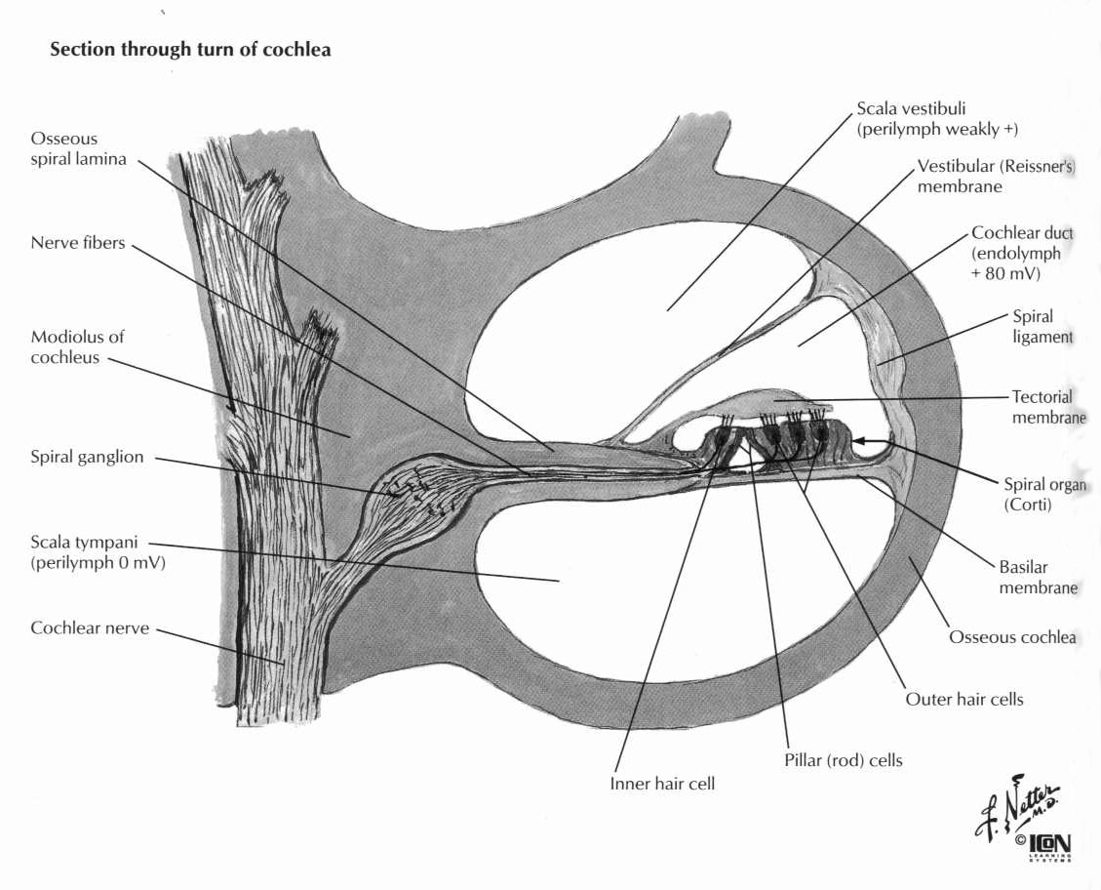
  - Organ of Corti – senses vibration; in basilar membrane; hair cells synapse with cochlear nerve in spinal ganglion (in modiolus at center of cochlea)
    - Each hair cell has 100 stereocilia in the gel of the tectorial membrane in the scala media – bends one way for hyperpol, the other for depol (increased K conductance leads to depol)
    - Hair cell body is in perilymph (-60 mV), while cilia is in endolymph (-140 mV so very sensitive)
    - Stiffer/shorter hair cells (detect higher frequency) are nearer to the base, so low frequency sounds travel to apex
    - Can detect 1 dB sound difference; can detect low frequency sounds only at higher intensity; range is 20-20,000 but only 500-5000 below 60 dB
  - Spiral ganglion to Cochlear nuclei (dorsal and ventral) to trapezoid body (some decussate here) to SLIM (superior olive to lateral lemniscus to inferior colliculus to medial geniculate) to auditory cortex (area 41)
    - Dorsal cochlear nuclei – direct to inferior colliculus
    - Ventral cochlear nuclei – trapezoid to superior olive, commisure of Probst to nucleus of the lateral lemniscus, inferior collicular commisure to inferior colliculus
  - Physiology of hearing
    - Pathway – external auditory meatus
      - Tympanic membrane
      - Ossicles (malleus, incus, stapes)
      - Oval window
      - Cochlea
      - Spiral ganglion (1st neuron)
      - Vestibulocochlear nerve
      - Cochlear nucleus (2nd neuron)
      - Superior olivary nucleus (3rd neuron)
      - Lateral lemniscus
      - Inferior colliculus
      - Brachium of the inferior colliculus
      - Medial geniculate body
      - Auditory cortex
    - Brainsten auditory evoked response
      - I – Vestibulocochlear nerve
      - II – Cochlear nuclei
      - III – Superior olivary nucleus
      - IV – Lateral lemniscus
      - V – Inferior colliculus
      - VI – Medial geniculate body
      - VII – Auditory cortex
    - Modulaton
      - Tensor tympani – innervated by the trigeminal nerve
      - Stapedius – innervated by the facial nerve
      - Reflex mediated by the superior olivary nucleus
- olfaction and taste
  - olfaction – 7 smells (camphor, musk, pungent, putrid, floral, peppermint, ethereal)
    - very small range of intensity (that smell is present is more important than how much is present)
    - olfactory membrane in superior nasal cavity – contain 100,000 olfactory cells supported by sustentacular cells; these are actually bipolar cells from the CNS; each cell has 6-12 olfactory hairs (cilia) that project through mucus (secreted by Bowman’s glands) with odor binding proteins (ion channel or cAMP activating)
    - RMP is -55 mV, continuous firing, stimulus increases rate of action potential; adapts in less than 1 second (inhibition at level of granule cells in olfactory bulb)
    - Olfactory cells → glomeruli in olfactory bulb (each glomerulus detects one type of smell and has 25,000 axons, 25 mitral cells, 60 tufted cells) → CN I → medial/lateral olfactory stria → medial/lateral olfactory area
      - Medial olfactory area – to septal nuclei – salivation/licking/emotion
      - Lateral olfactory area – to prepyriform cortex, pyriform cortex, and cortex over amygdala; ultimately to limbic system and hippocampus – memory, avoid nauseating foods
    - Bypasses thalamus!
    - Pathway:
      - Olfactory cells (1st neuron) in the olfactory membrain
        - Bipolar cells
        - Project to olfactory bulb (2nd membrane)
      - Olfactory nerve splits in the medial and lateral olfactory stria
        - Medial – projects to the septal nuclei
        - Lateral – projects to the pyriform cortex over the amygdlada
  - taste – 10,000 taste buds each contain 40 epithelial cells (taste cells with microvilli and supporting sustentacular cells)
    - receptors for Na, K, Cl, adenosine, inosine, glutamate, H, sweet, bitter
    - adapt quickly – 50% of adaptation is at CNS (most sensory systems adapt primarily at receptor level)
    - ant 2/3 of tongue – taste through VII, touch through V3
    - post 1/3 of tongue – taste and touch through IX
    - base of tongue/epiglottis – taste and touch through X
    - all taste travels to nucleus solitarius
    - Sour – lateral aspect of the tongue
    - Salt – tip
    - Sweet tip
    - Bitter – back of tongue and palate
    - Pathway
      - Anterior 2/3 of tongue – Sensation via V3, taste vis VII (through chorda tympani)
      - Posterior 1/3 of tongue – taste and sensation via IX
      - Base of tongue and pharynx – taste and sensation via X
      - Taste fibers converge in the anterior portion of the nucleus solitarius
      - Relayed to gustatory cortex via VPM in the thalamus

Physiology of Motor Systems
- overview
  - Cells in the anterior horn of the spinal cord
    - α-motor neurons – innervate skeletal muscle
    - γ-motor neurons – innervate muscle spindle fibers
    - Renshaw cells – inhibitory interneurons that use glycine to inhibit surrounding neurons (causes a negative feedback loop)
  - Muscle spindles
    - Detect stretch
    - In parallel with extrafusal fibers
    - Intrafusal fibers
      - Central regions are non-contractile, polar regions are contractile
      - Nuclear bag fibers – detect static state and dynamic changes
      - Nuclear chain fibers – detect static state
    - Large-diameter, myelinated sensory nerve endings
      - From central, non-contractile regions
      - IA – annulospiral endings in nuclear bag
      - II – flower spray endings in nuclear chain
    - Smaller-diameter myelinated motor nerve endings
      - Aγ fibers innervate polar, contractile regions
      - Modulate the sensitivity of the spindle by maintaining tension
  - Stretch reflex – works to resist the lengthening of a muscle
    - Monosynaptic
  - Golgi tendon organs
    - Detect tension
    - In series with muscle fibers
    - Innervated by IB fibers
    - Muscle contraction causes tendon stretching
    - Interneurons in the anterior horn decrease α-motor neuron firing
  - Polysynaptic reflex
  - 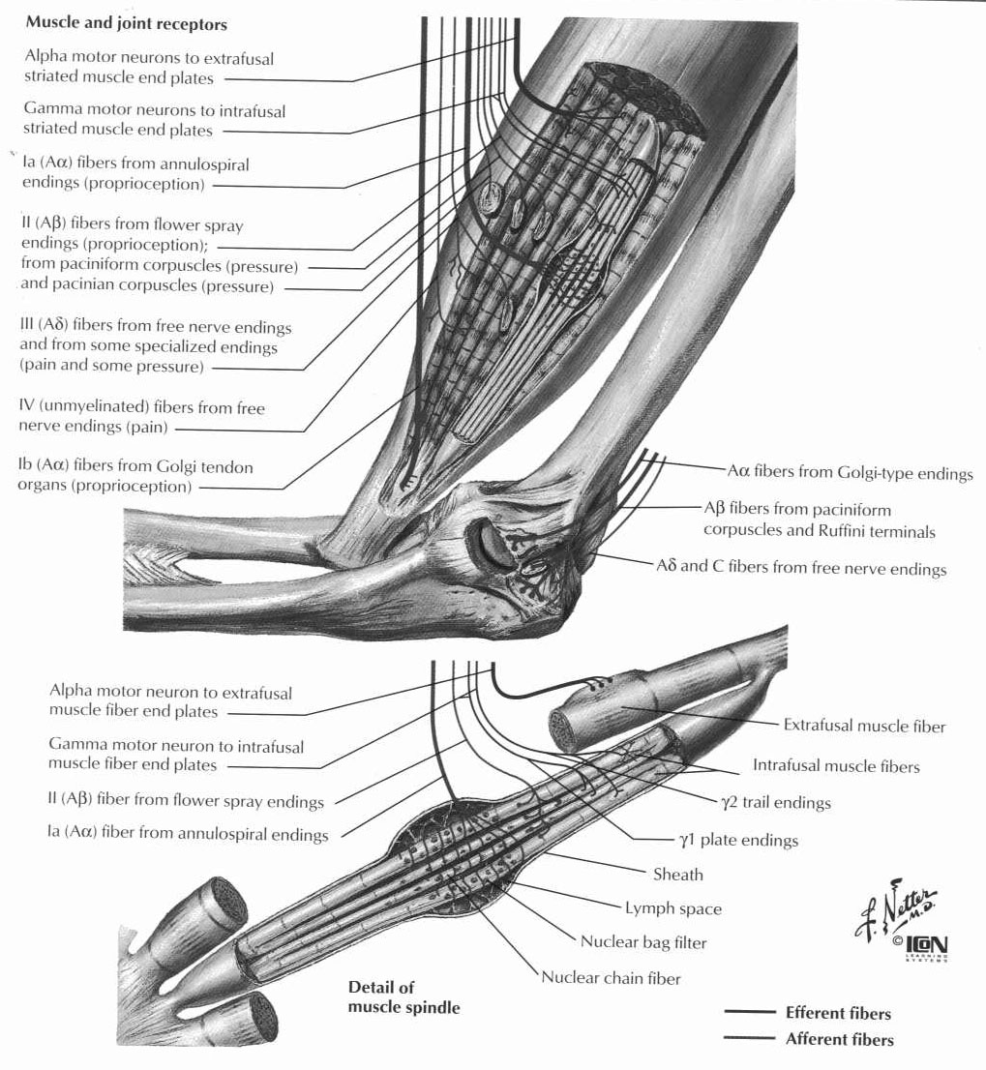
- mechanisms of muscle contraction
  - skeletal muscle
    - each myofibril contains 1500 myosin, 3000 actin molecules
    - light bands (I=isotropic to polarized light) have actin only; dark (A=anisotropic) have both; H (heavy) have myosin only; sarcomere=between Z discs=
    - 200 myosin molecules per filament, each with 2 heads and ATPase; actin filament also has tropomyosin and troponin C (binds 4 Ca ions, moving tropomyosin off actin’s binding site for myosin)
    - strongest contraction at overlap of 2-2.2 um
    - RMP = -80 to -90 mV; AP lasts 1-5 msec (5x as long as nerve), velocity 3-5 m/sec (much slower than nerve)
    - Phosphocreatine/ATP stores last 8 seconds, glycogenolysis depleted in 60 seconds, need oxidative metabolism for more prolonged contraction
    - Contraction/innervation depends on size of motor unit – ocular muscles have 6 nerves per muscle, last 1/40 sec; quadriceps have 1600 nerves, last 1/5 sec
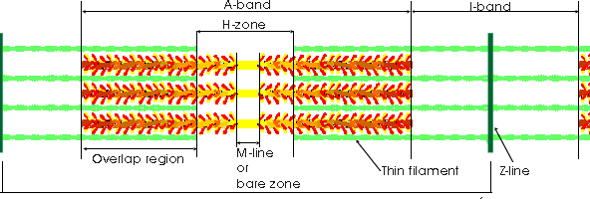
  - Smooth muscle – multi unit (no AP because too small): ciliary muiscle, iris, piloerectors; single unit (syncitial, have AP): gut, uterus, blood vessels
    - No troponin – 15x as much actin as myosin; no Z-disk – dense bands instead (anchor actin)
    - Slower, longer acting, more force with less energy, more shortening (2/3 of length compared to 1/3 for skeletal muscle) because longer actin filaments and interspersed units
    - Calmodulin – 4 Ca bind, activates myosin kinase (phosphorylates heads), stops with myosin phosphorylase (time to relax proportional to myosin phorphorylase concentration
    - RMP = -50 to -60; NMJ from autonomic nerves, no branching end feet (have varicosities instead); but most contraction is by local tissue factors (decreased O2, increased CO2, increased H, adenosine, lactate, K, decreased Ca, temperature, hormones, NE, epi, ach, 5-ht, histamine, angiotensin, ADH); stretching can decrease RMP
    - Increased Ca conductance can cause AP in single unit (visceral) – slower than Na channels so very slow AP; can act as pacemaker
    - Calcium comes from extracellular space (not SR as skeletal) so latent period 50x longer; if serum Ca low, decreased contraction
  - Cardiac muscle – striated, gap junction at intercalated discs, AP plateau longer (increased conductance of slow Ca channels), slower velocity than skeletal muscle
    - RMP -85 to -95 mV, -90 to -100 in purkinje cells
    - Excitation-contraction coupling – T tubules (have negative mucopolysaccharides) spread AP to myofibrils, Ca comes from outside cell and SR
    - SA node – RMP is -55 mV because of natural leak to Na; at -40 mV ca channels open; no contractile elements; repol by opening K channels; fast Na chalnnels are always blocked (since greater than -60) so only slow Ca and Na channels open
    - AV – delays signal 0.13 second due to small fiber size, few gap jct, low RMP (less driving force for ions)
    - Parasymp – innervates SA and AV nodes, increase K conductance (hyperpolarization); symp – innervates entire heart, NE increases Na and Ca conductance to increase rate 3x, contractility 2x
- sarcomere and muscle contraction
  - Each muscle fiber is innervated be one motor neuron ending
  - Each myofibril contains 1500 myosin and 3000 actin filaments
  - Light bands – Actin only
  - Dark bands – myosin and actin
  - A-band – myosin
  - H-band – space between actins in the same sarcomere
  - I-band – space between myosins in different sarcomeres
  - Z-line – separates sarcomeres
  - M-line – centers of myosin
  - Mechanism
    - Myosin molecule has two heads, binds ATP
    - At rest, troponin and tropomyosin block the actin-myosin binding sites
    - Ca⁺⁺ released by muscle fiber activation
    - Ca⁺⁺ binds to tropomyosin, exposing the actin-myosin binding sites
    - Myosin breaks down ATP to ADP to cock the heads and slide along the actin
    - ATP causes myosin to detach from the actin
- muscle receptors, spinal reflexes
  - A-alpha – skeletal muscle; A-gamma – muscle spindle; C – sympathetic
  - Renshaw cells – anterior horn; alpha motor neuron sends here to inhibit surrounding alpha motor neurons and disinhibit antagonist (sharpens like lateral inhibition in visual system)
  - Spinal reflexes – cortex needs only supply simple commands; all present in decerebrate animals
    - Flexor (withdrawal) – pain; uses interneurons; proportional to stimulus, can last 1-3 seconds
    - Crossed extensor – similar to flexor, occurs 0.2-0.5 seconds after flexor to push body away from stimulus
    - Positive supportive reaction – pressure over footpad leads to limb extension and standing
    - Cord righting reflex – stand up
    - Rhythmic steps reflex – reciprocal inhibition; sensory input can alter rate (Rhythmic walking reflex combines sides, rhythmic galloping reflex combines fore/hindlimbs)\
    - Scratch reflex – itch/tickle
    - Autonomic reflexes – vascular tone/temperature, sweat, blood pressure; peritoneo-intestinal (stop intestines with peritonitis); evacuation reflex (distension of bladder or gut); mass reflex (distension or pain of bladder/gut causes flexor spasms, evacuation, increased blood pressure, sweating; considered spinal cord seizure)
- spinal reflexes concerned with position
  - propriospinal fibers make up 50% of spinal cord fibers – make up dorsal spinocerebellar tract, fastest neurons in CNS (120 m/sec)
    - spindles – tonic, increased with stretch of muscle (length/velocity of change); parallel with muscle fibers; 3-12 intrafusal fibers (central part does not contract, ends have gamma motor neuron input)
    - primary annulospiral (Ia – fast) encircles center of muscle fiber; secondary flower-spray on one end only
    - intrafusal – consist of nuclear bag fibers (primary sensory ending, dynamic based on rate of stretch) and nuclear chain fibers (primary and secondary, static response based on amount of stretch)\
    - gamma motor neurons account for 31% of motor neurons, arise from bulboreticular facilitating region, cerebellum, basal ganglia, cortex – fire in parallel with alpha
    - servo-assist – load causes intrafusal fibers to become shorter than extrafusal causing reflex increase in muscle activity (so contraction becomes less load-sensitive)
    - stretch reflex – monosynaptic
    - golgi tendon organs – encapsulated receptors at muscle-tendon junction – one per 10-15 muscle fibers; send Ib fibers to interneurons that decrease alpha motor neurons to prevent tearing of muscle (not monosynaptic as with spindle stretch reflex); also project to cortex and spinocerebellum
- brain stem reflexes controlling motion
  - pontine reticular formation – lateral, excites antigravity muscles by way of lateral reticulospinal tract to medial anterior horn cells; stimulated by vestibular nucleus and cerebellum
  - medullary reticular formation – ventromedial, inhibits antigravity muscles by way of medial reticulospinal tract; stimulate by corticospinal/rubrospinal
- vestibular nuclei control of movement and posture
  - vestibular system
    - Bony labyrinth contains the membranous labyrinth
    - Membranous labyrinth contains endolymph
    - Bony labyrinth contains perilymph (around membranous labyrinth)
    - Macula – sense organ of the utricle and saccule
      - Contains hair cells embedded in gelatinous layer
      - Otoliths in gelatinous layer make it responsive to gravity
      - Detects linear acceleration (non-dynamic)
      - Detects movement in a plane parallel to itself
    - Utricle – macula is horizontal (able to sense changes) when one is upright
    - Saccule – maccule is horizontal (able to sense changes) when one lies down (when you hit the sac, you’re lying down)
    - Crista ampullaris – sense organ of the semicircular canals
      - Located in the ampulla (dilation) od each semicircular canal
      - Hair cells embedded in a gel cup called the cupula
      - Detect angular (dynamic) acceleration
    - Semicircular canals – anterior, posterior, and horizontal
      - In the same orientation as extraocular muscles
      - Horizontal canals are sensitive to rotations about a vertical axis
      - Anterior and posterior canals are 45° to the coronal plane
    - 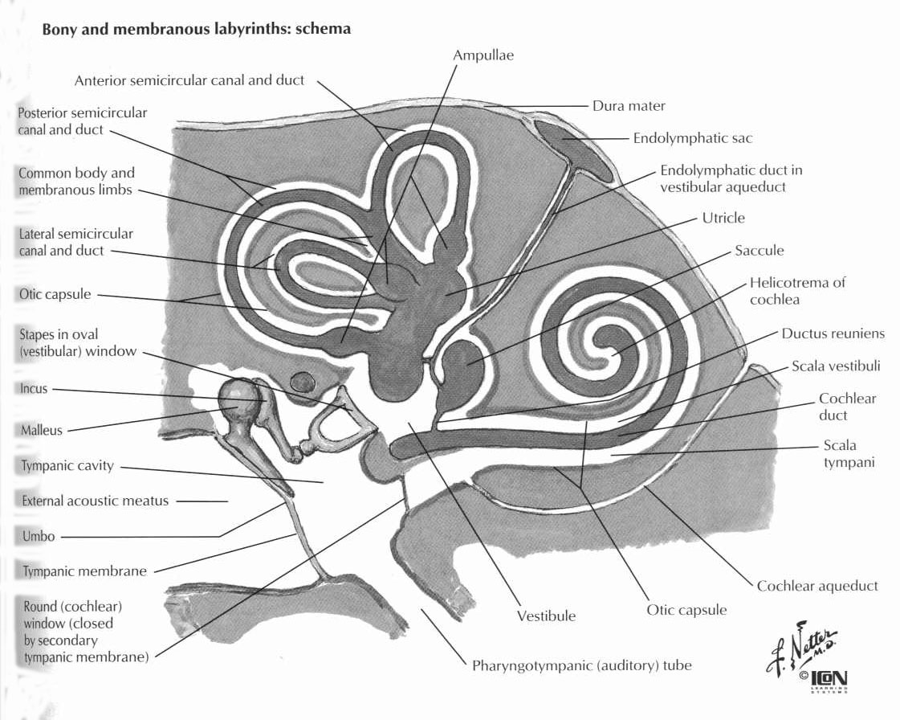
    - Vestibular nuclei
      - Superior and medial – involved in eye reflexes
        - Project to MLF and vestibulospinal tract
      - Medial – largest nucleus
        - Projects to all extraocular muscle nuclei and flocculonodular lobe
      - Superior – sends uncrossed fibers to III, IV via the MLF
      - Lateral (Deiter’s) – involved in posture
        - Receives input from the utricle (via Superior) and saccule (via Inferior)
        - Output to lateral vestibulospinal tract
  - linear acceleration – utricle (“upright” or vertical accelleration, to superior vestibular ganglion) and saccule (“supine” or forward/backward accelleration, to inferior vestibular ganglion) – sensory organ is maculae which has hair cells embedded in gelatinous layer containing CaCO3 otoliths
    - each hair cell contains 50-70 cilia and one large kinocilium – when cilia bend toward kinocilium, Na conductance increases which causes depol
    - baseline firing rate is 100/sec – can increase (hundreds) or decrease (to 0)
  - angular acceleration – semicircular canals – anterior, posterior, horizontal (when head is forward 30 degrees horizontal is parallel with floor, ant and post are both 45 degrees lateral and bent forward and backward, respectively)
    - ampulla – dilated end of canal, filled with endolymph and contains crista ampullaris (sensory organ) which has hair cells with cilia that project into gel cup (cupola)
    - with rotation fluid remains stationary (head rotates around it) which bends hair cells
  - vestibular nuclei:
    - lateral vestibular nucleus (Dieter’s nucleus) – stimulates antigravity muscles by way of medial and lateral vestibulospinal tracts, controls posture
      - from: utricle and saccule
      - to: lateral vestibulospinal tract (LE ext, UE flex) to alpha and gamma motor neurons
    - superior/medial vestibular nuclei – eye movements
      - from: semicircular canals
      - to: MLF, medial vestibulospinal tract (head and neck movements
      - medial (largest vestibular nucleus) to CN III/IV/VI and cerebellum; superior (uncrossed) to III/IV only (NOT CN VI)
    - inferior vestibular nucleus – integrates input from vestibular nucleus and cerebellum
      - from: semicircular canals/utricle/saccule
      - to: cerebellum, reticular formation
- red nucleus control of movement
  - like corticospinal but less fine control; somatotopically organized; input form branches of corticospinal neurons, also some dedicated corticorubral fibers; red nucleus consists of large Betz-like cells
  - rubrospinal tract just anterior to corticospinal tract
  - red nucleus also has input from dentate/interposed nuclei of cerebellum, and output to interposed
  - decerebrate (vs. decorticate) requires lesion below red nucleus but above pontine/vestibular nuclei
- cortical control of movement
  - corticospinal tract – 30% from area 4, 30% from area 6 (supplementary), 40% from parietal lobes
    - ventral corticospinal tract – mostly ipsilateral, crosses in lower segments, posture
  - Motor cortex – area 4 – 50% consists of hand and face
    - Betz cells (large pyramidal cells) in layer 5 – fibers travel 70 m/sec (fastest efferent); 50-100 Betz cells for each muscle; makes up less than 3% of corticospinal fibers (34,000 of the 1 million)
    - From: sensory (muscle spindles stimulate if they move more than extrafusal), visual, auditory, frontal, contralateral motor cortex (through corpus callosum), VL/VA thalamus (from cerebellum and basal ganglia), intralaminar thalamic nuclei (level of excitability)
    - To: spinal cord, cortex (lateral inhibition – mostly from layer 6), contralateral motor cortex, striatum, red nuclei, vestibular nuclei, inferior olive
  - Premotor cortex – anterior to area 4
    - area 44 – Broca’s (posterior inferior frontal gyrus) for breathing and voice control
    - area 8 (above Broca’s) – frontal eye fields for eyelid blinking and horizontal saccades to the opposite side
    - head rotation area (above area 8) to turn head with eye movement
    - hand skill area (above head rotation area, anterior to primary hand motor area) – lesion causes motor apraxia
  - Supplementary motor cortex – area 6, anterior and superior to premotor, mostly on medial surface of hemisphere adjacent to longitudinal fissure
    - Somatotopic – LE posterior, face anterior
    - Requires stronger stimulus and produces bilateral contractions
    - Sets complex actions that serve as background for finer actions
    - Injury produces decrease in voluntary movements and speech that resolves in 6 weeks
- cerebellar control of movement
  - regional and cellular organization of the cerebellum
    - 30 million functional units each centered around a Purkinje cell
    - 3 layers
      - molecular
        - “telegraph lines” of granule cell axons (parallel fibers) along folia
        - Basket/stellate cells – lie along parallel fibers and stimulated by them to inhibit adjacent Purkinje cells
      - Purkinke
        - climbing fibers – from inferior olive to Purkinje cells (also to deep nuclei, not as strong) – each fiber stimulates 10 Purkinje cells and has 300 synapses in molecular layer
        - Purkinje cells – arborize into molecular layer (spread along short axis); basal firing rate of 50-100/sec (like deep nuclei); each Purkinje cell contacts 80,000 to 200,000 parallel nerve fibers
      - Granular
        - mossy fibers – from cortex, brainstem, spinal cord to granular layer (also to deep nuclei) – each fiber synapses on hundreds of granule cells to form glomeruli
        - granule cells (glutamate) – each cell sends an axon up to the molecular layer where it bifurcates to form parallel nerve fibers parallel to folia; each fiber contacts 250-500 Purkinje cells
        - Golgi type II cells – inhibit granule cell to decrease duration of excitatory response
  - functional divisions of the cerebellum
    - Divisions of cerebellum:
      - vermis (axial)
        - from: motor cortex, brainstem, spinal cord
        - to: motor cortex, red nucleus, reticular formation
      - intermediate zone (distal)
        - from/to same areas as vermis
      - lateral (plan movement) – NOT somatotopic; association areas of cortex (no input from peripheral receptors or primary motor cortex)
    - Afferents to cerebellum:
      - ICP
        - juxtarextiform – vestibulocerebellar (from vestibular to fastigial nucleus)
        - restiform
          - olivocerebellar – from motor cortex, basal ganglia, reticular formation, spinal cord to inferior olive to cerebellum)
          - reticulocerebellar – to vermis
          - dorsal spinocerebellar – from spindles and golgi tendon organs through Clarke’s nucleus to vermis and intermediate zone
      - MCP – corticocerebellar; motor/premotor/sensory through pontine nuclei
      - SCP – ventral spinocerebellar; “efference copy” of cortico/rubrospinal motor fibers
    - Efferents from cerebellum:
      - ICP (juxtarestiform)
        - Flocullonodular lobe to lateral vestibular nucleus (lesions causes nystagmus)
        - Vermis to fastigial nucleus to pons and medulla – equilibrium/posture control (lesion causes truncal ataxia and scanning speech)
      - SCP
        - Intermediate zone to interposed nuclei to VL and VPLo thalamus and from there to the cortex, thalamus, basal ganglia, red nucleus, midbrain reticular formation for distal limb agonist/antagonist control (lesion causes appendicular ataxia)
        - Lateral zone to dentate to VL and VPLo thalamus and from there to the cortex (area 4) for coordination of sequential action (lesion causes intention tremor)
  - the role of the cerebellum in planning movement
    - cerebellar learning: climbing fibers act to adjust Purkinje cell sensitivity to allow learning of complex tasks
      - inferior olive compares corticospinal to motor centers of intent – if they do not correlate, it changes rate of climbing fibers firing (“error impulse”) – this subsequently alters the long-term sensitivity of the Purkinje fibers to the mossy fibers, allowing for learning of complex tasks
    - flocculonodular – rapid changes in body position (from vestibular apparatus) – velocity/direction of movement, calculates where body will be to maintain equilibrium
    - intermediate zone
      - compares intention of cortex/red nucleus (efference copy of alpha motor neurons through ventral spinocerebellar) with what actually happens (sensory) – sends corrections to thalamus
      - dampens movements and anticipates momentum (so damage causes intention tremor, ballistic movements, slowness in starting/stopping an action)
      - controls ballistic movements with no time for feedback (typing, eye saccades)
    - lateral zone – dentate nucleus contains information about what is about to happen (not what is happening)
      - planning/time sequencing of movements through connections with premotor cortex, basal ganglia, and sensory cortex – damage prevents smooth transition between movements
      - predicts information from auditory/visual stimuli (how fast something approaching)
- Basal ganglia
  - the anatomy of basal ganglia pathways
    - controls scale/timing of movement; have learned movements stored within it
    - essentially motor cortex (primary motor, premotor, supplementary motor, association cortex) stimulates striatum which inhibits globus pallidus (GPi) which inhibits thalamus (VLo, VA) which stimulates cortex
      - putamen circuit controls motor activity patterns (to GPi and GPe), associated with centromedian thalamic nucleus
      - caudate circuit controls cognitive control of motor patterns and integrates sensory information with memory to decide motor activity (to GPi), associated with parafascicular thalamic nucleus
      - GPe has reciprocal connections with STN which projects to thalamus
  - neural transmitters in the circuits within the basal ganglia
    - cortex and STN uses glutamate, striatum and GP use GABA, SNpc uses DA
- Thalamus
  - CM nucleus associated with putamen and area 4
  - PF nucleus associated with caudate and area 6
  - VLc and VPLo connect contralateral deep cerebellar nuclei to area 4
  - VLo connects GP to to premotor and area 6

Autonomic Nervous System
- Low stimulation rate (10-20/sec compared with 50-100/sec for muscle stimulation)
- Sympathetic
  - Intermediolateral cell column – T1-L2; fibers in anterior root to spinal nerves to preganglionic fibers (white ramus) to prevertebral ganglia, synapse here or in other ganglia, continue as postganglionic fibers (gray ramus) back to spinal nerves where they travel to end organ (travel with blood vessels in head/neck only)
  - T1 to head; T2 to neck; T3-6 thorax; T7-11 abdomen; T12-L2 lower extremities; innervates entire body
  - Spinal nerves to periphery, sympathetic nerves to viscera
  - adrenal medulla – 80% epi, 20% NE; lasts 5-10x longer than other symp stimulation (products elsewhere cleared quickly by presynaptic uptake and diffusion)
  - sympathetics control all vasculature (except capillaries, pericapillary sphincters, and metarterioles) – responsible for 50% of blood pressure
- Parasympathetic
  - 75% cranial (CN 3,7,9,10), 25% sacral (S2-4) – only part of the body (not limbs), CNIII papillary spincter/ciliary muscle, CNVII lacrimal/nasal/submandibular/sublingual, CNIX parotid, CNX body to midcolon, pelvic nerves (nervi erigentes leaving sacral plexus) descending colon, bladder, lower uterus, external genitalia
  - sacral preganglionic synapse in walls – short (mm to cm) postganglionics are in substance of the organ; no parasymp pass through ganglia without synapsing
- ANS pharmacology
  - Sympathomimetics – phenylephrine alpha, albuterol beta, ephedrine/tyramine/amphetamine NE release
  - Reserpine blocks synthesis and storage of NE and releases vesicles; guanethidine decreases NE release
  - Phenoxybenzamine and phentolamine block alpha; propranalol blocks beta
  - Hexamethonium/TEA/pentolinium block ganglia (symp>para)
  - Muscarinic – Pilocarpine/methacholine
    - atropine and scopolamine inhibit musc by blocking AChR; neostigmine, pyridostigmine, and physostigmine inhibit AChE (organophosphates permanently)
  - Nicotinic – acetylcholine, nicotine, methacholine
    - Ganglionic blocker – hexamethonium (not reversed by AChE)
    - Depol – succinylcholine and decamethonium (amplified with decreased muscle temp)
    - Nondepol – alphabungarotoxin and other curares
  - Cocaine – blocks DA reuptake as alpha1 uptake inhibitor

Arousal and Emotion
- noradrenergic systems
  - locus ceruleus – posterior pontine-midbrain junction – diffuse NE
  - SNpc – DA to caudate and putamen (inhib; but DA is excit elsewhere, in hypothal/limbic)
  - Raphe nuclei – lower pons/medulla, serotonin (thalamus for sleep and restful functions, also to cortex, spinal cord (anesthesia))
- limbic system
  - hypothalamus, septal area, paraolfactgory area, epithalamus, anterior thalamic nucleus, hippocampus, amygdala
  - orbitofrontal → subcallosal gyrus → parahippocampus and uncus
  - MFB connects RF with septal nuclei/orbitofrontal gyrus, thalamus, hypothalamus, cortex
  - Hypothalamus – lateral = hunger, posterior = sympathetic/increased temperature, mamillary = feeding (licking lips/swallowing)
  - Emotion
    - Reward – lateral/ventromedial hypothalamus, MFB, septum, amygdala, thalamus, basal ganglia, midbrain
    - Punishment – central gray, periventricular hypothalamus, amygdala, hippocampus
    - Rage – lateral hypothalamus, periventricular punishment areas
    - Fear – midline preoptic nucleus; balanced by ventromedial nucleus, amygdala, ant cingulate gyrus, ant subcallosal gyrus
    - Peace and satiety – ventromedial hypothalamus
    - Sex drive – ant/post hypothal nuclei
  - Amygdala – connects to hypothalamus
    - From: limbic cortex, parietal/occipital/temporal association areas to basolateral nucleus, also from olfactory tract to corticomedial nucleus under pyriform cortex (less important)
    - To: cortical association areas, hippocampus, septal areas, thalamus, hypothalamus
    - Serves as limbic system’s window to outside world
    - Bilateral destruction: Kluver-Bucy – oral examination of objects, decreased aggressiveness, tameness, carnivorous, psychic blindness (need to examine tactile/orally), increased sex drive, curiosity, fearfulness, forgetfulness
  - Hippocampus – 3 layered cortex, incoming sensory information travels from here to anterior thalamus
    - Parahippocampal gyri used for complex thought (with Wernicke’s)
  - Middle/posterior cingulate gyrus – sensorimotor associations
  - prosopognosia – bilateral damage to medial basal occipitotemporal cortex between limbic (temporal) and visual (occipital)
  - memory
    - immediate – thalamocortical reverberation
    - short term – chemical changes (blockage of K channels)
    - long term – structural changes (new synapses)
- sleeping and sleep states
  - RAS deaffernation, also raphe nuclei
- reticular activating system
  - keeps brain “on”; located in pons and midbrain; most output via large cholinergic cells to thalamus for diffuse spread; also small cells with slow fibers to the interlaminar nuclei of the thalamus and reticular nuclei over the thalamic surface that last longer and control background excitability of the brain
  - receives positive feedback from cortex

Physiologic Control of the Cerebral Vasculature
- Nl 50-55 cc/100g/min; 23 impaired, 8 death (ion pump)
- Brain gets 15% of CO and 20% of O2 (uses 3.5 cc/100g/min) even though only 2% of mass
  - Higher in gray matter (4x WM), highest in posterior pituitary
- No anaerobic glycolysis, only low stores of glycogen and O2, so need constant O2 and glucose (do not need insulin for glucose uptake)
- CBF increased by increased CO2, increased H; lowered by decreased O2
- Symp does not change much (autoreg 60-140) but will decrease CBF if BP high
- Vasomotor center – medullary RF
  - Vasoconstrictor (C1) anterolateral upper medulla, sends NE to spinal cord
  - Vasodilator (A1) anterolateral lower medulla, inhibits C1
  - Sensory center (A2) posterolateral pons/medulla, near solitary tract, bilateral input from CNIX/X
  - Lateral vasomotor center – symp to heart; medial vasomotor center – parasymp to heart
- Baroreceptors/chemoreceptors are in carotid body (CNIX through Herring’s nerve) and arota (CNX)
- Osmoreceptors are in anteroventral 3rd ventricle between subforniceal organ and organum vasculosum of the lamina terminalis; median preoptic nuclei is between these – connects to supraoptic nucleus and BP control centers; no BBB
- Respiratory center
  - dorsal respiratory group (main respiratory center) in dorsal medulla causes inspiration, input from nTS, chemo, baro
  - ventral repiratory group in ventrolat medulla (in the nucl ambig and retroambig) – controls large breaths (not normally active), both inspiration and expiration
  - pneumotaxic center – dorsal superior pons in nucl parabrachialis – controls rate and pattern

Physiology of the Hypothalamus and Pituitary
- Pituitary secretes 8 hormones – GH and prolactin (from acidophilic cells); FSH, LH, ACTH, and TSH (from basophilic cells) from anterior; oxytocin/vasopressin from posterior
- Hypothalamus controls pituitary by means of releasing factors – primary capillary plexus of median eminence of hypothalamus and tuber cinereum drain to hypothal-hypophyseal portal system with sinuses to anterior pituitary gland – hypothal releasing hormones are TRH, CRH, GHRH, GHIH (somatostatin), GnRH, and PIF (DA)
Development, Congenital Disorders

Development
- 3% of newborns have developmental abnormalities; 10% of these involve CNS
- Overview
  - Day 13 – formation of primitive streak
  - Day 17 – formation of notochord
  - Day 22 – neural folds form neural tube
  - Day 24 – closure of anterior neuropore
  - Day 26 – closure of caudal neuropore
- Sequence of Events
  - Primary neuralation – 3-4 weeks
    - day 13 streak, day 17 notocord, day 22 fusion begins, day 24 anterior neuropore (lamina terminalis) closes, day 26 posterior neuropore closes)
    - nondisjunction causes lipomas, dermoids, spinal dysraphism
  - Secondary neuralation – 4-5 weeks
    - Disruption causes dysraphism below L1-2
  - Migration – 2-5 months
  - Myelination – 5 months; starts caudal, dorsal, central, sensory and progresses from there
  - Germinal matrix – 7-30 weeks (pockets persist as late as 39 weeks)
  - Brainstem – 2-6 months
- Origin of tissues
  - Neural crest – meninges (except dura/arachnoid which are mesenchymal), Schwann cells, sympathetic ganglion, adrenal medulla, melanocytes, APUD cells (including pineal)
  - Telencelaphalon – caudate, putamen, fornix, anterior commissure, corpus callosum, hippocampus
  - Diencephalon – thalamus, globus pallidus, posterior hypothalamus, infundibulum, optic nerve, retina, posterior commissure, habenular commissure
- Spinal dysraphism
  - Anencephaly – most common (0.5%) – usually white females; 90% have no family history but 5% risk with additional children
    - Associated with twins, polyhydramnios, hypothyroidism, decreased folate/zinc/copper
  - Myelomeningocele – 0.07%, F>M, associated with decreased materal folate or maternal valproic acid/carbamazepine; 100% have chiari II; also associated with hydrocephalus, syrinx, split cord, kyphosis, scoliosis, orthopedic deformities, corpus callosal dysgenesis
    - Meningocele 10% as common as myelomeningocele
- Cephalocele
  - Occipital – Europe/North America; F>M; foramen magnum and lambdoid suture; associated with myelomeningocele, split cord, Dandy-Walker, Klippel-Feil syndrome
  - Parietal – M>F, lambda/bregma; associated with midline agenesis of corpus callosum, holoprosenecephaly, Dandy-Walker
  - Transphenoidal – associated with endocrine abnormalities and corpus callosum agenesis
  - Sincipital (frontoethmoidal) – southeast asia, M>F, between nasal/ethmoid bones, no neural tube defects
  - Nasal (sphenoethmoidal) – from dural diverticulum that normally regresses; crista galli absent or eroded with enlarged foramen cecum
  - Meckel’s disease – cystic dysplastic kidneys, cardiac disease, cephaloceles
- Dermal sinus – 50% end in dermoid
- Cleavage abnormalities
  - Holoprosencephaly – associated with trisomy 13, 14, 15, 18; also polydactyly, renal dysplasia, maternal diabetes; can be alobar, semilobar (with partial falx partially separated thalamus and basal ganglia), or lobar (squared frontal horns, gray matter in corpus callosum, no facial abnormalities)
  - Arhinencephaly – no olfactory bulb or tract; gray matter in corpus callosum; includes Kallman syndrome (anosmia, hypogonadism, mental retardation)
  - Septo-optic dysplasia (Demorsier’s syndrome) – mild lobar holoprosencephaly with no septum, hypoplastic optic nerves, seizures, mental retardation, hypotelorism, ventriculomegaly
  - Cleidocranial dysostosis – retention of mandibular teeth, delayed closure of fontanelle, wormian bones, midline deficits
- Migrational abnormalities – heterotopia, ectopia, lissencephaly; often caused by intrauterine infections
  - Agenesis of corpus callosum – high third ventricle, radial spokelike gyri, Probst bundles (long white matter tracts indenting medial ventricle), culpocephaly (dilated occipital horns), sometimes absent cingulate gyrus, anterior commissure, or fornix; associated with Chiari II, Dandy-Walker, migrational abnormalities, azygous ACA
  - Aicardi syndrome – F>M, corpus callosum agenesis with ocular abnormalities and infantile spasms
  - Chiari I – herniation of tonsils below foramen magnum; as age increases, less herniation will produce symptoms; associated with basilar invagination, Klippel-Feil, atlanto-occipital fusion; causes pain, occipital headache, L’hermitte sign, long tract changes, syrinx, hydrocephalus; causes nystagmus/bulbar symptoms in very young patients
  - Chiari II – herniation of cerebellum through enlarged foramen magnum, skull lacunae, concave petrous bone, short clivus, thin falx, medullary kinking, enhancing ectopic choroid, tectal beaking, enlarged massa intermedia, most have hydrocephalus; associated with heterotopias, polymicrogyria, corpus callosum dysgenesis
  - Dandy-Walker – usually with hydrocephalus (otherwise is variant); associated with corpus callosum agenesis, heterotopias, cephalocele, dolicoectasia, cardiac disease, polydactyly
  - Lhermitte-Duclos – hypertrophic cerebellar granular cell layer with increased myelin in molecular layer and thick folia
  - Fetal alcohol syndrome – growth retardation, craniofacial dysmorphism, CNS/visceral malformation, mental retardation, microcephaly
- Craniosynostosis
  - Sagittal – most common; M>F; causes scaphocephaly and dolicocephaly
  - Unilateral coronal – F>M; anterior plagiocephaly
  - Bilateral coronal – brachycephaly
  - Unilateral lambdoid – M>F; posterior plagiocephaly
  - Metopic – trigonencephaly
  - Bilateral coronal and sphenofrontal – turricephaly
  - Multiple – oxycephaly (cone shaped head)
  - Scaphocephaly – sagittal suture
  - Plagiocephaly – half of coronal suture
  - Brachycephaly – both coronal and lambdoid
  - Trigonocephaly – metopic synostosis (10-16%)
  - Syndromic craniosynostosis
    - Crouzon – most common; autosomal dominant; shallow orbit, exophthalmos, sphenoid and frontal synostosis; midface hypoplasia, malformed ears, agenesis of corpus callosum, hydrocephalus more common than mental retardation, oxycephaly/turricephaly/dolicocephaly
    - Apert – autosomal dominant; mental retardation more common than hydrocephalus; maxillary hypoplasia, hypotelorism, syndactyly, flat nose, deafness; fronal cephaloceles; associated with vertebral, skeletal, GI, GU, cardiac abnormalities; coronal; turricephaly
    - Common to both:
      - Autosomal dominant
      - Exorbitum and midface deformity
      - Proptosis, hypertelorism, hearing loss
      - Optic atrophy, seizures
    - Characteristics unique to Crouzon’s:
      - Multiple synostosis
      - Agenesis of corpus callosum
      - Normal IQ
    - Characteristics unique to Apert’s:
      - Coronal suture only
      - Anterior open bite
      - GI/GU/cardiac abnormalities
      - Mental retardation
      - Cleft palate
      - Syndactyly
      - Frontal encephalocele
      - Normal corpus callosum
- Genetic abnormalities
  - Trisomy 13 (Patau) – F>M, hypotelorism, holoprosencephaly, microcephaly, microphthalmia, cleft lip/palate, polydactyly, dextrocardia, ocular abnormalities
  - Trisomy 18 (Edward) – F>M, gyral dysplasia, corpus callosum agenesis, hypertelorism, microphthalmia, syndactyly
  - Trisomy 21 (Down) – brachycephaly, hypertelorism, hypoplastic maxilla/nose, skull base abnormalities, cervical stenosis, atlanto-occipital instability, underdeveloped superior and inferior temporal gyrus, flat occipital pole, mental retardation, lens opacities, congenital heart disease
  - 5p deletion – cri-du-chat; mental retardation, microcephaly, hypotelorism, congenital heart disease
  - 15q deletion – Prader-Willi; mental retardation, short, hypogonadism, obesity due to obsessive eating
  - Fragile X – most common inherited

Developmental Spinal Pathology
- Tethered cord – filum usually greater than 1.5 mm
  - 70% have associated lipoma
  - Usually first decade of life, but can present in 30s
  - Symptoms: pain, hypesthesia, bladder problems
- Caudal regression syndrome (lumbosacral agenesis)
  - Imperferate anus, genital malformation, renal dysplasia, sirenomelia (fused lower extremities)
- Anterior sacral meningocele – associated with NF1 and Marfan’s
- Split cord malformation – affects females more than males; affects 20% of patients with Chiari II
  - hemicords separated by fibrous/cartilaginous or bony spike
  - 50% are in single dural tube
  - Usually associated with stigmata (hairy patch, telangiectasia)
- Enterogenous cyst – no separation of notochord from foregut
  - Thin-walled cyst with columnar cells with goblet cells
  - Can be anywhere in spinal cord (40% are thoracic)
  - Symptoms: pain, myelopathy, meningitis
- Syringomyelia/Hydromyelia – cyst in cord (hydromyelia if lined by ependymal cells); represents dilation of primitive central canal
  - can be continuous with obex (20%)
  - caused by chiari, tumor, trauma, cord compression
  - symptoms: capelike pain/temperature loss, UMN defect in lower extremities and LMN defect in upper extremities
  - associated with Charcot joint (erosion of joint)

Congenital Metabolic Disorders
- Phenylketonuria – most frequent; deficiency of phenylalanine hydoxylase in liver; phenylalanine accumulates; autosomal recessive on chromosome 12; increased urine phenylpyruvic acid, increased serum phenylalanine
- Homocysteinuria – defect metabolism of methionine; decreased collagen and elastin; like Marfans but with mental retardation and strokes
- Maple syrup urine disease – branched chain amino acids, autosomal recessive, death in 4 weeks unless intake stopped
- Spongolipidoses – lysosomal accumulation of glycolytic/peptide degradation products; spingomyelin = phospholipid + sphingosine = ceramide + phosphocholine; ganglioside = ceramide + sialic acid; gray matter has more gangliosides, less phospholipids than white matter; accumulation damages neurons and myelin sheaths; cherry-red macules due to ganglion cell degeneration of retina allowing visualization of vascular choroid behind it
  - Nieman-Pick – deficiency of sphingomyelinase, accumulation of sphingomelin and cholesterol
    - Autosomal recessive, Ashkenazi Jews
    - 3-9 months, death 2 years
    - Cherry-red macula, hepatosplenomegaly, normal head size, psychomotor retardation
    - Nieman-Pick cells (foam cells) – large vacuolated histiocytes and lymphocytes in brainstem, cerebellum, spinal cord, visceral organs
  - Gaucher – deficiency of glucocerebrosidase, accumulation of glucocerebroside
    - most frequent of all sphingolipidoses
    - Autosomal recessive, Ashkenazi Jews
    - Late childhood, no neurological symptoms, liver/spleen/bone marrow/lung symptoms (hypersplenism, anemia, thrombocytopenia)
    - Gaucher cells – wrinkled tissue paper appearance from stored glucose
  - Fabry – deficiency alpha galactosidase, accumulation of ceramide trihexose
    - X-linked recessive
    - Adolescents; dysesthesia; deposits in cornea, blood vessel walls, kidneys, non-cortical neurons, cardiac muscle fibers
    - Associated with hypertension, renal failure, CHF, MI, stroke by 6th decade
    - Painful sensory neuropathy
    - Eruption of dark macules/papules (angiokeratoma corporis diffusum)
  - Tay-Sachs – deficiency hexosaminidase A, accumulation of GM2 gangliosides
    - Autosomal recessive, Ashkenazi Jews
    - 6 months, death by 4 years
    - gray matter affected more than white matter
    - cherry-red macule, macrocephaly
  - Sandhoff – deficiency hexoxaminidase A and B, accumulation of GM2 gangliosides
    - Like Tay-Sachs but visceral storage in liver, spleen, kidney, heart
  - GM1 gangliosidosis – deficiency acid beta-galactosidase, accumulation GM1 gangliosides
    - Autosomal recessive, onset 3 months-2 years, CNS/visceral accumulation with dysmorphic face, cherry-red macula, hepatosplenomegaly, bone abnormalities, contractures
- Mucopolysaccharidoses – defective mucopolysaccharide degeneration with accumulation of lipids in gray matter lysosomes culminating in neural death; also accumulation of polysaccharides in connective tissue
  - Hurler’s (MPS1H) – deficiency alpha-L-iduronidase, accumulation of mucopolysaccharides
    - Heparin and dermatan in urine
    - Autosomal recessive
    - Onset 1 year, death 5-10 years (cardiorespiratory death)
    - Gargoyle face, mental retardation, corneal opacities, conduction deafness, hepatosplenomegaly, cardiac dysfunction, skeletal abnormalities, thick meninges with spinal cord compression
  - Sheie’s (MPS1S) – milder form of Hurler’s with no mental retardation or neuronal storage; spinal cord compression, carpal tunnel syndrome, and corneal opacities are present
  - Hunter’s (MPS2) – deficiency of iduronate sulfatase
    - X-linked recessive
    - Heparin and dermatan in urine
    - Similar to Hurler’s except survive to adulthood, no mental retardation, less corneal clouding, slower progression
    - Skin pebbling, peripheral nerve entrapment
  - San Fillippo (MPS3) – defect in multiple enzymes
    - Autosomal recessive
    - Heparin in urine
    - Mental retardation, less clouding clouding and fewer skeletal abnormalities than others
  - Morquio’s (MPS4) – deficiency galactose-6-sulfatase and beta galactosidase
    - Autosomal recessive
    - Keratin in urine
    - No mental retardation
    - Severe skeletal abnormalities, ligamentous laxity, odontoid hyperplasia, thick cervical dura
  - Muroteaux-Laury (MPS6) – deficiency arylsulfatase B
    - Autosomal recessive
    - Dermatan in urine
    - No mental retardation
    - Compressive myelopathy, hepatosplenomegaly
  - Sly (MPS7) – deficiency beta-glucuronidase
    - Autosomal recessive
    - Dermatan, heparin, chondroitin in urine
    - Moderate mental retardation, corneal clouding, hepatosplenomegaly, bony changes
- Leukodystrophies – abnormal formation, destruction, and maintenance of myelin; widespread confluent myelin loss with astrocytosis, minimal inflammation (except adrenoleukodystrophy which has perivascular lymphocytes); most spare subcortical U fibers (they myelinate later)
  - Krabbe (globoid cell leukodystrophy) – deficiency galactocerebrosidase-beta-galactosidase, accumulate galactocerebroside (from myelin sheaths)
    - Autosomal recessive
    - Globoid macrophages around blood vessels
    - Onset 3-6 months, death 2 years
    - Motor delay, microcephaly
    - Psychosine accumulation kills oligodendrocytes (spares subcortical U fibers)
    - Basal ganglia and thalamus hyperdense on CT
  - Metachromatic leukodystrophy – accumulation arylsulfatase A, accumulate sulfatides
    - Most common
    - Autosomal recessive, chromosome 22
    - Onset 1-4 years, death 3 years later
    - Motor delay, degeneration of peripheral myelin
    - Damage to liver/spleen/kidney
    - Hirsch-Pfeiffer reaction – stain with acidic cresyl violet aniline dye; arylsulfatase is brown, background purple
  - Adrenoleukodystrophy – deficiency of lipid oxidation in peroxisomes, accumulate long chain fatty acids
    - X-linked recessive
    - Onset 3-10 years, death 3-5 years later
    - Cavitation of parieto-occipital white matter
    - Motor, behavioral, intellectual, visual, auditory delay
    - Adrenal insufficiency with bronze skin
  - Pelizaeus-Merzbacher – deficiency of synthesis of proteolipid apoprotein (myelin basic protein required for oligo differentiation and survival)
    - X-linked recessive
    - Onset infancy, death adult
    - Atrophic brain, demyelination sparing perivascular white matter (opposite of most demyelinating diseases)
    - Tigroid MRI due to degeneration of myelin
    - Abnormal eye movements (100% have nystagmus)
    - Spasticity, ataxia, mental retardation
  - Canavan – deficiency N-acetyl-aspartoacylase
    - Increased urine N-acetyl-aspartic acid
    - Autosomal recessive in Ashkenazi Jews
    - Onset infancy, death in 5 years
    - Spongy white matter degeneration with vacuoles
    - Does not spare U fibers
    - Brain enlarged, motor regression, spasticity, blindness
  - Alexander’s disease – unknown deficiency
    - Sporadic
    - Onset infancy, death 5 years
    - Frontal hemispheric demyelination front to back, macrocephaly, mitochondrial dysfunction
    - Rosenthal fibers (eosinophilic hyaline bodies representing glial degeneration products) especially periventricular, perivascular, and subpial
    - Motor and sensory changes
  - Sudanophilic dystrophy
    - Can be early onset (3 months, death 2 years) or delayed onset (7 years, chronic)
    - Diffuse degeneration of medullary fibers, phagocytosis of sudanophilic myelin products
    - Spasticity, blindness, motor regression
- Other Metabolic Diseases
  - Menke’s kinky hair disease – defect copper absorption in GI tract
    - X-linked recessive, death by 2 years
    - Diffuse loss of all neurons, mental retardation, seizures, tortuous vessels
    - Hair brittle, twisted, colorless
  - Leigh disease (subacute necrotizing encephalomyelitis) – deficiency mitochondrial cytochrome c oxidase
    - Autosomal recessive
    - Onset before 1 year
    - Decreased muscle tone and head control, seizures, myoclonus, ophthalmoplegia, respiratory problems, swallowing problems
    - Bilateral symmetric spongiform degeneration and necrosis in thalamus, basal ganlia, brainstem, spinal cord; peripheral nervous system demyelination
  - Lowe syndrome (oculo-cerebral-renal syndrome)
    - X-linked recessive
    - Bilateral cataracts, motor delay, large eyes, nystagmus
    - Death from renal failure
  - Zellweger (cerebro-hepato-renal) syndrome – decrease in peroxisomes, accumulation long chain fatty acids in white matter and gray matter dysgenesis
    - Autosomal recessive
    - Hepatorenal dysfunction
    - Death in few months
  - Ataxia-Telangiectasia – defective DNA repair
    - Autosomal recessive
    - Cerebellar atrophy, basal ganglia calcifications, pachygyria, impaired immunity (decreased antibodies), increased lymphatic cancers
    - Death by 20 years due to infection or lymphoma
  - Leisch-Nyham – deficiency HGPRT, elevated uric acid
    - X-linked recessive
    - Self-mutilating behavior, choreoathetosis

Vascular

Overview of Vascular Supply
- Brain is 2% of body weight
- CBF is usually 50 ml/100g/min
- Mean O₂ consumption is 3.3ml/100g/min
- Cerebral Blood Flow
  - Normal – 55 ml/100g/min
  - Neural function impaired – below 23 ml/100g/min
  - Irreversible damage – below 8 ml/100g/min
  - CBF usually takes up 15% of cardiac output
  - Brain consumes 20% f body oxygen
  - Autoregulation between MAP of 50 and 150
- Central Arteries
  - Anteromedial arteries – from ACA and AComm
    - To anterior hypothalamus, preoptic area, and supraoptic region
  - Posteriomedial arteries – from PComm
    - To hypophysis, infundibulum, tuberal regions of hypothalamus
    - Includes thalamoperforators (deep renetrators)
  - Posteriolateral arteries – from PCA (lateral to PComm junction)
    - To caudal half of thalamus (thalamogeniculates)
  - Anterolateral group (striate arteries) – from proximal MCA and ACA
    - Medial striate artery (Recurrent artery of Heubner)
    - From ACA (usually A2)
    - To head of caudate and adjacent putamen and internal capsule
  - Lateral striate arteries
    - From MCA
    - To remainder of caudate and putamen, lateral globus pallidus, and anterior limb of the internal capsule (some of posterior limb)
- Choroidal Arteries
  - Anterior choroidal artery
    - From ICA distal to PComm
    - Enters the lateral ventricle at the choroidal point
    - Runs in the choroidal fissure
    - Supplies choroid plexusm hippocampus, GP, posterior limb of the internal capsule, optic tract, amygdala, caudate tail, posterior putamen, and ventrolateral thalamus
  - Posterior choroidal arteries
    - Medial posterior choroidal artery
    - Lateral posterior choroidal artery
- Supply of Deep Structures
  - Striatum
    - Primarily from lateral striates
    - Rostromedially from recurrent artery of Heubner
    - Tail of caudate/putamen from anterior choroidal
  - GP
    - Lateral striates and anterior choroidal
  - Internal capsule
    - Primarily from lateral striates
    - Recurrent artery of Heubner
    - Direct branches of the ICA – genu of IC
    - Anterior choroidal – posterior limb
  - Thalamus
    - Primarily branches of the PCA
    - Thalamoperforator
    - Thalamogeniculates (pulvinar and lateral nuclei)
    - Medial posterior choroidal artery
    - Inferior thalamic artery from PComm
    - Anterior choroidal
  - Anterior hypothalamus and preoptic region
    - Anteromedian ganglionic artery
  - Caudal hypothalamus
    - PCA/PComm branches
- Veins
  - Vein of Trolard – superficial middle cerebral vein to SSS
  - Vein of Labbe – superficial middle cerebral vein to junction of sigmoid and transverse sinuses

Details of Blood Supply to the Head/Brain (names of arteries are in italics)
- External Carotid Artery – 8 branches (SALFOPS)
  - Superior thyroid – larynx, upper thyroid (rest of thyroid supplied by branch of thyrocervical trunk)
  - Ascending pharyngeal – nasopharynx, oropharynx, middle ear, CN IX/X/XI, meninges; has anastemoses with vertebral artery
  - Lingual – tongue and floor of mouth
  - Facial – face, palate, lips; angular branch anastemosis with orbital branch of ophthalmic
  - Occipital – posterior scalp, upper cervical musculature, posterior fossa meninges
  - Posterior auricular – pinna, external auditory canal, scalp
  - Superficial temporal – scalp and ear
  - Internal maxillary – deep face; supplies middle meningeal; ethmoidal branches anastemose with inferolateral cavernous sinus and ophthalmic artery
- Internal Carotid Artery – 4 segments
  - (1) Cervical – no branches; lies posterolateral to ECA
  - (2) Petrosal (intraosseous) – in carotid canal of petrous temporal bone
    - Caroticotympanic – middle/inner ear; anastemosis with anterior tympanic branch of maxillary artery
    - Vidian (artery of pterygoid canal) – foramen lacerum, vindian canal; anastemosis with external carotid branches
    - Persistent stapedial artery – provides middle meningeal if no foramen spinosum develops
  - (3) Intracavernous – 3 branches
    - (a) Posterior (meningohypophyseal trunk)
      - tentorial artery of Bernasconi and Cessinari (tentorium)
      - inferior hypophyseal artery (posterior pituitary capsule)
      - dorsal meningeal (CN VI, part of clivus)
    - (b) Lateral (inferior cavernous sinus artery) – inferior wall of cavernous, foramina ovale/spinosum
    - (c) Medial (McConnel’s capsular artery) – anterior and inferior pituitary capsule (present in only 28%)
  - (4) Intradural (supraclinoid)
    - Ophthalmic – sometimes intracavernous or even middle meningeal (0.5%, blindness with middle meningeal embolization)
      - inferior then superolateral to optic nerve, supplies orbit via central retinal artery and ciliary branches (orbit also supplied by infraorbital branch of the maxillary artery)
      - aneurysms point superior and can compress optic nerve (arise on superior ICA distal to origin)
    - superior hypophyseal – off inferolateral wall of ICA beneath optic nerve; supplies pituitary stalk, tuber cinereum, anterior lobe of the pituitary, inferior chiasm
      - aneurysms point inferior and medial
    - Pcomm – off inferolateral wall of ICA, travels posterolateral above CNIII to anastemose with PCA
      - 50% anomalous (such as fetal PCA where Pcomm caliber equals PCA, found in 30% bilateral in 8%)
      - Perforators to posterior hypothalamus, anterior thalamus, posterior internal capsule, and subtahalamus
      - Anterior thalamoperforators (largest perforators between mamillary bodies and optic tract)
      - Aneurysms point posterolateral and can compress CNIII (arise from posterior wall of carotid distal to Pcomm); Pcomm aneurysms are usually superomedial to Pcomm and inferolateral to anterior choroidal
    - Anterior choroidal – off posterior ICA 2-4 mm distal to pcomm, inferolateral to the optic tract
      - Cisternal segment – through supracellar cistern, posteromedially around uncus then posterolaterally through crural and ambient cisterns to enter choroidal fissure (“plexal point”)
        - Perforators to inferior optic chisam, posterior optic tract, globus pallidus, internal capsule (genu), middle part of cerebral peduncle, substantia nigra, upper red nucleus, subthalamus, and lateral VA and VL thalamus
      - Plexal segment – supplies choroids plexus of anterior lateral ventricle
        - Perforators to lateral half of geniculate body, internal capsule (inferior posterior and retrolenticular), optic radiations, and choroid plexus
      - aneurysms arise superior or superolateral to origin
- Anterior Cerebral Artery – 25% are anomalous (azygous), which have higher risk of aneurysms; 3 segments
  - (1) A1 (precommunicating) – prior to Acomm
    - Medial lenticulostriate (usually about 8) – superior surface of optic nerve and chiasm, anterior hypothalamus, septum pellicidum, anterior commissure, pillars of fornix, anteroinferior striatum
    - Medial proximal striate (Huebner is medial distal striate, from A2)
    - Acomm – in cistern of lamina terminalis, supplies 2 perforators to infundibulum, chiasm, subcallosal area, preoptic hypothalamus, “subcallosal artery” and “medial artery of corpus callosum”
    - Acomm aneurysms arise from the dominant A1 and point toward the opposite side
  - (2) A2 (proximal pericallosal)
    - Medial distal striate (Recurrent Artery of Huebner) – courses back toward proximal A1 and enters anterior perforating substance to supply head of caudate, anterior internal capsule, anterior globus pallidus and putamen, septal nuclei, and inferior frontal lobe
    - Orbitofrontal – hyrus rectus, medial orbibtal gyrus, olfactory bulb and tract
    - Frontopolar – medial frontal lobe and lateral surface of superior frontal gyrus
    - Anterior inferior frontal – anteromedial frontal lobe
  - (3) A3 – supplies anterior 2/3 of medial cortex
    - Callosalmarginal – cingulated gyrus, paracentral lobule
      - Medial inferior frontal
      - Posterior inferior frontal
      - Paracentral – central sulcus
    - Distal Pericallosal – medial parietal cortex, precuneus
      - Superior parietal
      - Inferior parietal
- Middle Cerebral Artery – sylvian point is the most posterior branch, lies 5 cm from midline on AP projection
  - (1) M1 – to M2 bifurcation
    - Uncal (often from distal ICA)
    - Temperopolar – temporal tip
    - Anterior temporal
    - Lateral lenticulostriate (usually 2-15) – supply inferomedial substantia innomonata, lateral anterior commissure, putamen, lateral globus pallidus, superior internal capsule, and caudate
  - (2) M2 – to opercular branches leaving Sylvian fissure; 2 branches
    - (a) Superior trunk
      - Orbitofrontal – middle/inferior frontal gyri, inferior pars orbitalis
      - Prefrontal – superior pars orbitalis, pars triangularis, anterior pars opercularis, part of middle frontal gyrus
      - Precentral – posterior pars opercularis, middle frontal gyrus, inferior and medial precentral gyrus
      - Central – superior postcentral gyrus, upper central sulcus, anterior inferior parietal lobule
      - Anterior parietal – superior parietal lobule
    - (b) Inferior trunk
      - Middle temporal – superior temporal gyri, central middle temporal gyrus, posterior inferior temporal gyrus
      - Posterior temporal – middle/posterior superior temporal gyrus, posterior middle and extreme posterior inferior temporal gyrus
      - Temperooccipital – posterior half of superior temporal gyrus, posterior extreme middle temporal gyurs, inferolateral occipital lobe
      - Angular – posterior aspect superior temporal gyurs, portions of supramarginal and angular gyri, superior aspect of lateral occipital lobe
      - Posterior parietal – posterosuperior and inferior parietal lobule, inferior supramarginal gyrus
  - (3) M3 branches are continuations of the above
- Vertebral – from subclavian artery (5% from aorta on left); enters foramen transversarium at C6, exits laterally at C2, travels posteriorly along atlas and enters foramen magnum; 50% left dominant, 25% right dominant, 40% have one hypoplastic; anastemoses with ECA and branches of thyrocervical and costocervical trunks
  - Perforators supply pyramids, inferior olive, vagal and hypoglossal nuclei, and reticular formation
  - Posterior spinal – gracilis and cuneatis, inferior cerebellar peduncle
  - Anterior spinal – pyramid, medial lemniscus, medial longitudinal fasciculus, inferior olive, vagal/hypoglossal nuclei
  - PICA (occasionally arises extracranially, 25% of vertebral arteries end in PICA) – 4 segments (Anterior medullary, Lateral medullary (CNIX/X/XI), Tonsillomedullary, Telovelotonsilar); supplies choroids plexus of 4th ventricle, posterior lateral medulla, tonsils, vermis, posterior inferior hemispheres
    - Wallenburg’s syndrome – crossed pain/temperature (ipsilateral face), ipsilateral laryngeal paralysis/ataxia/Horner’s
  - Posterior meningeal (near atlas and falx cerebelli) – also contributions from ECA branches (occipital, ascending pharyngeal)
- Basilar
  - AICA – crosses CNVI and CPA cistern to internal acoustic canal, anterior/inferior to CN VII/VIII; supplies CNVII/VIII, inferolateral pons, middle cerebellar peduncle, flocculus, anterolateral cerebellar hemispheres
    - Internal auditory
    - Recurrent perforating arteries
    - Subarcuate
  - Labarinthine
  - Paramedian branches –ventral pons and midbrain
  - Long and short circumferential arteries – ventral pons, anastemose with AICA at middle cerebellar peduncle
  - SCA – below CN III/IV to superior vermis and hemispheres of cerebellum, deep white matter, deep nuclei
    - Weber – ipsilateral CNIII, pyramid (contralateral body motor deficit)
    - Benedict – ipsilateral CNIII, red nucleus (contralateral hemiparesis), inferior cerebellar peduncle
- Posterior Cerebral Artery – supplies inferior temporal gyrus, most of occipital lobe, superior parietal lobule, brainstem, and choroid of 3rd/lateral ventricles
  - (1) P1 – peduncular cistern to Pcomm
    - Posterior thalamoperforators – to thalamus and midbrain
    - Medial posterior choroidal artery – anteromedial along rostral 3rd ventricle to supply midbrain tectum, posterior thalamus, pineal, and choroid plexus of 3rd ventricle (not lateral)
  - (2) P2 – in ambient cistern from Pcomm to quadrigeminal plate, around midbrain above CNIV and tentorial incisura
    - Lateral posterior choroidal – thalamus, choroid plexus of lateral ventricles (anastemosis with anterior choroidal)
    - Medial and lateral thalamogeniculate – medial and lateral geniculate bodies, pulvinar, superior colliculus, crus cerebri, pineal
  - (3) P3 – starts posterior to midbrain
    - Posterior temporal – posterior temporal lobes, occipital/temporal/lingual gyri
      - Anterior temporal branches – inferior temporal lobes, anastemose with MCA branches
    - Internal occipital
      - Patietooccipital – posterior 1/3 of cerebral hemispheres, anastemoses with ACA
      - Calcarine – occipital pole anastemoses with MCA
      - Posterior pericallosal – supplies splenium of corpus callosum, anastemses with ACA
- Summary of perforators
  - Anteromedial
    - From: ACA, Acomm
    - To: anterior perforating substance to anterior pituitary, supraoptic, preoptic nuclei
  - Anterolateral
    - From: MCA, ACA (Huebner)
    - To: striatum, internal capsule
  - Posteromedial
    - From: PCA, Pcomm
    - To: pituitary, infundubulum, tuberal hypothalamus; thalamoperforators also supply mamillary bodies, subthalamus, and midbrain
  - Posterolateral
    - From: PCA (thalamogeniculate)
    - To: caudal thalamus
- Supply to Internal Capsule
  - Lateral/rostral anterior – supplied by lenticulostriate (MCA)
  - Genu – supplied by ICA perforators
  - Caudal posterior and retrolenticular – supplied by anterior chroidal
  - Rostral posterior – supplied by Huebner
  - Caudal posterior – supplied by Pcomm
- EC-IC Anastemoses
  - Ascending pharyngeal to vertebral artery (C3) and petrous/cavernous branches of ICA
  - Facial (angular) to ophthalmic (orbital)
  - Occipital to vertebral (C1C2)
  - Posterior auricular to ICA (stylomastoid)
  - Maxillary to ICA:
    - Middle meningeal to ophthalmic (ethmoidal)
    - Artery of foramen rotundum/accessory meningeal to inferolateral trunk of ICA
    - Vidian artery to infratemporal ICA
    - Anterior and deep temporal arteries to ophthalmic (lacrimal, palpebral, muscular)
- Persistant fetal carotid-vertebral anastemoses (higher risk of aneurysm)
  - Primitive trigeminal – most common (besides fetal PCA), 0.1-0.5%
    - From: ICA (usually proximal to cavernous sinus) or meiningohypophyseal trunk
    - To: basilar artery between SCA and AICA
  - Persistent otic/acoustic – through internal acoustic meatus
    - From: petrous ICA
    - To: basilar
  - Persistent hypoglossal – 2nd most frequent, 0.1%; through hypoglossal canal
    - From: cervical ICA
    - To: basilar
  - Proatlantal intersegmental artery
    - From: ECA or cervical ICA
    - To: vertebral artery between C1 and occiput
- Blood Supply to Dura
  - Anterior meningeal artery – from ophthalmic
  - Middle meningeal artery – from maxillary branch of external carotid
  - Posterior meningeal – from occipital and vertebral arteries

Venous Drainage of the Brain
- Superior sagittal sinus – usually drains right
  - Superior anastemotic vein (of Trolard) connects to Sylvian fissure
- Inferior sagittal sinus – usually drains left
- Deep veins
  - Internal cerebral vein – from tela choroidea of 3rd ventricle (velum interpositum) over thalamus posterior to quadrigeminal cistern, join to form vein of Galen
    - Formed from thalamostriate and septal veins (venous angle), also choroidal, epithalamic, and lateral ventricular
  - Vein of Rosenthal – from inferior and medial temporal lobes, travel posterosuperiorly through ambient cistern, joins internal cerebral vein to become vein of Galen
  - Vein of Galen – internal cerebral + vein of Rosenthal, also from occipital and posterior callosal; travels under splenium to merge with inferior sagittal sinus to form straight sinus
- Straight sinus
- Transverse sinus
  - Inferior anastemotic vein (of Labbe) connects to Sylvian fissure
- Sigmoid sinus
- Cavernous sinus
  - Superior petrosal vein – to transverse/sigmoid junction
  - Inferior petrosal vein – to jugular bulb
  - Pterygoid plexus
  - Pharyngeal plexus

Spinal Blood Supply
- Posterior spinal artery (paired) – supplies posterior 1/3, lie medial to dorsal roots; perforators centripetal
  - Radicular arteries smaller and more evenly distributed (10-23 vs. 2-17 anterior)
- Anterior spinal artery (paired, join at medulla to form anterior median spinal artery) – supply anterior 2/3; peforators are centrifugal (from anterior median fissure)
  - anastemose with anterior radicular arteries (usually 6 cervical, 2-4 thoracic, 1-2 lumbar)
- Distal cord: radicular anastemoses (come through foramen; anterior and posterior radicular arteries) – more prominent on left, join spinal arterial system
- Blood supply by level:
  - C1-C4 – anterior/posterior spinal
  - C5-C6 – ascending vertebral artery branches, thyrocervical trunk
  - C7-T3 – costocervical trunk
  - T4-T8 – single radicular artery at T7 – most vulnerable region to low flow
  - T9-sacrum – artery of Adamkiewicz (75% between T10-12, usually left T11)
  - Lumbar – branches from aorta and iliac arteries
  - Sacrum – lateral sacral arteries
- Watershed areas – T1-4, L1, between intermediate and dorsal horns (anterior/posterior perforator watershed)
- Veins
  - Anterior median spinal vein
  - Posterior coronal veins

Vascular Diseases
- Stroke
  - Pathological changes
    - 1 hour – axonal swelling
    - 12-24 hours – necrosis, eosinophilia, pyknosis
    - 24-48 hours – neutrophils (peak 48 hours)
    - 2-5 days – blood brain barrier breaks down, axon retraction balls visible
    - 1 week – gitter cells (lipid laden macrophages), neovascularity
    - 10-20 days – astrocytes (gemistocytes) around edge
    - 3 months – cystic area with sparse fibrillary astrocytes
  - Most vulnerable areas are hippocampus (CA1 and CA3), parieto-occipital layers with largest neurons (3, 4, 6, leads to pseudolaminar necrosis), caudate/putamen, Purkinje cells
  - Sparing of U-fibers, external capsule, claustrum
  - Strokes in infancy/peripartum: watershed areas
    - Germinal matrix in premature – leads to periventricular leukomalacia
    - Cortex/subcortical white matter in term infants
  - Strokes in children (3%)
    - Usually caused by congenital heart disease with shunt; also infection, dissection, syphilis, drugs, hypercoagulable state, Fabry’s disease, Marfan’s syndrome, neurofibromatosis type 1, tuberous sclerosis, moya moya
  - Strokes calcify only in children
- Atherosclerotic stenosis – usually at ICA bifurcation or distal basilar
  - Carotid endarterectomy should be done if stenosis greater than 70% in symptomatic patient; if ACA/AComm/PCA open, no need for shunt
  - Most patients undergoing CEA ultimately die of MI
- Venous Thrombosis – most frequently affects SSS, followed by transverse sinus; also sigmoid, cavernous
  - 25% mortality
  - causes changes in white matter
  - associated with dehydration, pregnancy, infection, hypercoagulable state (such as tumor, contraceptives, lupus anticoagulant, etc.)
- Moya moya – due to stenosis and eventual occlusion of distal ICA/proximal MCA (intimal thickening/fibrosis
  - Enlarged lenticulostriate and thalamoperforating collaterals
  - Most have stroke and cerebral atrophy
  - Presents with weakness (children) or SAH (adults)
- Sickle cell disease – stroke (endothelial injury leads to vascular degeneration); aneurysms in unusual locations
- Marfan’s syndrome – large vessel vasculopathy
- Ehlers-Danlos – vascular fragility (CCF, arterial narrowing)
- Fibromuscular dysplasia – segmental noninflammatory narrowing of arteries due to degeneration of elastin/muscle in wall of artery and replacement with fibrous tissue
  - F>M, middle age
  - 75% involve anterior circulation, 25% posterior; 75% bilateral; 20% risk of aneurysm
- Arterial Dissection – nonthrobbing ipsilateral headache
  - Often due to trauma, FMD, cystic medial necrosis, hypertension, migraine, drugs, pharyngitis, vasculitis, Marfan’s, homocysteinuria
  - ICA starts 2 cm above bifurcation; vertebral starts between C2 and occiput
  - Treat with anticoagulation
  - Only 15% will have stroke, but stroke is associated with 25% mortality
- Intracerebral Hemorrhage – 15% of nontraumatic due to anticoagulation
  - Hypertension – younger than thrombotic stroke; often due to Charcot aneurysms or lipohyalinosis; common locations include putamen, thalamus, pons, dentate, subcortical white matter
  - Amyloid – usually elderly adults (except familial form in Netherlands/Iceland); contractile tissue replaced by amyloid beta; associated with Down syndrome, alcoholism, prion disease
  - Drugs – often associated aneurysms or AVM; cocaine alters platelet aggregation, amphetamines cause vasculitis
- Vasculitis
  - Infection – H.flu, TB, actinomycosis, HSV, syphilis, endocarditis (10% risk due to mycotic aneurysms)
  - Immune complex vasculitis
    - Polyarteritis nodosa (most common in CNS) – small to medium vessels (obliteration of vaso vasorum); sometimes produces mononeuropathy multiplex; microaneurysms, stenosis, skin purpura, renal dysfunction
    - Lupus – 75% involve nervous system (myopathy, peripheral neuropathy, strokes from antiphospholipid antibody, hemorrhage from coagulopathy, Liebman-Sachs endocarditis) – lupus vasculitis is rare
  - Cell mediated vasculitis
    - temporal arteritis (elderly, M>F); extracranial circulation (ophthalmic); giant cells seen in all three layers; resorption of internal elastic lamina
    - Takayasu (occlusive giant cell arteritis, pulseless disease) – fever, weight loss, increased ESR
    - Wegener’s – M>F, respiratory/renal problems, peripheral/central neuropathy, anti-neutrophil antibody
  - Chemical – ergot drugs, pseudoephedrine, contraceptives
  - Sarcoid
  - Kawasaki – fusiform ectasia/aneurysm
  - Bueger’s disease (thromboangiitis obliterans) – small to medium vessels
  - Becet disease – involves veins as well as arteries; also oral/genital ulcers, uveitis, ulcerative colitis, erythema nodosum, polyarteritis, thrombophlebitis; arterial occlusions and aneurysms seen
  - TTP – small vessels
- Hypertensive disease
  - Acute – endothelial pinocytosis, breakdown of blood brain barrier
  - Chronic – dilated perivascular spaces in centrum ovale/basal ganglia; lipohyalinosis
  - Binswanger’s disease – hypertensive dementia; lacunae in centrum ovale
  - Preeclampsia – hypertension and proteinuria; seen in 5-10% of pregnancies; 1% of these have eclampsia (cerebral edema/seizures/deep hemorrhage/white matter changes)
- Aneurysms – 85% of nontraumatic SAH (rest from AVM, dissection)
  - Saccular aneurysms – middle age, F>M, Pcomm/Acomm/MCA most common, then ICA/basilar/SCA/VBJ/PICA
    - Associated with hypertension, atherosclerosis, FMD, Marfan’s, Ehlers-Danlos, polycystic kidney disease, AVMs
    - No internal elastic lamina
    - Childhood – M>F, often due to trauma or infection
    - Rehemorrhage rate 20% 2 weeks, 50% 6 months, 3% per year thereafter; does depend on size of aneurysm; rehemorrhage fatal 50%
    - Vasospasm seen 4-14 days after rupture – 30% by angio, 20% symptomatic
  - Fusiform – damage to media (atherosclerosis, vasculitis, syphilis)
    - Older patients, most often in posterior circulation
  - Mycotic – due to embolization of infected material to intima or vasa vasorum
    - 2-3% of aneurysms
    - usually distal MCA territory
  - Dissecting
  - Traumatic – distal ACA
  - Oncotic – often due to left atrial myxoma or choriocarcinoma
- Arteriovenous Malformations
  - AVM – 20-40 years old (25% under 15 years of age), M=F
    - Risk of rupture 2-4% per year
    - 10% associated with aneurysms
    - most often present with hemorrhage, although can present with headaches, seizures, focal symptoms
  - Cavernous Malformation – endothelial lined sinusoids
    - Middle age, F=M, most supratentorial, 10% multiple
    - Contain hemosiderin due to repeated hemorrhage
    - Only malformation without intervening normal brain
  - Capillary telangiectasia – 2nd most common, found in white matter
    - No smooth muscle or elastic layer
    - Associated with Rendu-Osler-Weber disease
    - Do not hemorrhage (no hemosiderin)
  - Venous malformation – most common
    - 30% associated with cavernous malformation
    - multiple with blue rubber nevus syndrome
- Arteriovenous Fistulas
  - Vein of Galen malformation – neonate with cyanotic heart disease
    - Presents as hydrocephalus or SAH
    - Type 1 (AVF) – congenital, anterior/posterior choroidal to median venous sac (precursor of vein of galen)
    - Type 2 (AVM) – older, parenchymal (in thalamus/midbrain), thalamoperforator feeders, developmental delay/ocular symptoms
  - Dural AVF – 10% of AVM, 30% of AVM in posterior fossa
    - Presents older than true AVM
    - No nidus; feeder in wall of dural sinus; feeders from ECA occipital or meningeal, occasionally tentorial/dural ICA or vertebral
    - Acquired after dural thrombosis with revascularization
    - Most often in transverse or sigmoid; can be seen in SSS or straight sinus
    - Rarely hemorrhage as long as drain forward
  - CCF – traumatic has one feeder, spontaneous has multiple feeders
    - Middle age, F>M
    - 50% of low flow will spontaneously thrombose – observe if intraocular pressure less than 25

Spinal Vascular Disease
- Aneurysm – usually on anterior spinal artery in cervical spine
  - Frequently associated with AVM (feeder)
  - NOT at arterial branch point (unlike cerebral aneurysms)
  - Usually present with SAH, but can cause compression
- AVM – four types
  - Type I – Dural AVF – acquired
    - most common, acquired
    - Single feeder, rostral drainage, often over several segments
    - Progressive
    - 90% have good outcome
    - Older men
    - Chronic stepwise progression
    - Usually in T-L spine
    - Fistula is at dural root sleeve where intercostals artery enters thecal sac
    - Low flow, rare hemorrhage
    - Usually symptomatic from venous hypertension
    - Treatment: interruption of feeding vessels as they penetrate the dural sleeve
  - Type II – Glomus, congenital
    - Young patient (male=female)
    - Anywhere in spine (often cervical)
    - intramedullary, multiple feeders
    - drains into venous plexus (dorsal)
    - Compact intramedullary nidus
    - High flow
    - Acutely symptomatic from SAH or intramedullary hemorrhage
    - Fed by arterial branches of anterior and posterior spinal arteries
    - Treatment: embolization
  - Type III – Juvenile
    - May be both intra – and extramedullary
    - Large and complex, intervening cord parenchyma between abnormal vessels
    - Multiple arterial feeders (more than type II)
    - High flow
    - Treatment: embolization
    - Large (entire cross section of cord)
    - Intramedullary, multiple extraspinal feeders
    - Associated with arterial and venous aneurysm
    - Bidirectional venous drainage
    - 50% have good outcome
  - Type IV – Intradural Extramedullary AVF
    - Abnormal connection between artery and vein (no real nidus) – dilated venous drainage
    - Usually anterior cord near conus
    - If dorsal, may operate and divide the fistula
    - acquired, middle age
    - Anterior to cord – from anterior spinal artery
- Foix-Alajouanine Syndrome – subacute necrotizing gray matter myelitis with type 1 (dural) AVF; due to thrombophlebitis of spinal veins; painful flaccid paralysis
- Klippel-Trenaunay-Weber syndrome – enlarged arm due to anomalous development of bone and muscle; associated with spinal cord AVM’s
- Cavernous Malformation – occasionally multiple
- Stroke – from aortic dissection, aortic cross-clamping, atherosclerosis
  - Most vulnerable at watershed areas
  - Artery of Adamkiewicz supplies most of the blood to the lower 2/3 of the anterior spinal artery
Tumors, Phakomatoses

Intracranial Tumors
- Stains
  - Vimentin and EMA – positive in meningiomas and pituitary tumors
  - GFAP – positive in gliomas and ependymomas, negative in oligodendrogliomas
  - S-100 – positive in schwannomas and oligodendrogliomas, negative in meningiomas
  - Chromogranin – positive in pituitary adenomas
  - Common leukocyte antigen – lymphoma, germinoma
  - Cytokeratin – carcinoma, craniopharyngioma, chordoma
  - Desmin – rhabdosarcoma, teratoma
  - EMA – carcinoma, meningioma, epithelial cyst
  - GFAP – glioma
  - HMB45 – melanoma
  - S100 – schwannoma, neurofibroma, glioma, PNET, chordoma, melanoma, RCC
  - Transthyretin – choroids plexus tumors
  - Vimentin – meningioma
  - Synaptophysin – positive in neurocytoma, ganglioglioma, medulloblastoma, PNET
  - Neurocytomas and oligodendrogliomas look very similar microscopically; differentiate by scan and location
  - Germ cell tumors have inflammatory infiltrate and bizarre germ cells
  - Meningiomas have nuclear pseudoinclusions (clear areas)
  - Medulloblastomas are synaptophysin positive and GFAP negative (opposite of ependymomas)
  - AFP – Germinomas, embryonal cell cancer, yolk sac tumors, endodermal sinus tumors – positive for AFP
  - Choriocarcinoma – positive for hCG
  - Yolk sac carcinoma – Shiller-Duvall bodies
- DNA Cycle – G1 is period prior to synthesis and after G0; G2 is period after synthesis and prior to mitosis; cells are most sensitive to radiation during G1 and mitosis
  - p53 on 17p – 33% of astrocytomas
- Paraneoplastic disorders
  - Limbic encephalitis – associated with small cell lung cancer
    - perivascular mononuclear infiltrate without viral inclusions
    - Affects medial temporal lobe, cingulate gyrus, insula
    - Hyperintensity on T2
    - M>F
  - Anti-Yo – cerebellar degeneration, ovary/breast cancer
  - Anti-Hu – sensory neuropathy, oat cell cancer
  - Anti-Ri – opsoclonus, breast cancer
  - Stiffman Syndrome – involuntary spasms/rigidity; 60% have antibodies to glutamic acid decarboxylase
- Radiation therapy – works best for lymphoma and germ cell tumor
  - Metastases – 30 Gy over 2 wks
  - Gliomas – 6 gy in 200 cGy doses
- Glial tumors
  - Circumscribed
    - Juvenile pilocytic astrocytoma – 1/3 of pediatric tumors, 10% of all gliomas
      - Often associated with cyst
      - Mostly found in cerebellum, brain stem, optic tract, infundibulum
      - Biphasic with loose cells and microcysts; dense elongated hairlike cells with Rosenthal fibers
      - Leptomeningeal invasion, nuclear atypia, multinucleated cells, and vascular proliferation are not adverse prognostic indicators
      - Distinct from adult pilocytic astrocytoma (not encapsulated, poorer prognosis)
    - Pleomorphic Xanthoastrocytoma (PXA
      - 7-25 years, often presents with seizures
      - usually superficial temporal lobe (cortex/meninges, not dural)
      - cystic with mural nodule
      - bizarre pleomorphic astrocytes, xanthomatous cells, spindle cells, multinucleated cells
      - mitoses, calcium, reticulin frequently found
      - no necrosist
      - good prognosis
    - Subependymal Giant Cell Astrocytoma (SEGA)
      - Found at foramen of monro
      - Enhancing, calcified, cystic, lobulated, well-demarcated, large multinucleated cells
      - Found in 25% of tuberous sclerosis cases
      - Mitoses rare
  - Diffuse
    - Grade I-II Astrocytoma – 15% of astrocytomas
      - 30 years, M>F
      - usually frontal, in fibrillary white matter
      - gray, homogenous, indistinct borders, expands white matter
      - no mitosis, rare hemorrhage, 15% calcify
      - Pathologically resembles reactive astrocytosis, except patternless, violate gray-white junction, contain microcysts, microcalcification, nuclear atypia/pleomorphism
      - 25% survive 5 years (increases to 38% if resected)
    - Grade III Astrocytomas – 30% of astrocytomas
      - 40-60 years, M>F
      - no necrosis, rare calcification
      - secondary structures of Scherer around neurons in gray matter, also subpial and subependymal
    - Grade IV Astrocytomas – 50% of astrocytomas, 20% of all brain tumors
      - Many have EGFr (chromosome 7)
      - Necrosis, endothelial proliferation
      - 3% multicentric
      - Giant Cell GBM – multinucleated, increased reticulin, better prognosis (no division)
      - Gliomatosis cerebri – younger, 20-30 years
      - Gliosarcoma (Feign tumor) – 2% glioblastoma
        - 40-60 years
        - temporal lobe with dural invasion
        - lobulated with spindle cells (silver stain), astrocytoma cells (GFAP
        - 15-30% metastasize intracranially or extracranially
        - origin: vascular structures in GBM or leptomeningeal fibroblasts
    - Gemistocytic – 20%; worse prognosis
    - Optic Glioma
      - 3-5 years, F>M
      - 20% malignant
      - associated with NF1
      - resect to chiasm only (preserve vision on other side)
    - Brainstem Gliomas – 20% of intracranial tumors in children; unresectable unless exophytic
    - Oligodendrogliomas – 10% of gliomas
      - 35-40 years old, M=F
      - usually mixed with astrocytoma elements (pure form rare)
      - more likely to hemorrhage than astrocytomas
      - often present with seizures
      - start in white matter, can involve cortex
      - round, scant cytoplasm, chicken-wire vasculature, serpentine configuration, Indian-file lineup in white matter, satellitosis in gray matter
      - fried-egg nuclei on frozen section – artifact found mostly with oligodendrogliomas
      - GFAP+, S100+
      - presence of 1p deletion makes them more sensitive to chemo
      - 1p and 19q deletions are associated with lower grade and better prognosis
- Mixed Gliomas
  - Ganglioglioma – neoplastic neurons and neoplastic glia
    - Usually found in temporal lobe causing seizures
    - Well-circumscribed
    - Cystic with mural nodule
    - Calcified
    - Usually enhance
    - Perivascular inflammatory cells, reticulin, glia, binucleated neurons
    - Stains for neurofilament, synaptophysin, neurosecretory granules, GFAP
  - Gangliocytoma – neoplastic neurons, reactive glia (may represent dysplastic brain rather than true neoplasm)
  - Desmoplastic infantile ganglioglioma
    - Usually <18 month
    - Massive frontal tumor adherent to dura
    - Enhancing, cystic
    - Similar to meningioma pathologically, but GFAP+, EMA-
  - Dysembryoplastic neuroepithelial tumor (DNT) – normal neurons, dysplastic glia
    - 1-19 years
    - temporal lobe (seizures)
    - circumscribed, cystic, multinodular, superficial cortex
    - resection causes cure
- Central neurocytoma
  - Septum pellucidum/foramen of monro
  - Young adult
  - Circumscribed, lobulated, enhancing, calcified, rare mitosis, frequent cyst and necrosis, occasional hemorrhage
  - Synaptophysin+
  - monotonous hypercellularity like oligodendroglioma
- Ependymoma
  - Biphasic – 1 year, 35 years; M>F
  - Supratentorial in children, fourth ventricle in adults, also found in spinal cord
  - 50% calcify
  - cellular, papillary, myxopapillary (sacral), clear cell variants
  - cell population monomorphic with rosettes, pseudorosettes (around blood vessel), blepharoplasts
  - GFAP+, PTAH+
  - Look similar to medulloblastoma but smaller nuclei, fewer mitoses, GFAP+ and synaptophysin- (medulloblastoma GFAP- synaptophysin+)
- Subependymoma
  - 40-60 years, M>F
  - floor of fourth ventricle or septum pellucidum
  - hypocellular – nests of cells separated by glial fibrils
  - uniform cells, microcysts, calcification, vascular hyalinization, hemosiderin, mitosis – none of these have prognostic value
  - no necrosis, rosettes, or seeding
- Choroid plexus papilloma – one of most common tumors <2 years
  - 1% of brain tumors
  - lateral ventricle in childhood (L>R), fourth ventricle in adults, 10% in 3rd ventricle and CPA, 4% bilateral
  - no cilia except in very young children
  - 25% calcify
  - cells in single layer (helps differentiate from papillary ependymoma which is multilayered)
  - stains for transthyretin, vimentin, keratin, S100
  - choroid plexus carcinoma – 15% of choroids plexus tumors
    - peak age 2 years
    - differentiate from metastasis by immunochemistry (EMA+, S100-)
- Primitive Neuroectodermal Tumor (PNET)
  - Medulloblastoma
    - Usually near 4th ventricle in children
    - Most common solid tumor in children
    - Associated with basal cell nevus syndrome
    - Homer-Wright Rosettes – around central granulofibrillar material with radially arranged nuclei
    - Linear Indian file and round island of cells
    - 50% metastasize – 2/3 CNS, rest to bone
    - 20-50% disseminated at diagnosis
  - Retinoblastoma – most common malignant solid tumor in children; most less than 5 years of age
    - Flexner-Wintersteiner rosettes – columnar, small lumen, like cones of retina (also found in pinealoblastoma)
  - Central neuroblastoma
    - supratentorial, hemispheric, circumscribed
    - usually less than 5 years
    - hemorrhagic with necrosis and cyst
  - Neuroblastoma – 3rd most common tumor in children after leukemia/brain tumors
    - 2% are cerebral
    - also found adrenal
    - common spinal epidural metastasis in children
  - Medulloepithelioma – tumor of ventricular matrix cells; most primitive of all brain tumors
- Meningioma – 15% of intracranial tumors
  - F>M
  - Hormone receptors (enlarge during pregnancy/breast cancer) – estrogen, progesterone, peptide, amine, cortisol, somatostatin, CCK
  - 2/3 of these tumors have monosomy 22
  - more often osteoblastic than lytic
  - cell of origin arachnoid cap cell
  - 50% are parasagittal or convexity; other locations: tuberculum > olfactory groove > foramen magnum > optic nerve > tentorial > choroid plexus (left) > thoracic spine
  - 9% multiple
  - can be atypical (6%, increased cellularity, necrosis, mitosis) or anaplastic (2%, invasion and metastasis)
  - sunburst dural feeders, basophilic psamoma bodies, whorls
  - stain for vimentin and EMA (mesenchymal and epithelial origin)
  - Types:
    - Meningothelial (syncitial) – whorls, lobules, few psammoma bodies
    - Fibroblastic – sheets of cells
    - Transitional
    - Psammomatous
    - Angioblastic
- Hemangioblastoma
  - 2% of intracranial tumors, 10% of posterior fossa tumors (also found in spine)
  - 20-40 years old, M>F
  - 50% cystic; increased reticulin, no mitosis, rare calcium/necrosis
  - 80% sporadic, rest vHL (multiple)
  - hypoplastic endothelial cells, pericytes, stromal cells with lipid vacuoles
- Craniopharyngioma
  - 2-5% of intracranial tumors
  - 2 peaks: 0-20 years, 50 years; M>F
  - 60% suprasellar or infrasellar; rarely sellar, CPA, pineal, nasopharyngeal
  - from squamous cells of rathke cleft
  - cyst with nodule filled with machine oil fluid and cholesterol crystals with granulomatous reaction
  - most calcify (100% children, 50% adult)
  - sharp irregular margins with surrounding gliosis
  - adamantinomatous – rests of epithelial cells surrounded by layer of columnar basal cells separated by myxoid stroma of loose stellate cells; whorles and wet keratinized nodules also present
- Hemangiopericytoma
  - 2% of meningioma
  - 40-50 years, M>F
  - usually supratentorial
  - similar prognosis to anaplastic meningiomas (30% metastasize, 70% recur); no psammoma bodies, no whorles
  - intracranial blood supply (unlike mengiomas)
  - dense cellularity, frequent mitosis, increased reticulin
  - lobules around staghorn vascular channels
  - vimentin+, EMA-
- Pineal Gland Tumors – pineal gland consists of APUD cells and astrocytes; calcified by 16 years; receives sympathetics from superior cervical ganglion which increase melatonin; inhibits gonad development and regulates menstrual, adrenal, thyroid function
  - Pinealocytoma
    - 30 years, M=F
    - pineocytomatous pseudorosettes
    - Better prognosis if neural or astrocyte differentiation
  - Pinealblastoma – PNET
  - Germ Cell Tumor – most common
    - 10-20 years
    - pineal most common location (also occurs suprasellar, third ventrical, posterior fossa, mediastinum, retroperitoneum)
    - Germinoma – most common (2/3 germ cell tumor), 40% pineal tumors
      - 10-30 years, M>F, 10% found in both pineal and suprasellar
      - large polygonal cells without necrosis or hemorrhage
      - T-cell infiltrate with follicles
      - Iso T1, hyper T2, hyper CT, enhances
      - Beta-HCG+
      - Precocious puberty in males
    - Embryonal carcinoma – frequently necrosis and hemorrhage; secretes AFP and beta HCG
    - Yolk Sac Tumor (endodermal sinus) – young patients, Schiller-Duvall bodies, secretes AFP
    - Choriocarcinoma – can be primary or metastatic, hemorrhage very common due to thin walled vessels; stains with bHCG
    - Teratoma – 15% of pineal tumors, M>F
- Pituitary – 15% of all intracranial tumors, 20-40 years old, F>M (except growth hormone M>F)
  - Prolactinoma > ACTH > GH > FSH > TSH
  - Nelson’s disease – pituitary enlargement after adrenalectomy, associated with Crooke’s hyaline change (intermediate filaments)
  - Lymphocytic hypophysitis – peripartum, autoimmune
  - Giant cell granuloma – noncaseating
  - Empty sella syndrome – primary (developmental) or secondary (radiation, stroke, Sheehan’s syndrome)
- Rathke’s cleft cyst – remnant of craniopharyngeal duct
  - F>M, 30-40 years
  - 70% supra and infrasellar
  - 50% enhance
  - symptoms usually visual change or increased prolactin (stalk effect)
  - no calcification
  - watery mucous fluid with ciliated columnar cells with goblet cells
- Epidermoid – 1% intracranial tumors; usually off midline
  - 30-50 years old, M=F
  - CPA most common location (also suprasellar, intraventricular, thalamic)
  - 10% extradural or intradiploic
  - 50% calcify
- Dermoid – 0.1% of intracranial tumors; most common parasellar (also fourth ventricle, hemispheric, spinal); midline
- Lipoma – 0.2% of intracranial tumors
  - M=F, majority in midline (corpus callosum, quadrigeminal plate, third ventricle, CP angle, sylvian fissure
  - 50% associated with brain malformation
  - maldifferentiation of meninx primitiva (mesenchymal derivative of neural crest)
  - tubulonodular – anterior corpus callosum with frontal lobe abnormalities and callosal agenesis
  - curvilinear – in splenium, corpus callosum normal
  - demonstrates peripheral calcification (visible on plain film)
- Chordoma
  - 20-60 years old, M=F
  - occurs in clivus or sacrum
  - from remnants of notochord
  - lobulated with gray soft sheets of cells, large vacuolated cells (physalipherous) surrounded by mucin
  - cytokeratin+, EMA+, S100+
  - chondroid chordoma – contains cartilage, better prognosis, cytokeratin-, EMA-, S100+
- Paraganglioma
  - 30-50 years old, F>M
  - glomus jugulare arises from paraganglia in adventitia of dome of jugular bulb
  - produce catacholamines, very vascular
- Carotid body tumor
  - Painless mass below jaw at bifurcation of carotid (like salivary tumor, branchial cleft cyst)
  - Neurosecretory granules and catecholamines
  - 5% bilateral, 5% malignant, often family history
- Esthesioneuroblastoma
  - 50 years
  - high in nasal cavity
  - neurosecretory receptor cells or basal cells
  - small round blue cells
- Tumors of Blood Cell Origin
  - NHL – usually B cell, diffuse, have concentric reticulin
    - Primary CNS lymphoma – parenchymal, subependymal, or subpial
      - Usually 60 year old unless immunosuppressed
      - 30% multiple
    - Metastatic lymphoma – usually meningeal or spinal epidural; can be intravascular causing stroke and dementia
  - Hodgkin’s disease – binucleated Reed-Stirnberg cells are seen
  - Plasmacytoma/Multiple Myeloma – 70% involve skull
    - Mixture large/small cells
    - Russel bodies – eosinophilic intracytoplasmic bodies filled with reticulin
  - Waldenstroms – plasma cells in liver, spleen, lymph nodes; no lytic lesions; 25% have neurological problems (autonomic, stroke, subarachnoid)
  - Heavy Chain disease
  - Primary amyloidosis (light chains)
  - Histiocytosis X – usually involved bone but 25% extraskeletal (most of these have intracranial component) – associated with diabetes insipidus; EM shows birbeck bodies (tennis-racket shaped) in cytoplasm
    - Leterer-Siwe disease – acute disseminated histiocytosis in young children; death in 2 years
    - Multifocal histiocytosis – chronic, recurrent, associated with respiratory infections; histiocytes found in lymph node, liver, spleen, bone, pituitary, hypothalamus; Hans-Schuller-Christian disease consists of lytic bone disease, exophthalmos, diabetes insipidus
    - Eosinophilic granuloma – solitary benign painful; lytic with clear margins (no sclerotic rim); full thickness of skull; can be found in brain/spinal cord/dura
  - Chloroma (leukemia) – likely to hemorrhage
- Cysts
  - Colloid cyst
    - 20-40 years, M=F
    - anterior roof of third ventricle between fornices
    - attached to stroma of choroid
    - endodermal origin – from vestigial structure (paraphysis)
    - hyper T1, hypo T2, cyst wall enhances
    - filled with mucopolysaccharides
    - no calficiation
    - present with headaches or drop attacks
  - Arachnoid cyst
    - M>F; only 30% symptomatic
    - Middle fossa most common location (also suprasellar, quadrigeminal, posterior fossa, convexity)
    - Can cause SDH (tearing of vein)
  - Neuroepithelial cyst
    - Infolding of developing neuroectoderm
    - Ependymal, choroid plexus
  - Neuroenteric cyst (enterogenous cyst)
    - Single layer of cuboidal/columnar cells with goblet cells
    - GI or respiratory mucosa
    - Usually spine or CPA
- Nerve Sheath Tumors
  - Schwannoma – 7% intracranial, 5% multiple (NF2)
    - M=F, younger if NF2
    - From neural crest cells
    - Arise from entry zone of sensory nerves, flexor surface extremities
    - Can be intraaxial
    - Account for 30% of spinal tumors
    - Fusiform when intraneural, enlarge and become eccentric
    - Antoni A – fusiform with reticulin and collagen; contains verocay bodies (anuclear material with pallisading cells)
    - Antoni B – stellate round cells in stroma, school of fish pattern
    - Contains cyst, hemorrhage, mitosis (no change in prognosis)
  - Neurofibroma
    - Not intracranial
    - Consist of schwann cells, fibroblasts, collagen, reticulin
    - Fusiform, unencapsulated, infiltrate nerves
    - No fat or hemorrhage (unlike schwannomas)
    - Can undergo malignant change
    - Most are solitary cutaneous nodules on small terminal nerves
    - Plexiform – very large
  - Perineuroma – rare, adolescent, distal extremity
    - EMA+, S100-
    - Motor neuropathy
    - Onion ball perineural cells
  - Malignant peripheral nerve sheath tumor
    - Very painful
    - Increased cellularity, mitosis, necrosis
    - 50% have NF1
    - rarely from schwannoma
    - worse prognosis if necrosis, large, or associated with neurofibroma
- Juvenile Angiofibroma – vascular, invasive, starts at sphenoidal foramen in adolescent males; most common benign nasopharyngeal tumor
  - Can erode through foramen to posterior fossa
- Fibrous Dysplasia – can be monoostotic or polyostotic; elderly adults, 30-50% involve skull/face; vascular fibrocellular woven bone (ground glass appearance)
  - Hypo T1, enhances
  - McCune-Albright Syndrome – unilateral polyostotic disease with pigmented skin lesions and precocious puberty
- Paget’s Disease – middle age, M>F, can be monostotic or polyostotic; can be associated with basilar invagination or hydrocephalus; associated with osteosarcoma

Phakomatosis
- Neurofibromatosis type 1 – peripheral form, 1/3000; 20% involve CNS
  - Autosomal dominant on chromosome 17 (but 50% spontaneous); Caucasians affected more
  - Criteria for diagnosis – need 2 of following:
    - 2 neurofibromas (or one plexiform)
    - 6 café au lait spots
    - axillary or inguinal freckling
    - osseous lesions (thin long bones, sphenoid dysplasia)
    - optic glioma
    - 2 Lisch nodules
    - family history of NF1
  - Associated tumors: malignant peripheral nerve sheath tumors, optic glioma, astrocytoma, ependymoma, hamartomas in white matter and basal ganglia, spinal hamartomas/astrocytomas
  - Associated with scoliosis, widened spinal canal, posterior vertebral body scalloping (from dural ectasia), patulous dura, meningocele, renal artery stenosis, mental retardation, seizure, acqueductal stenosis with hydrocephalus, microphthalmia, retinal phakomatosis, moya-moya disease, aneurysms, AVM
  - 1:4000, autosomal dominant, chromosome 17
  - skin: café au lait spots, subcutaneous neurofibromas, mollusca fibrosa (cutaneous fibromas), plexiform neuroma, axillary freckles
  - ocular: lisch nodules (melanocytic hamartomas of iris)
  - neoplasia: leukemia, neuroblastoma, medullary thyroid cancer, MEN syndromes
  - neurologic: MR, epilepsy in 10-15%
  - intracranial neoplasm: optic nerve glioma, multiple meningiomas
  - spinal neoplasm: meningioma, neurofibroma, glioma
  - peripheral nerve neoplasm – neurofibroma
  - skeletal – scoliosis
- Neurofibromatosis type 2 – central form, CNS usually affected
  - 1:50,000, autosomal dominant, chromosome 22
  - skin: plaques (well circumscribed, raised area, rough and associated with excess hair)
  - bilateral CN VIII tumors
  - no lisch nodules
  - rare café au lait spots, cutaneous neurofibromas, and plexiform neurofibromas
  - Autosomal dominant on chromosome 22
  - Hallmark is vestibular schwannoma (usually bilateral); 5% of patients with vestibular schwannoma have NF2
  - Criteria for diagnosis – need bilateral vestibular schwannoma (or family history and one vestibular schwannoma) and 2 of the following:
    - Neurofibroma
    - Schwannoma
    - Meningioma
    - Glioma
    - Postcapsular cataract
  - Associated tumors: meningiomas, astrocytomas, hamartomas, spinal ependymomas and schwannomas
  - Osseous changes due to tumors NOT dural ectasias
  - Rarely see café au lait spots, plexiform neurofibromas, cutanous neurofibromas (cutaneous lesions are usually schwannomas); Lisch nodules not seen; no vascular malformation/risk of stroke (as with type 1)
- Tuberous Sclerosis – Bourneville’s disease, 1/100,000
  - 1:30,000, autosomal dominant on chromosome 9
  - pathology: dysplastic neuronal/glial cells located periventricular (periventricular nodules, “candle guttering”), in white matter (heterotopias), and in cortex (tubers)
  - subependymal giant cell astrocytomas
  - primitive renal tumors, cystic lung hamartomas
  - shagreen patches in 20%
  - skin: adenoma sebaceum (end of 1 year old) in 80-90%; depigmented areas of trunk (ash spots), occasional fibromas and café au lait spots
  - neuro: MR in 60%; seizures in up to 100%
  - neoplasia: renal cell carcinoma in 50%; multiple tumors of heart common (rhabdomyomas)
  - CT may show subependymal areas of calcium deposition
  - MRI shows uncalcified subependymal tubers
  - Autosomal dominant but often sporadic; chromosomes 9 and 11
  - Classic triad (seen in less than half): mental retardation, seizures, adenoma sebaceum
  - Associated with facial angiofibroma, periungual/subungual fibromas, fibrous plaque on forehead/scalp, hydrocephalus, moya moya, aortic aneurysms, ash leaf hypopigmented macules, shagreen patches (subepidermal orange peel fibrosis of lower trunk), cystic metacarpals, salaam spasms (flexor myoclonus treated with ACTH), aggressive behavior; 90% have skin lesion by 10 years of age
  - Associated tumors: tubers (95%, firm hamartomas of large dysplastic neurons and astrocytes in thalamostriate sulcus, cortex, subependymal region), SEGA, cardiac rhabdomyoma, renal angiomyolipoma, cysts of lung/liver/spleen, pancreatic adenoma, retinal hamartoma (in most patients but rarely affects vision)
  - Candle guttering is seen in the floor of the lateral ventricles with frequent calcification; occasionally enhance
  - Associated with West sydrome (infantile spasm and hypsarrythmia in EEG), treated with ACTH
- Sturge-Weber – no genetic transmission; possibly due to congested cortical drainage due to venous stasis and hypoxia leading to atrophy and dystrophic calcification
  - Port-wine stain (nevus flammeus) in V1 distribution, ipsilateral venous angioma of leptomeninges, choroid of eye, choroid plexus, glaucoma
  - Hemispheric atrophy with hemiparesis/hemisensory loss/homonymous hemianopsia, intracortical parietooccipital tram-track calcifications (in middle cortical layer), seizures, mental retardation, ipsilateral skull thickening with large frontal sinus, prominent subependymal veins
  - facial angioma association with leptomeningeal venous angioma
  - Capillary nevus – port wine stain in 1st and 2nd division of CN V
  - Atrophic hemisphere – ipsilateral to nevus; parietooccipital calcifications in cortex (not vessels)
  - epilepsy in 75%
  - homonymous hemianopsia in 30%; MR in 50%
  - Eye disorders – congenital glaucoma (bupthalmous), choroidal angioma
  - Skull xrays – tram-tracking (linear calcifications)
  - Angio – meningeal venous angiomas
- Von Hippel Lindau – 1/40,000
  - Autosomal dominant, chromosome 3
  - Usually presents as young adult
  - 20% of hemangioblastoma patients have vHL
  - associated with hemangioblastoma (Lindau tumor), retinal neurofibroma (von Hippel tumor), renal cell carcinoma, pheochromocytoma, cyst in liver/pancreas/kidney, epididymal cystadenoma
  - Criteria for diagnosis: multiple hemangioblastomas (or one with family history)
  - Visceral abnormalities:
  - Retinal angiomas
  - Renal cell cancer
  - Pheochromocytoma
  - Pancreatic adenoma/cyst
  - Erythrocytosis
  - Cysts and hemangiomas in liver and epididymis
  - Retinal hemangioblastomas – may cause sudden blindness
  - Cerebellar hemangioblastoma
  - Spinal cord hemangioblastoma
- Rendu-Osler-Weber – hereditary hemorrhagic telangiectasia; 50% have CNS lesions, usually due to pulmonary AVF; most present with epistaxis
  - Autosomal dominant
- Ryburg-Mason syndrome – unilateral cutaneous vascular nevi in face and trunk; AVM of retina/optic nerve/visual pathway/midbrain

Spinal Tumors
- Hemangioma – proliferation of blood vessels
  - 75% are in vertebral body; 25% are multiple
  - Most are asymptomatic (discovered in 10% of autopsies) but can present with pain or acute neurologic deficit (usually with hemorrhage), usually presents 30-50 years old
  - CT shows polka dot pattern; MR shows presence of fat; enhances
- Osteoid Osteoma – painful benign nidus of osteoid material, vascularized osteogenic stroma, and poorly formed bone surrounded by reactive sclerotic bone
  - Usually presents in long bones, but 10% are in spine (make up 6% of spinal tumors)
  - M>F; 10-20 years old
  - Usually in posterior elements (classic appearance – lumbar neural arch)
  - X-ray/CT shows sclerosis around lytic lesion with calcified nidus of osteoid
  - If greater than 2 cm, called osteoblastoma
- Osteochondroma – pedicle of normal bone protruding from the cortex covered with a rim of proliferating cartilage cells (from growth plate)
  - Usually presents in long bones, but 5% are in spine
  - M>F; 10-20 years old
  - Outcropping of bony spicule at
  - Usually on C2 spinous process or transverse process of other vertebrae
- Giant Cell Tumor of Bone – osteolytic tumor composed of multinucleated giant cells and ovoid or spindle-shaped cells
  - Usually at ends of long bones, but can be found in sacral body
  - Soft, reddish brown, lytic, expansile, benign but locally aggressive, 10% undergo malignant degeneration
  - F>M, 10-40 years old
  - Symptoms: pain, neuro deficit (if hemorrhage)
- Aneurysmal Bone Cyst – solitary benign expansile osteolytic lesion consisting of thin-walled blood-filled spaces (no elastic lamina) separated by fibrous tissue containing multinucleated giant cells
  - Usually in metaphyses of long bones, but 20% are spinal, usually in cervical or thoracic posterior elements
  - Nonneoplastic (enlarge by repeated hemorrhage?)
  - Symptoms: pain, tenderness
  - Eggshell cortical bone at periphery; cyst does not calcify
  - Associated with chondroblastoma, giant cell tumor, osteoblastoma, and fibrous dysplasia
- Eosinophilic granuloma – painful solitary lesion consisting of numerous Langerhans cells, eosinophils, and occasional foci of necrosis
  - M=F, 5-10 years old
  - Lytic without sclerosis
  - MRI: hyper on T2, enhances
- Chordoma – slowly growing solitary lytic soft tissue mass derived from persistent portions of the notochord; found in clivus or lumbosacral spine
  - M>F, 50-60 years old
  - cells arranged in lobules with abundant quantities of extracellular mucin
  - some cells contain vacuoles of mucin that resemble soap bubbles (physaliphorous cells)
- Lymphoma – neoplasm of lymph cells
  - usually non-Hodgkin’s in spine
  - M>F, 40-65 years old
- Ewing’s Sarcoma (endothelial myoma) – malignant neoplasm; usually metastasizes to spine from metaphyseal long bones
  - M>F, 0-20 years old
  - conspicuous foci of necrosis in association with irregular masses of small, regular, rounded, or ovoid cells (2 to 3 times the diameter of erythrocytes), with very scanty cytoplasm
- Osteosarcoma – most common and malignant of bone sarcomas
  - arises from bone-forming cells
  - M>F, 10-25 years old, usually have Paget’s disease
  - Sunburst matrix calficication on CT
- Chondrosarcoma – malignant neoplasm derived from cartilage cells
  - M>F, 50-70 years old
  - Can arise from preexisting benign cartilaginous lesion (such as osteochondroma)
- Tumors by Location
  - Extradural
    - Metastasis – most common
      - Usually found in lower thoracic and upper lumbar spine (most red marrow there)
    - Epidural lipomatosis – with steroid use or obesity
    - Angiolipoma – lipoma with multiple dilated vascular channels
      - Usually dorsal thoracic spine
      - F>M, 0-10 years old
  - Intradural Extramedullary
    - Nerve sheath tumor (most common) – can also be extradural (15%), “dumbbell” intradural-extradural (15%), or intramedullary (<1%)
    - Meningioma
    - Rarely: Paraganglioma, epidermoid, neurenteric cyst (ventral to cord), arachnoid cyst (usually dorsal to cord), hypertrophic neuropathic neuroma (from Dejerinne-Sottas or Charcot-Marie-Tooth)
  - Intramedullary
    - Ependymoma – 60% of intramedullary tumors
      - Most common intramedullary tumor in adults
      - T1 iso, T2 hyper
      - Two types:
        - Cellular – usually in cervical spine, F>M, 40-50 years old, circumscribed but unencapsulated, can be associated with cyst or hemorrhage
        - Myxopapillary – in conus or filum, M>F, 20-30 years old, encapsulated, cuboidal cells in papillary arrangement around a mucinous vascular core, 20% destroy bone
    - Astrocytoma – 30% of intramedullary tumors
      - Most common intramedullary tumor in children
      - Usually benign (70% overall, 90% children)
      - Usually cervical
      - M=F
      - Often associated with cyst or syrinx
    - Hemangioblastoma – 5% of intramedullary tumors
      - M=F, 20-40 years old
      - Consists of capillary vessel-forming endothelial cells and stromal cells
      - Sometimes associated with vHL
      - Usually associated with syrinx
    - Rarely: oligodendroglioma, ganglioglioma, schwannoma, metastasis

Neuropathology: Degenerative, Toxic, Demyelinating, Infection, Trauma

General
- Nissl stains nucleic acids (cell bodies), GFAP stains neurofilaments
- Vasogenic edema – breakdown of blood brain barrier, white matter, extracellular, common
- Cytotoxic edema – Na/K pump breakdown, no proteins, intracellular
- Inclusion bodies
  - Viral – can be intranuclear, intracytoplasmic (rabies), or both (HSV, CMV); cowdry type A have halo
  - Degenerative – all intracytoplasmic
    - Pick – round, silver
    - Lewy – halo, parkinsons
    - Lafora – PAS+, basophilic with dense core; associated with Lafora’s disease
    - Hirano – eosinophilic, hippocampus of elderly/Alzheimer
    - Bunina – eosinophilic, ALS patients
    - Marinesco – eosinophilic, normal patients, in melanin cells of brainstem

Degenerative Diseases
- Alzheimer’s – 7% of elderly population, M=F, often family history
  - Diffuse atrophy with decreased neurons/synapses in neocortex and hippocampus
  - Neurofibrillary tangles – intracytoplasmic paired helical fragments immunoreactive for tau
  - Neuritic amylolid plaques – core of beta-amyloid
  - Hirano bodies – rod-shaped eosinophilic intracytoplasmic inclusions
  - Decreased acetylcholine, fewer neurons in basal nucleus of Meynert
- Pick’s – younger than Alzheimer’s, F>M, sporadic (occasionally autosomal dominant)
  - Similar to Alzheimer’s but more frontal lobe dysfunction, frontotemporal atrophy, no plaques or tangles
  - Pick bodies – incytoplasmic eosinophilic inclusions – especially in hippocampus
  - Gray matter and white matter equally affected
  - Death 3-5 years
- Huntington’s – onset 30’s, survive 30 years
  - Autosomal dominant, chromosome 4, M=F
  - Starts with suspicious personality, then subcortical dementia, then chorea of hand/face
  - Caudate atrophy with boxcar ventricles (cortex/putamen/globus pallidus spared)
  - Spiny neurons affected more than aspiny
  - Decreased GABA and acetylcholine
  - Increased norepinephrine and somatostatin
- Wilson’s disease (hepatolenticular degeneration) – M>F
  - Autosomal recessive, chromosome 13
  - Onset 10 years, liver disease (cirrhosis)/splenomegaly by 20 years
  - Copper accumulates in brain
  - Decreased ceruloplasmin, decreased serum copper, increased urine copper
  - CT shows hypodense basal ganglia
  - Kayser-Fleischer rings in deepest corneal layer around iris
  - Alzheimer type II astrocytes seen
  - Tremor, dysarthria, rigidity
  - Spongy red degeneration in putaman and globus pallidus (opalski cells)
  - Atrophy superior, middle, frontal gyri
  - Low copper diet helps; also chelate with D-penicillamine
- Fahr’s disease (idiopathic basal ganglia calcification) – calcified basal ganglia and cerebellar blood vessels especially around dentate; associated with renal disease and decreased PTH
- Progressive supranuclear palsy (Stiele-Richardson-Olzenski)
  - M>F, onset 50-60 years (sometimes after pneumonia), death 10 years later
  - Downgaze palsy first, then loss of all eye movements
  - Pseudobulbar palsy
  - Gait ataxia
  - Parkinsonism
  - Frontal lobe signs
  - Loss of neurons in midbrain
  - Decreased intellect/vision/speech, gait palsies, vertical gaze palsies, loss of voluntary eye movements, loss of optokinetic nystagmus, decreased oculocephalic reflexes, pseudobulbar palsy, axial rigidity without tremor
  - Atrophy in midbrain (superior colliculus and subthalamic nucleus), fewer neurons in globus pallidus/substantia nigra/brainstem nuclei ventriculomegaly
  - Neurofibrillary tangles seen (different than those in Alzheimer’s)
- Striatonigral degeneration
  - 50 years old
  - Rigidity, parkinsonism, akinesia, syncope, atrophic brown putamen, depigmented substantia nigra
  - No lewy bodies or neurofibrillary tangles are seen
- Hallervorden-Spatz
  - Onset late childhood, death 20 years later
  - Sporadic (occasionally autosomal recessive)
  - Extrapyramidal corticospinal dysfunction, dementia
  - Basal ganglia hypodense on CT
  - Brown atrophic globus pallidus and substantia nigra with iron deposition
- Acquired heptaolenticular degeneration
  - Liver disease causes increased ammonia
  - Often long-term TPN causing manganese toxicity
  - Hypodense basal ganglia on T1
  - Pseudolaminar necrosis, changes at gray-white junction
- Hepatic encephalopathy
  - asterixis, mental status change, EEG slow waves; ammonia greater than 20; Alzheimer type II cells (large with vesicular nucleoli for increased production of glutamine synthetase to detoxify environment) in basal ganglia, cortex, substantia nigra; increased GABA
  - Reye’s syndrome – nonicteric hepatic encephalopathy with influenza or varicella treated with aspirin; brain edema, liver failure, mortality 10%
- Uremic encephalopathy – no edema, peripheral polyneuropathy
- Parkinson’s disease (paralysis agitans)
  - 40-50 years old, M>F, 1% of elderly population
  - Bradykinesia, pill-rolling tremor, rigidity, dementia
  - Decreased neuromelanin and neurons in substantia nigra pars compacta, locus ceruleus, dorsal motor nucleus of vagus – tyrosinase hydroxylase is rate-limiting step in dopamine production
  - Lewy bodies – eosinophilic intracytoplasmic, neurofilament with laminated core and clear halo
  - Can be idiopathic, CO, Mn, MPTP, von Ecomo encephalitis (1930’s) – no lewy bodies
  - Medications to treat:
    - MAO inhibitors – slows progression early
    - Anticholinergics
    - Amantadine – increases release of dopamine
    - Bromocriptine or pergolide – stimulate dopamine receptors
    - Levodopa and carbidopa – dopadecarboxylase inhibition
  - Drugs causing parkinsonism:
    - Manganese, MPTP, ethanol/methanol, disulfuram, carbon monoxide, cyanide
- Lewy Body Disease – Lewy bodies seen in cortex as well (unlike Parkinson’s)
  - Can cause cortical dementia
- Multisystem atrophy (“Parkinson’s plus”) – autonomic dysfunction (anhidrosis/impotence/incontinence/orthostasis), poor response to dopamine
  - Shy-Drager – 50 years old, death 7 years, M>F, usually sporadic, loss of cells in putamen and intermediolateral spinal cord
  - Olivopontocerebellar degeneration – 15 years, usually sporadic, ataxia in lower extremities, atrophy in pons/inferior olive/cerebellar cortex
- Friedrich’s Ataxia – most frequent hereditary ataxia
  - Autosomal recessive, chromosome 9, M=F
  - Onset 20 years, wheelchair 5 years after onset, death 10 years after onset
  - Spares motor function
  - Associated with cardiomyopathy and diabetes
  - Degeneration of axons and myelin in posterior columns and spinocerebellar tracts
  - Cerebellar purkinje, inferior vermis, inferior olive, brainstem nuclei, dorsal root ganglion, large peripheral myelinated nerves
  - Mental status normal
  - Starts lower extremities, then upper extremities, then speech
  - degeneration of spinocerebellar tracts
  - Loss of vibration and position sense, ataxia, dysarthria, decreased position sense
  - Hypoactive DTR’s
  - Club foot, kyphoscoliosis, vision loss (retinitis pigmentosa)
  - Autosomal recessive, chromosome 9
  - Normal intellect
  - Diabetes and cardiomyopathy
- Familial Myoclonic Epilepsy – autosomal recessive, myoclonic seizures
  - Lafora body disease – mid teens, dementia, cerebral atrophy
    - Lafora bodies – basophilic intracytoplasmic polyglucosan inclusions; found diffusely in neurons, also heart, muscle, liver
  - Baltic myoclonus – onset 1st decade, purkinje atrophy
- Pelizaeus Merzbacher Disease – defective synthesis of myelin basic protein
  - X-linked, pendular nystagmus, ataxia, choreiform movements, corticospinal and white matter signs
  - Can resemble Cochayne’s syndrome; this and Cochayne’s are the only leukodystrophies that always have nystagmus
  - Tigroid pattern of degenerated and intact myelin in cerebrum
- Cochayne’s Syndrome
  - Autosomal recessive
  - Photosensitivity of skin, retinitis pigmentosa, pendular nystagmus
  - Ataxia, demyelination; prognathism, anhidrosis, decreased lacrimation
  - Striatocerebellar calcifications
- Hartnup’s Disease – intestinal malabsorption of tryptophan; aminoaciduria
  - Scaly erythematous rash on face
  - Episodic ataxia
  - Treatment with PO nicotinamide
- Cogan’s Syndrome – subset of polyarteritis nodosa with keratitis, deafness, vertigo
- Kugelberg-Wellander Disease – less severe form of Werdnig-Hoffman, older kids
- Tay-Sachs Disease – macrocephaly, atonia followed by spasticity, no hepatosplenomegaly
- Ataxia-Telangiectasia – conjunctival telangiectasias, ataxia, and recurrent infections
- Dejerine-Roussy – thalamic pain syndrome due to infarction of VPm or VPl (PCA, thalamoperforators)
- Lennox-Gestaut – childhood epilepsy; tonic, atonic, absence of myoclonic seizures; with mental retardation
  - EEG shows 1-2 Hz spike and wave (slower than typical absence)
  - Treat with depakote
- West Syndrome – infantile spasms; short tonic seizures with mental retardation, hypsarrthmia on EEG, myoclonus
  - Onset 6-8 months of age
  - Treat with ACTH
- Homocysteinuria
  - tall thin frame, arachnodactyly (like Marfan’s)
  - mental retardation, strokes
  - cystathione synthase deficiency
- Abetalipoproteinemia (Bassen Kornzweig Syndrome) – clinically similar to Friedrich’s ataxia
  - Autosomal recessive
  - Near absence of beta-lipoprotein and low cholesterol, fatty acids, and chylomicrons
  - Retinal (macular) degeneration
  - Acanthosis of RBC’s
  - Chronic progressive neurologic deficit (cerebellum and peripheral nerves)
    - Ataxia of gait, trunk, extremities
    - Pes cavus and kyphoscoliosis
  - Malabsorption syndrome
- Tangier Disease
  - Increased cholesterol, triglycerides producing atherosclerosis
  - Asymmetric neuropathy, sensorimotor, fluctuating course
  - Entire body pain and temperature sensory loss
- Familial Dysautonomia
  - Hyporeflexia at birth, sensory loss
  - Autonomic dysfunction (lack of tears, corneal ulceration, fixed pupils, blotchiness of skin, labile blood pressure, postural hypotension)
- Porphyria
  - Autosomal dominant
  - Deficiency of hydroxymetylbilane synthase – causes increased production and excretionof porphybilinogen and delta-aminolevulinic acid
  - Signs/Symptoms
    - Abdominal pain, constipation, nausea/vomiting, tachycardia, hypertension, urine discoloration, fever, psychosis
    - Hyponatremia, limb weakness, delirium, hyporeflexia, seizures
    - Peripheral neuropathy with segmental demyelination
    - Autonomic neuropathy with ganglionic and postganglionic involvement
    - SIADH with hyponatremia (loss of cells in supraoptic and paraventricular hypothalamic nuclei
    - Polyneuropathy – motor greater than sensory
      - May have facial paralysis, dysphagia, ocular palsies
      - Truncal sensory loss
      - Tachycardia, hypertension
      - Starts in upper extremity
  - Symptoms and signs may be caused by vagus nerve damage (abdominal pain, constipation, sinus tachycardia, hypertension, hyperhidrosis, and sphincter bladder problems)
- Paget’s Disease
  - Associated with increased alkaline phosphatase
  - Associated symptoms:
    - CN XII palsy due to involvement of nerve along extramedullary course
    - Deafness due to direct involvement of ossicles of middle ear on impingement by bone on CN VIII
    - Loss of sight due to compression of CN II
    - CN IX/X/XI compression producing dysphagia, dysphonia, or pain at the base of the occiput
    - Enlargement of vertebral bodies, pedicles, and laminae produce narrowing of canal with spinal cord compression, especially in thoracic spine
    - NPH (rare) – due to involvement at base of skull
- Benign Rolanding Epilepsy
  - Self-limited – ends by adolescence
  - Autosomal dominant, onset age 5-9 years
  - Nocturnal tonic clonic seizures with focal onset followed by clonic contractures of one side of face (or arm or leg)
  - EEG shows high voltage spikes in contralateral rolandic (centrotemporal) area
  - Spikes in EEG are greatly accentuated by sleep

Toxicology
- Dilantin – atrophy of Purkinje and granular layers of cerebellum; congenital fetal hydantoin syndrome (growth retardation, mental retardation, craniofacial abnormalities, limb abnormalities, microcephaly, hydrocephalus, neural tube defects)
  - Decreased by carbamazepine, pregnancy
  - Increased by almost everything else (coumadin, sulfa, INH, cimetidine, chloramphenicol, valproate, uremia)
  - Depakote increases phenobarb and dilantin; Tegratol decreases them
- Opiates – hypothermia, decreased respiration, miosis, constipation, urinary retention, pruritis, sphincter of Oddi spasm (pancreatitis); withdrawal causes rhinorrhea, lacrimation, sweating, insomnia, mydriasis, cold/hot flashes
- Barbiturates – decreased mental status, respiratory/blood pressure/temperature changes; intoxication causes poor respirations, coma, pulmonary edema; chronic use causes nystagmus
- Antipsychotics – phenothiazines can cause parkinsonism, dystonia, tardive dyskinesia, neuroleptic malignant syndrome (hyperthermia with increased CK and autonomic instability), ridigity, stupor, catatonia, cholestatic jaundice
- CPM – osmotic injury to vascular endothelium; involves gray and white matter; demyelination and necrosis without inflammation
- Marchiafava-Bignami – cheap red wine; demyelination and necrosis of genu and body of corpus callosum
- Vincristine – axonal degeneration, peripheral neuropathy; causes respiratory failure if injected intrathecally
- Nitrosuria – necrotizing encephalomyelitis, arterial obliteration, axonal swelling
- Methotrexate – meningoencephalitis, transverse myelitis, stroke, subacute necrotizing leukoencephalitis
- Arsenic – encephalitis, peripheral neuropathy, nausea/vomiting/abdominal pain; chronic exposure causes increased pigments in palms and soles with Mee’s transverse white lines; treat with BAL
- Lead – in children causes irritability/seizures then ataxia and coma; in adults causes peripheral neuropathy (often radial causing wrist drop), anemia with RBC stippling, metaphyseal lines, gingival lines; increased urinary copoprophyrin and delta ALA; treat with EDTA, BAL, penicillamine
- Mercury – psychiatric dysfunction, tremor, movement disorder, peripheral neuropathy, cerebellar changes, GI and ATN; treat with penicillamine (not BAL which increases mercury levels in brain)
- Mangenese – mostly in minors; parkinsonism, psychiatric changes, headache – treat with L-dopa
- Thiamine – used for transketolase; mostly in mamillary bodies, also periventricular thalamus, periaqueductal gray, dorsal motor nucleus of vagus, vestibular nuclei, superior cerebellar vermis, cranial nerves III-IV
  - Wernicke’s encephalopathy – release of excitatory neurotransmitters; causes conjugate gaze abnormalities with lateral rectus palsy, nystagmus, ataxia, confusion; brown-gray discoloration with edema and hemorrhage in gray matter and white matter from demyelination, necrosis, loss of Purkinje cells and dentate astrocytes
  - Korsakoff psychosis – loss of short-term memory; affects mediodorsal thalamus (similar to HSV)
- Dajlj – beri-beri; rice eating; peripheral neuropathy with axonal degeneration, demyelination, orthostasis, heart disease
- Niacin – tryotophan deficiency in corn eaters; pellagra (skin rash, decreased posterior column function, spastic lower extremities, weakness, confusion)
- B12 – subacute combined deficiency – spongiform demyelination of posterior column of lower cervical/upper thoracic spinal cord; decreased vision, decreased mental status, peripheral neuropathy; low intracellular levels of B12 confirmed by high levels of serum methylmalonic acid and homocysteine
- Pyridoxine – causes lower extremity pain/weakness
- Vitamin A – decreased vision, pseudotumor
- Vitamin D – rickets
- Vitamin C – biliary atresia, thick dystrophic axons in posterior column, polyneuropathy

Chemotherapeutic agent toxicities
- Vincristine – microtubules
  - Causes Peripheral neuropathy
- Vinblastine – microtubules
  - Causes peripheral neuropathy
- Procarbazine
  - Causes diffuse aching, reversible ataxia and polyneuropathy
- 5-FU and Ara-C
  - Cerebellar ataxia
- Methotrexate
  - Aseptic memingitis and necrotizing leukoencephalopathy
- Cisplatin
  - Periheral polyneuropathy
- Paclitaxel – inhibits tubulin depolymerization
  - Sensory neuropathy
- Actinomycin D – inhibits transcription
- Dinitrophenol – inhibits oxidative phosphorylation

Heavy Metal Toxicities
- Arsenic
  - Reacts with enzyme sulfhydryl radicals
  - Fowler’s solution used to treat syphilis
  - Causes seizures, encephalopathy, peripheral neuropathy, punctate white matter hemorrhages
  - MEE’s lines – transverse white lines on fingernails
  - Test hair and urine for arsenic levels
  - Treat with BAL (dimercaprol), gastric lavage, and exchange transfusion
- Lead
  - Causes emesis, ataxic, lethargy, seizures, encephalopathy, abdominal pain
  - May increase ICO over time causing papilledema
  - Also called Plumbism
  - Lead lnes at metaphyses of long bones
  - Basophilic stippling of RBCs and bone marrow normoblasts
  - In adults, see black line along gingival margins and bilateral wrist drop
  - Increased urine excretion of coproprophyrin and δ-aminolovulic acid
  - Historic diadnosis – add acetic acid to urine – turns red under Woods lamp
  - Treat with BAL, EDTA, oral penicillamine
- Manganese
  - Causes hallucinations and either dystonic or Parkinsonian syndrome
  - Seen in manganese ore workers
  - Neuronal loss in the pallidium and striatum
  - No real treatment
- Mercury
  - Causes confusion, pregressive cerebellar syndrome (ataxia, dysarthria), choreoathetosis, concentric constriction of the vsual fields, tremor, hearing loss
  - Behavioral changes – Mad Hatter
  - Children have painful neuropathy – acrodynia
  - Neuronal loss in the calcarine cortex and cerebellar granular layer
  - Inhobits RNA translation
  - Treatment with penicillamine and dimercaptosuccinic acid
  - DO NOT treat with BAL (increases mercury in the brain)
- Thallium
  - Causes painful sensory polyneuropathy, optic atrophy, opthalmoplegia, alopecia
  - Detectable in urine
  - Oral potassium may help with excretion
- Iron
  - Treat with defroxamine
- Gold
  - Causes polyneuropathy
  - Treat with BAL, penicillamine

Organophosphates
- Malathion, parathion
- Long-lasting acetylcholinesterare inhibitors – indirect cholinergic agonists
- Acute – causes sweating, salivation, lacrimation, cramping, emesis, diarrhea, miosis, bradycardia, confusion
- Chronic
  - Distal symmetric sensorimotor neuropathy
  - Weakness of proximal muscles and motor cranial nerves
- Treat with atropine, Pralidoxime (2-PAM)

Plant and animal toxins
- Jamison weed/atropine
  - Indirect cholinergic agonist
  - Causes tachycardia, flushed skin, mydriasis, confusion
  - Treat with physostigmine
- Ergot
  - From the rye fungus Claviceps purpurea
  - Used as a vasoconstrictor for migraine or uterine atony
  - Overdose causes degeneration of posterior columns and peripheral neuropathy
  - Loss of sensation and reflexes (similar to tabes dorsalis)
  - Can result in seizures and myoclonus
- Lathyrism
  - Toxin in chickling cetch
  - Seen in India and North Africa
  - Causes pain, parasthesias, and LE weakness
  - Dagnosed by beta-N-oxalylaminoalanine (BOAA, an excitatory amino acide) in urine
- Mushrooms
  - Amantia phalloides and muscaria
  - Cyclopeptides disrupt RNA metabolism
  - Cause nausea, emesis, diarrhea, ataxia, seizures, hallucinations, coma
  - No effective antidote
- Buckthorn toxin
  - Causes rapidly-progressively motor polyneuropathy
  - Resembles Guillian-Barre clinically but has normal CSF findings
  - From a shrub in Mexico
- Fish neurotoxins
  - Tetrodotoxin, cinguatoxin, saxitoxin, brevitoxin
  - Block sodium channels
  - Cause nausea, emesis, diarrhea, perioral and distal parasthesias, coma
  - Supportive treatment only
- α-bungarotoxin
  - Anticholinergic
- Black widow spider venom – depletion of acetylcholine stores in neuromuscular junction; causes cramp, spasm, weakness; treat with calcium and magnesium
  - Depletes ACh from stores at the NMJ
  - Causes cramps and spasms followed by weakness
- Tetraethylammonium (TEA) – blocks potassium channels

Demyelinating disease
- Peripheral – diphtheria (inhibits Shwann cell myelin synthesis), hexachloropheme, lead, diabetes, uremia, hypothyroidism
  - Guillane-Barre – idiopathic polyneuritis; rapid onset, often after trauma, surgery, infection, immunization, or neoplasm; usually monophasic but can recur; mostly motor and autonomic; CSF acellular with increased protein after 5 weeks; segmental demyelination; perivascular mononuclear infiltrate; plasmapheresis helps, steroids do not
- Central
  - multiple sclerosis – 20-40 years, F>M, northern Europe before 15 years
    - associated with optic neuritis (15% of optic neuritis will get MS; 25% of MS get optic neuritis) – most improve in 2 weeks, 1/3 recover completely; visual evoked potentials almost always abnormal (involvement of optic nerve, chiasm, tract)
    - plaques seen throughout white matter
    - symptoms include L’hermitte’s sign, trigeminal neuralgia, bladder spasticity, Charcot’s triad (nyastagmus, scanning speech, intention tremor), bilateral INO (pathognomonic)
    - usually relapsing-remitting (“Charcot type”), but can be progressive (high mortality)
    - one attack every 2.5 years
    - oligoclonal bands in CSF (also in SSPE, syphilis); also increased protein, increased macrophages, elevated IgG index (ratio CSF:serum IgG to CSF:serum albumin); MBP seen in CSF during exacerbations
    - acute plaques are gelatinous, firm, ovoid, perpendicular to ventricles; decreased myelin, macrophages, destruction/proliferation of oligodendrocytes, axonal sparing; remyelination seen at periphery of plaques; perivascular inflammation (mostly T cells)
    - does not involve peripheral nerves
    - can be transmitted by T-cells (autoimmune to oligodendrocytes or MBP)
    - Devic’s disease – neuromyelitis optica
    - Balo’s concentric sclerosis – concentric loss of myelin
    - Schilder’s disease – children, involves axons, fatal
  - Acute disseminated encephalomyelitis
    - Acute, monophasic, after infection or vaccination (smallpox or rabies); most recover
    - Perivenous demyelination with axonal sparing
  - Acute hemorrhagic leukencephalitis (Weston-Hunt)
    - Monophasic, rapidly progressive, after respiratory infection, drugs, immunization
    - Fatal with white matter edema and hemorrhage

Infection
- Bacteria
  - Meningitis – most often H. flu, S. pneumo, Neisseria
    - Newborns – usually group B strep (usually associated with pneumonia; 50% mortality) or E. coli, listeria
    - Infants – strep pneumonia
    - Young children – H. flu (b subtype) – nasopharyngeal colonization leading to sepsis (blood cultures usually positive); bilateral subdural effusion (culture negative); steroids can prevent deafness; frequently have long-term seizures
    - Older children/adults – Neisseria – nasopharyngeal colonization leading to sepsis; most have petichiae; Waterhouse-Friederischen syndrome (shock, hemorrhage especially in adrenals)
    - Elderly/alcoholics – strep pneumo
  - Abscess – usually direct connection from ear or sinus infection although can be hematogenous spread (MCA, GWJ) – 5% mortality
    - Increased risk with cyanotic heart disease or pulmonary AVM (5% of these patients get cerebral abscesses); accounts for 60% of abscesses in children
    - Acute bacterial endocarditis
    - NOT Subacute bacterial endocarditis – this causes strokes not abscesses (although 10% get mycotic aneurysms)
  - Encephalitis – usually due to legionella, mycoplasma, listeria, viral
  - Subdural empyema – often strep from adjacent infection
  - Epidural abscess – staph aureus, strep, gram negative, TB; usually associated with osteomyelitis in spine
  - Osteomyelitis – moth-eaten bone with poor margins; similar radiographic appearance to metastasis
    - Gradenigo’s syndrome – CN VI palsy and retroorbital pain caused by osteomyelitis
  - Tuberculosis – 2/3 of patients with CNS tuberculomas have tuberculosis elsewhere (hematogenous spread); mortality 30%; caseating necrosis with giant cells
    - CSF – increased lymphocytes/protein, decreased glucose (not as low as bacterial meningitis)
    - Sarcoid
  - Leprosy
    - Lepromatous – lepra cells (histiocytes filled with organisms); in cold parts of body; leprosin test negative
    - Tuberculoid – less severe; caseating granulomas; hypesthetic skin; lepromin test positive
  - Whipple’s disease – trephonema whipilli – foamy macrophages with PAS+ granules (the organisms); weight loss, abdominal pain, diarrhea, lymphadenopathy, arthralgia
  - Actinomycosis – branching, like fungus, sulfur granules, AFB-
  - Nocardia – usually in lung, multiple abscesses, weakly AFB+
  - Syphilis – 25% with CNS symptoms (years after untreated primary infection)
    - Congenital – notched tooth, deafness, interstitial keratitis
    - CNS
      - Meningovascular (lues) – 7 years after infection; subacute meningitis with perivascular lymphocytes, Huebner’s arteritis (intimal proliferation), strokes of basal ganglia and MCA
      - General paresis of the insane – 15 years after infection; encephalitis, gummas, atrophy, necrosis, Argyll-Robinson pupils
      - Tabes dorsalis – 20 years after infection; myelopathy with demyelination of thoracic spine, meningeal fibrosis; lightning pains, sensory ataxia, urinary incontinence, decreased tendon reflexes, decreased proprioception and vibration sense, Argyll-Robinson pupils, optic atrophy, charcot joints in hip/knee/ankle
  - Lyme – May to July, immune complex mediated, associated with skin rash (erethyma migrans); can cause aseptic meningitis with cranial nerve involvement (esp. CN VII), myopathy, radiculopathy, myopathy
  - Tetanus – inhibits renshaw cells; can be generalized (more common) or local; similar to strinchnine, black widow, Stiffman syndrome; EMG shows loss of silent period after contraction; treat with antitoxin, penicillin, dilantin
  - Diphtheria – pharyngeal; causes tracheal inflammatory exudate; exotoxin causes ascending paralysis, cardiomyopathy; delayed symmetric sensormotor polyneuropathy with demyelination
- Fungi – usually immunosuppressed patients; causes basilar meningitis (cranial nerve symptoms)
  - Candida – most common; normally found in GI, skin, genitals; causes multiple microabscesses, rarely meningitis
  - Histoplasma – pulmonary, rare in CNS; basilar meningitis, parenchymal granulomas
  - Blastomyces – causes abscesses rather than meningitis; asymmetric single bud
  - Cryptococcus – most frequent fungal meningitis, can involve parenchyma in AIDS patients; India ink test
  - Coccidiomyces – San-Joachin valley or Arizona; causes meningitis/cerebritis/CNS granulomas in 1/3 of cases; half die; see sporangia filled with endospores
  - Aspergillus – rarely diagnosed before death; angioinvasive causing hemorrhagic cerebritis, rarely meningitis; branching septate hyphae
  - Mucormyces – rhinocerebral involvement; associated with acidotic condition (diabetes, diarrhea); angioinvasive with necrosis/ischemic strokes; nonseptate right-angle branching large hyphae
- Parasites
  - Nematodes
    - Trichinosis – undercooked pork, rare in CNS
    - Angiostrongylus – rat lung worm, causes eosinophilic meningitis
    - Strongyloid – usually mixed infection with bacteria
  - Platyhelminths
    - Cestodes (tapeworms)
      - Cysticercosis – most frequent parasitic infection worldwide; T. soleum; definitive host is human (adult tapeworms in GI causing taeniasis), intermediate host is pig (cysts); humans can get cysticercosis due to eating undercooked pork or human fecal contamination
      - Echinococcus – hydatid disease; E. granulosum (dog tapeworm); definitive host is dog, intermediate host is sheep; humans can get intermediate disease due to eating fecal contamination; cyst has multiple larvae, hydatid sand can rupture to produce more cyst; usually involves liver/lung (rarely brain)
    - Trematodes (flukes)
      - Schistosomiasis – can involve spinal cord (S. hematobium or mansoni) or brain (S. japonicum); human definitive host, freshwater snails intermediate host; live in blood vessels
      - Paragonomiasis – lung fluke; humans get by eating raw fish; rarely to brain by traveling through basal foramina
  - Protozoa
    - Toxoplasmosis – intracellular; cat is definitive host; humans get by eating cat feces or raw meat
      - 50% of population has been exposed, but immunosuppressed can get meningitis or abscess
      - most frequent mass lesion in AIDS
      - congenital: brain necrosis, periventricular calcification, hydrocephalus, hydrancephaly, chrioretinitis, hepatosplenomegaly
  - Amoeba
    - Naegleria fowler – swimming in freshwater pond; erodes cribriform plate to cause basilar meningitis
    - Acanthamoeba/E. hystolytica – rarely involve CNS
  - Malaria – plasmodium; cause capillary obstruction, seizures/encephalitis, fever
  - Trypanosomiasis – T. brucei (sleeping sickness), T. rhobesiense (meningoencephalitis), T. gambiense (chorea), T. cruzi (chagas from reduviid bug with cardiomyopathy/megacolon)
- Viruses
  - Types
    - DNA – can be enveloped (with circular (pox) or linear (herpes) DNA), or unenveloped (with circular (JC/SV40) or linear (adenovirus) DNA)
    - RNA – all have envelope except picornavirus (polio, echo, cocksackie); can be + sense (togavirus, retrovirus, flavivirus) or - sense (paramyxovirus, orthomyxovirus, rhabdovirus, bunyavirus, arenavirus)
  - Aseptic meningitis – 70% caused by enterovirus (also caused by syphilis, Cryptococcus, TB, lymphoma, etc.); fever/headache/nuchal rigidity without focal signs or encephalitis; CSF has lymphocytes
  - Encephalitis – can be epidemic (arbovirus) or sporadic (HSV, CMV, papovavirus, toxo, aspergillus, listeria)
    - Arbovirus – perivascular mononuclear infiltrate – togavirus, bunyavirus, flavivirus, reovirus; causes Eastern (70% mortality, late summer); Western (less severe); Venezuelan (mild); La Cross (causes meningitis as well); St. Louis (summer, birds); Japanese (most common worldwide, 50% mortality)
  - Herpes – shielded from host immune system by blood brain barrier; usually transmitted through peripheral nerve (rarely hematogenous) or olfactory mucosa in children
    - causes meningitis, encephalitis, myelitis, keratitis, hemorrhagic temporal lobe encephalitis
    - HSV2 – diffuse encephalitis in neonates
    - Virus appears as Cowdry type A inclusions in first few days of infection – intranuclear, eosinophilic with halo (type B have no halo and look like ground glass)
    - Ramsey-Hunt syndrome – infection of V1 with lesions on cornea
  - CMV – found in all body fluids; most often causes intrauterine infection (microcephaly, microphthalmia, hydrocephalus, chorioretinitis); can also cause necrotizing encephalomyelitis in AIDS
    - Rasmussen’s encephalitis – seizures (complex partial status) with unilateral atrophy; possibly CMV or antibodies to glutamate receptors
  - Varicella – shingles; 70% involves T5-9, 15% involves CN V1; Ramsey-Hunt involves geniculate ganglion
    - Causes encephalitis, myelitis, angiitis
    - Located in dorsal root ganglion
  - Rabies – through peripheral nerve; 1-3 months incubation; causes encephalitis or paralytic (GBS-like) prodrome; 100% mortality in 2-25 days
    - affects limbic lobe
    - negri bodies – intracytoplasmic inclusions (ribonucleoprotein) in purkinje cells, brainstem, hippocampus
  - Enterovirus – picornavirus
    - Polio – 7-21 day incubation, 10% have viremia, most are subclinical nonparalytic, involves anterior horn cells and brainstem nuclei; no viruses in CSF; causes perivascular mononuclear infiltrate; most from vaccine (1 in 2.5 million)
    - Cocksackie or echovirus – meningitis, polymyositis; can be cultured from CSF; associated with humoral immune deficiency
  - Mumps – causes meningitis in 10% (25% viral encephalitis before vaccine)
  - Measles – rash; encephalomyelitis in 1%
    - If infected before 2 years can get SSPE (childhood behavioral changes followed by myoclonus, seizures, weakness, death in 1-3 years); perivascular lymphocytes in gray and white matter with neuronophagia and demyelination; intranuclear and intracytoplasmic inclusions in neurons and glia; 2-3/sec EEG pattern
  - PML – caused by JC virus (papovavirus) – white matter hypodensities with no enhancement; spares cortex; minimal cellularity; CSF normal
  - Prion disease – includes kuru, CJD (with myoclonus, extrapyramidal symptoms, visual deterioration), Gerstmann-Straussler syndrome (ataxia/hyperreflexia without myoclonus); 1.5-2/sec EEG reaction to painful stimuli
  - HTLV1 – retrovirus causing tropical spastic paraparesis without sensory deficit (anterior/lateral column)
  - HIV (HTLV2)
    - AIDS-dementia complex – 80% of AIDS patients; dementia, behavioral changes, motor deficits
    - Congenital – atrophy, hydrocephalus, microcephaly, facial dysmorphism, calcification of basal ganglia
    - Encephalitis – microglial nodules in white matter, focal demyelination with neuronal loss, reactive astrocytes, calcified basal ganglia, multinucleated giant cells
    - AIDS myelitis – vacuolization of lower thoracic spinal cord – mostly anterior and lateral
- Review of Toxins
  - Tetanus
    - Caused by Claustridium tetani
    - Bacterial enters through a cut and travels to the CNS via peripheral nerves
    - Causes presynaptic excitation of agonist and antagonist muscles (especially the massater) by inhibiting the release if inhibitory neurotransmitters (especially from Renshaw cells)
    - Generalized tetanus has a 50% mortality
    - EMG shows a loss of the silent period after contractions with a continuous discharge of normal motor unit
    - Differential includes strychnine poisoning, black widow spider bite, and stiff-man syndrome
    - Treat with antitoxin, penicillin, and wound debridement
  - Diptheria
    - From Corynebacterium diphtheriae
    - Causes throat and tracheal inflammation with pseudomembrane
    - Affects the heart and nerves, causing ascending paralysis and cardiomyopathy, early bulbar and ciliary dysfunction, delayed symmetric sensorimotor peripheral polyneuropathy with demyelination
    - Treat with antitoxin
  - Botulism
    - Caused by Clostridium botulinim
    - Exotoxin causes presynaptic inhibition at the NMJ by decreasing ACh release
    - Symptoms include blurred vision, unreactive pupils, diplopia, bulbar paralysis, respiratory suspension, descending quadriparesis
    - EMG shows incremental response (similar to Eaton-Lambert syndrome)
    - Treat with antiserum, guanidine, and supportive respiratory case
    - decreased presynaptic acetylcholine like Lambert-Eaton; 2-4 days; descending paralysis; incremental EMG; extraocular muscles affected first; pupils affected
  - Cholera
    - Inhibits G-protein

Sarcoidosis
- General
  - Disease of granulomatous tubercles most frequently in mediastinal and peripheral lymph nodes, lungs, liver, skin, phalangeal bones, eyes, muscle, and parotid glands
  - 5% of cases have neurosarcoidosis
  - In 50% of neurosarcoidosis cases, presentation with neurologic symptoms precedes systemic symptoms
- Presentation
  - Granulomas of peripheral/cranial nerves lead to mononeuropathies (mutiple= mononeuropathy multiplex. Can be distinguished from other forms of MM by large, irregular zones of sensory loss over the trunk). The facial nerve is the most frequently involved cranial nerve (see facial nerve anatomy to localize lesion along the course of the nerve. Hyperacusis indicates that a lesion is proximal to the stylomastoid foramen).
  - CNS sarcoidosis is rare and consists of granulomatous infiltration of the meninges and underlying parenchyma, mostly at the base of the brain. These can affect cranial nerves (including the optic nerve) and the hypothalamus/pituitary system (causing endocrine dysfunction). Other complications include seizure, hydrocephalus, corticospinal tract dysfunction, or cerebellar involvement. In the spine, involvement of the meninges and spinal cord can mimic arachnoiditis or inflammatory myelopathy
- Differential Diagnosis
  - Entities causing subacute/chronic deficits that may be multifocal
  - SLE, MS, lymphoma, fungal infections (can cause basilar meningitis), Sjogren syndrome, toxoplasmosis, TB, syphilis, metastatic disease
- Diagnosis
  - Systemic involvement such as lymph nodes (especially bilateral hilar lymphadenopathy), skin, liver, ling lesions.
  - Mantoux test (skin injection for tuberculosis) causes non-caseating granuloma in 2/3 of patients
  - Serum and CSF ACE elevations
  - Biopsy
- Imaging
  - MRI may demonstrate a thickened infundibular stalk, focal hypothalamic mass, or diffuse basilar leptomeningeal thickning. These findings are non-specific (other entities in differential diagnosis may have similar findings)
- Pathology
  - Grossly, thickened and yellowed leptomeninges are seen over the base of the brain, particularly around the infundibular stalk and optic chiasm, or spinal cord. Grey, gelatinous deposits maybe present in the walls of the ventricles and the choroids plexus (may be associated with obstructive hydrocephalus)
  - Microscopically consist of non-caseating granulomas that may have fibrotic or (rarely) necrotic centers. These may be associated with an inflammatory infiltrate. Small veins and arteries may be incorporated into the granulomas. Other granulomatous diseases include TB, fungal infection (Coccidiomycosis (Southwest U.S. and Latin America), Histoplasmosis, Cryptococcosis). These are best diagnosed by the identification of the specific organism within the lesion. Non-infectious granulomas may be caused by Wegner’s disease (has prominent necrotizing vasculitis), idiopathic hypertrophic pachymeningitis (causes extensive fibrosis with less prominent granulomatous infiltration, no deep parenchymal or systemic involvement), or isolated CNS angiitis (different clinical presentation, granulomatous infiltration restricted to blood vessels)
- Treatment/Prognosis
  - Corticosteroids, especially for recent onset of symptoms (indicates active disease) or disabling syndrome such as myelopathy
  - Cyclosporine for patients who cannot tolerate steroids (other immunosuppressants do not work)
  - 50% of cases remit spontaneously

TORCH organisms
- maternal infection leads to congenital malformations
- may be acquired transplacental, partruitionally, or by ascending infection (bacteria)
- manifest as 1) Malformations (from abnormal neuronal migration); 2) Destruction (so-called encephaloclastic); 3) Calcifications
- Mneumonic
  - To – Toxoplasma
  - R – Rubella
  - C – CMV
  - H – Herpes, HIV
  - E – Enteroviruses
  - S – Syphilis
- Toxoplasma gondii – an INTRAcellular protozoan acquired via cat feces or infected meat
  - TRANSPLACENTAL infection
  - has a high rate of conversion from fetal infx to symptomatic disease
  - causes CNS necrosis
  - Brain atrophy, microcephaly, hydranencephaly, calcifications in basal ganglia, and periventricular
  - Path show granulomas, eosinophils (think parasites), sometimes organisms.
  - Early (< 26 week) fetal period = highest risk of developing problems
  - Babies present w/ seizures, small heads, and chorioretinitis (eye infections)
  - Calcifications may occur anywhere but mostly in basal ganglia and cortex
  - Hydrocephalus results from aqueductal scarring and subsequent stenosis -> non communicating hydrocephalus
  - TRIAD = calcifications + bilateral chorioretinitis + hydrocephalus
- Rubella – togavirus, ss RNA virus, causes “German measles” acquired via inhalation
  - baby gets infected via TRANSPLACENTAL route
  - most severe during first 8-12 weeks’ of gestation. Few effects seen if infected in 3rd trimester
  - affects dividing cells in the GERMINAL MATRIX (periventricular region)
  - loss of dividing neurons leads to small brain, and oligodendroglia loss leads to less myelination, copious calcifications seen
  - causes meningitis, vasculitis, lack of myelination and encephalitis
  - path shows inflammatory cells in meninges, and perivascular spaces w/ necrosis
  - clinically manifests as abortive fetus, still birth, and the following findings if the baby lives:
    - cataracts and other eye abnormalities
    - deafness
    - bone marrow suppression
    - heart malformations
  - US shows subependymal cysts (not specific)
  - CT shows widespread calcifications
  - MRI show perivascular lesions and brain loss
- CMV – cytomegalovirus, member of herpes family, DNA genome, human reservoir
  - TRANSPLACENTAL infection
  - Affects during 1st and 2nd trimesters
  - Causes porencephaly, microcephaly
  - Path shows NUCLEAR + CYTOPLASMIC inclusions, microglial nodules
  - 40% of babies of those who are seropositive are also infected
  - most common cause of TORCH infections (toxo is #2)
  - most common clinical manifestation is neurological
  - neuronal migration abnormalities, necrosis and calcification
  - Diagnosed by a positive culture, seropositivity for IgM, and path showing inclusions
  - CT shows atrophy, ventriculomegaly, and periventricular calcification
  - MRI shows heterotopias, prominent sulci, delayed myelination and cysts
  - Clinically babies are premature w/ hepatosplenomegaly, jaundice, chorioretinitis…later babies have seizures, retardation, hearing loss and hydrocephalus
  - ?active infection?? Treat w/ ganciclovir – but does not reverse abnormalities
- HERPES – usually HSV-2 (sexually-transmitted), rarely HSV-1 (cold sores), see also Herpes Zoster
  - diffusely affects brain but infection usually occurs during PARTRUITION (down birth canal)
  - intrauterine infection occurs but clinically rarely seen b/c spontaneous abortion usually happens
  - Clinically see hydrocephalus, small heads, chorioretinitis
  - Virus has predilection for endothelial tissue
  - Pathologically see INTRANUCLEAR inclusions, and perivascular anoxic injury (strokes)
  - 3 types of lesions: 1) mucosal – skin lesions (drop on rosepetal lesions), eye, mouth; 2) CNS – fever, lethargy, seizures; 3) Disseminated – full-on sepsis if untreated
  - CT shows hypodense white matter, “falsely dense” cortical matter
  - MRI shows meningeal and cortical enhancement
  - Treat w/ acyclovir
  - **Varicella Zoster – can infect during and trimester, see worse lesions if infected LATER in pregnancy, may see necrotizing encephalitis if infected early.
- HIV – retrovirus (RNA), sexually transmitted
  - usually perinatal (down birth canal), also sometimes transplacental
  - 1/3 mothers pass onto their babies, 80% of childhood infections are from mothers
  - diffuse brain atrophy, basal ganglia calcifications
  - clinically see encephalitis, rarely see opportunistic, wt loss, failure to thrive, may rarely see thrush, may progress to spastic quadriparesis, rarely seizures
  - path shows glial nodules, giant cells, perivascular calcification, also in caudate and putamen, or demyelination
- Enteroviruses – include coxsackie A + B, Echo, Polioviruses
  - infection is POSTNATAL and seasonal (not true TORCH)
  - may affect anterior horn cells, cranial nerve nuclei
  - Polio – ssRNA, spreads via cell lysis once consumed, may cause bulbar or myelo symptoms, has affinity for anterior horn cells in spinal cord gray
  - MRI suggest encephalitis
- Syphilis – treponema pallidum (spirochete), sexually transmitted
  - infection occurs transplacentally, usually from 4-7 months
  - HUTCHINSON’s triad = dental disorders (notched teeth) + bilateral deafness + interstitial keratitis
  - See hydrocephalus, strokes
  - Dx w/ VDRL, FTA-Abs
  - Tx w/ penicillin until CSF has no WBCs, and normal protein

Spinal Infectious/Inflammatory Lesions
- Ankylosing Spondylitis – 10-30 years old, 1% of population, affects site of ligament attachment to bone
- Rheumatoid arthritis – 80% of cases involve the spine
  - causes pannus (can compress cord), atlantooccipital instability, necrotizing parenchymal vasculitis, cranial settling, leptomeningeal rheumatoid nodules
- Acute Transverse Myelitis – acute inflammation and softening of spinal cord throughout its cross section
  - all ages, M=F, usually thoracic spine
  - MRI normal
  - Caused by infection, vasculitis, multiple sclerosis, malignancy, lupus
- Radiation necrosis – usually chronic progressive
  - starts about 18 months after exposure
  - painless paresthesias (sensory > motor, white > gray)
  - hyaline intimal thickening of blood vessels causes fibrinoid necrosis and thrombosis
- Necrotizing Myelopathy – Devic’s disease (form of MS), lupus, paraneoplastic
- Nonnecrotizing Myelopathy – radiation, AIDS (vacuolar), viral, compression, AVM, ethanol, B12 deficiency
- Infection
  - Osteomyelitis – usually caused by staphylococcus (60%) or enterococcus (30%)
    - Originates in subchondral body in adult, vascular disc space in children
    - Associated with end plate erosion and marrow changes (hypo T1, hyper T2)
  - Tuberculosis – 6% of TB cases involve spine (usually lower thoracic/upper lumbar)
    - 90% involve at least 2 bodies (50% at least 3)
    - usually associated with paraspinal abscess
    - also known as Pott’s disease
  - Epidural Abscess – usually staph aureus; 80% have associated discitis

Spinal Degenerative Disease
- Disc bulge – affects 35% by age 30, 100% by age 60 (30% will have asymptomatic herniation by age 60)
- Schmorl’s Nodule – herniation of disc through endplate into spongiosa of vertebra
- Osteophytes – at insertion of Sharpey’s fibers
- Spinal stenosis – hypertrophy of superior articular facet
  - Cervical spine normally 18 mm; symptomatic at 10 mm
  - Congenital stenosis caused by achondroplasia, Moquio’s syndrome (also hypoplastic dens)
- Spondylolysis – congential absence of pars interarticularis
- Spondylolisthesis – more than half at L45, most of the rest at L5S1
- Ossification of the Posterior Longitudinal Ligament (OPLL) – more common in Japan; usually at C3-5 or T4-7
- Ossification of the Ligamentum Flavum – more common in Japan

Spinal Trauma
- Anterior Cord Syndrome – flexion injury
  - Loss of sensation and pain (anterior and lateral spinothalamic) with spastic paralysis (corticospinal)
- Central Cord Syndrome – extension injury in previously stenotic spine
  - Loss of sensation/joint position (posterior columns), loss of sensation in arms and shoulders, weakness of upper extremities (medial corticospinal tract)
- Brown-Sequard Sydrome
- Atlantooccipital dislocation – distance between dens and basion greater than 12.5 mm
- Jefferson Burst – bilateral burst fracture of C1 anterior and posterior neural arch; stable unless transverse ligament disrupted
  - Rule of Spence – 7 mm overlap of both lateral masses; indicates disruption of transverse ligament, need for halo fixation
- Rotatory Atlanto-axial Subulxation – C1 rotates on C2 with locked facet; associated with flexion injury; more common with rheumatoid arthritis or pharyngitis
- Odontoid fracture – three types
  - Type 1 – tip of dens
  - Type 2 – neck of dens – most unstable; 30% nonunion rate (70% if greater than 6 mm; 10% if less than 6 mm)
  - Type 3 – body of C2
- Hangman’s fracture – C2 traumatic spondylolisthesis with bilateral pedicle fracture; due to hyperextension and axial loading, often due to diving

Cranial Trauma
- Elevated ICP present in:
  - 3% of patients with GCS greater than 13
  - 10% of patients with GCS 8-12
  - 50% of paitents with GCS less than 8
- Monitor ICP if:
  - GCS less than 8 and abnormal CT
  - GCS less than 8, normal CT, and two of following:
    - Age greater than 40
    - Decerebrate
    - Blood pressure less than 90
  - GCS greater than 8 with mass lesion that cannot follow clinically

Peripheral Nerve, Muscle

Peripheral Nerve Diseases
- Wallerian degeneration – loss of axis cylinder and myelin distal to site of axonal interruption
- Segmental demyelination – axon is spared; no muscle atrophy
- Axonal degeneration – distal degeneration of myelin and axis cylinder due to neuronal disease
- Recurrent demyelination and remyelination leads to “onion bulb” formations and enlargement of nerves
- Toxic – vincristine, mercery, actinomycin D
  - Thallium Salt Toxicity (resembles GBS)
    - Abdominal pain, vomiting, diarrhea, then weakness progressing distal to proximal
    - Decreased DTR’s
    - Decreased pain sensation; acral pain with allodynia
    - Cranial nerve palsies
    - Rapid loss of hair, painful paresthesias, sensory loss, pain in joints/back/chest
  - Drug Induced Neuropathy – usually sensory
    - Isoniazid – sensory loss progressing to distal weakness and loss of DTR’s
      - Due to interference with pyridoxine metabolism
      - Prevent with pyridoxine
    - Disulfuram
    - Vincristine
    - Toxol/Cisplatin – sensory, acrochymia, color changes of fingers and toes, sensory ataxia and athetosis
    - Nitrofurantoin
    - Amiodarone
    - Dilantin – distal sensory loss, loss of DTR’s
    - Neuronal Dysfunction produced by drugs:
      - Transcription – actinomycin D
      - Translation – methylmercury
      - Microtubule – vincristine, vinblastine
      - Oxidative phosphorylation – dinitrophenol
      - Turnaround – acrylamide, diabetes
  - Diphtheric polyneuropathy
    - 5-8 weeks after infection, there is acute limb weakness with paresthesias and distal loss of vibratory and position sense
    - demyelination seen without inflammatory reaction of spinal roots, ganglia, and nerves
- Metabolic
  - Diabetes – ischemia of vaso nervorum; painful pupil-sparing CNIII palsy (center of nerve); ischemic femoral neuropathy; distal symmetric sensory loss
    - Acute Diabetic Mononeuropathy – due to nerve infarction
      - Diabetic ophthalmoplegia – isolated CN III palsy (rarely CN IV)
      - Femoral and sciatic neuropathy
    - Multiple Mononeuropathy and Radiculopathy – painful, asymmetric
      - pain in low hip radiating to thigh
      - weakness, atrophy, loss of DTR’s on affected side
      - recovery over months to years
    - Distal Polyneurophaty – distal, symmetric, primarily sensory form; absent DTR’s
    - Autonomic Neuropathy – papillary and lacrimation dysfunction, impaired sweating and vascular reflex, nocturnal diarrhea, atonicity of GI and bladder, impotence, postural hypotension
  - Amyloid – immunoglobulin light chain forms extracellular beta-sheets; congo red dye green with polarized light
  - Porphyria – rapid symmetric
    - Motor > sensory
    - Abdominal pain, psychiatric changes, seizures
    - Axon and myelin degeneration without inflammation
  - Uremia – painless, symmetric, worse in lower extremities
  - Leukodystrophy – central and peripheral
  - Fabry’s disease
  - Viramin deficiency
  - Hypothyroid
- Autoimmune
  - Guilliane-Barre – cell mediated reaction to myelin basic protein 2
    - 1.7 cases per 100,000
    - weakness, lower > upper, distal then proximal, progresses over days to respiratory paralysis
    - paresthesias progress to numbness over 1-2 weeks
    - greatly decreased or absent DTR’s
    - facial diplegia, cranial nerve palsies late
    - Autonomic dysfunction common, including urinary retention
    - CSF demonstrates increase in protein (mostly acellular)
    - Nerve conduction studies are consistent with peripheral demyelination, prolonged F response, and prolonged latencies
    - Pathology – perivascular lymphocyte infiltrate (usually perivenous), widespread demyelination, Wallerian degeneration
    - Treatment – immune globulin or plasmapheresis; steroids have no role
    - 10-14 days to peak; usually monophasic
    - caused by trauma, surgery, infection, neoplasm
    - CSF acellular with increased protein
    - Steroids do not work
    - NCV show decreased velocity and amplitude
  - Chronic Inflammatory Demyelating Polyneuropathy (CIDP)
    - Characteristics different from GBS:
      - Chronic relapsing
      - Nerves enlarged
      - Responds to steroids
    - Characteristics similar to GBS:
      - CSF cytoalbuminologic dissociation
      - Decreased conduction velocity, partial conduction block consistent with demyelination
      - Inflammatory changes
      - Mixed sensorimotor involvement
    - CSF protein elevated in 80%; some have papilledema and pseudotumor when protein > 1000; protein increase due to CSF gamma globulin and mild lymphocyte pleocytosis
    - Can treat with plasmapheresis and IVIG; steroids work but are used as a last resort (require chronic treatment)
- Ischemic
  - Polyarteritis nodosa – most common vasculitis affecting central nervous system
    - Mononeuritis multiplex from obstruction of vaso nervorum
    - Axonal degeneration
    - Vessel walls show intimal proliferation with infiltration of polys, lymph, eosinophils
    - Skin purpura, renal problems
    - Diffuse, asymmetric, due to multiple nerve infarctions (like a polyneuritis)
    - Can also look like a mononeuritis multiples (random infarction of two or more individual nerves) – produces abrupt onset of pain or numbness in distribution of affected nerve
- Infectious – nerves usually protected by perineurium
  - Zoster – hemorrhagic ganglioradiculitis/myelopathy
  - Leprosy
  - HSV
- Hereditary (onion bulb) – demyelination and remyelination with decreased nerve conduction velocities
  - Peroneal muscular atrophy (Charcot-Marie-Tooth disease or hereditary motor sensory neuropathy (HMSN type I or II))
    - Autosomal dominant, usually on chromosome 17
    - Type I – slow conduction velocity in median and ulnar nerve (<38 m/sec)
    - Type II – normal conduction velocity
    - Symptoms:
      - Chronic degeneration of peripheral nerves and roots resulting in distal muscle atrophy
      - Feet and legs involved before hands
      - Equinovarous deformity (pied en griffe) – “stork” legs
      - Eventual inability to plantarflex
      - Claw hands (main en griffe)
    - Rarely extends above elbows or midthighs
    - Sensory loss distally
    - Affects anterior horn, posterior column, dorsal root ganglion
    - Both axon and myelin affected
    - Atrophy of feet and hands (pes cavus, clawhand)
    - No autonomic changes, CSF normal
    - Sensory changes and weakness
    - Ataxia
    - Pathology – degeneration of nerves (axons and myelin), especially motor nerves and dorsal root ganglion
      - Type I – onion bulbs
  - Hypertrophic Neuropathy of Infancy (Dejerine-Sottas Disease, HMSN type III)
    - Usually autosomal recessive
    - 1st decade of life
    - Pain and paresthesias of feet, progressive symmetric weakness and distal wasting
    - DTR absent
    - Ataxia, nystagmus
    - Enlarged nerves (feel like ropelike tendons)
    - Greatly increased CSF protein because of involvement of roots
    - Disabling – usually wheelchair bound
    - Clawfoot/hand, weakness,wasting, foot parasthesia
    - Enlarged nontender ulnar/median/radial/peroneal nerves
  - Hereditary Areflexic Dystonia (Ramsey-Levy Syndrome)
    - Sensory ataxia with pes cavus and areflexia, atrophy
    - Distinct from Friedrich’s ataxia, which has faster course, cerebellar/brainstem/corticospinal signs, and NO atrophy
    - Distinct from peroneal muscular atrophy, which has later onset, lacks sensory ataxia, and lacks kyphoscoliosis
  - Refsum’s disease (HMSN type IV)
    - Autosomal recessive
    - due to phytanic acid oxidase deficiency, accumulate phytanic acid
    - Distal symmetric sensorimotor
    - Retinitis pigmentosa, cerebellar ataxia of gait (prominent finding), chronic polyneuropathy
    - Increased levels of phytanic acid in blood
    - Cardiomyopathy and neurogenic deafness (congenital)
    - Anosmia and night blindness
    - Decreased sensation, distal weakness, onion bulbs, absent DTR’s
  - Amyloid Neuropathies
    - Autosomal dominant
    - Amyloid infiltration and deposition in small diameter sensory and autonomic nerves
- Trauma
  - Neuropraxia – motor > sensory, recover in 6-8 weeks
  - Axontmesis – sheath intact
  - Neornotmesis
  - Morton neuroma – traumatic neuroma (digital neuroma between toes)
- Paraneoplastic polyneuropathy
  - Distal, symmetric, sensorimotor, weakness, atrophy, ataxia, sensory loss of limbs
  - Associated with Anti-Hu antibody in serum and CSF; typically small cell of lung
  - Seen in 2-5% of patients with cancer
  - Treatment – gamma globulin
  - Seen frequently in multiple myeloma and other paraproteinemias due to antimylein antibodies (IgM against myelin associated glycoprotein); see deep sensory loss with imbalance, Romberg sign
- Compressive Syndromes
  - Median
    - Carpal Tunnel Syndrome
      - Associated with multiple myeloma, rheumatoid arthritis, amyoidosis, acromegaly, mucopolysaccharidosis, hypothyroidism, pregnancy
      - Compression of motor branches deep to transverse carpal ligament
      - LOAF muscles (lumbricals 1-2, opponens pollicis, abductor pollicis brevis, flexor pollicis brevis)
      - Phalan’s test – wrist flexion for 30-60 sec (80% positive)
      - Tinel’s test – percussion over nerve (60% positive)
      - Nerve conduction velocities normal in 25% of patients (sensory latency more sensitive than motor)
    - Pronator syndrome – median nerve between heads of pronator teres
      - Generally no nocturl symptoms (as with carpal tunnel)
      - Ache, fatigue of grip (especially thumb to index finger)
      - Numb palm (palmar cutaneous branch travels over transverse carpal ligament and is spared with carpal tunnel)
    - Struther’s ligament – median nerve compression at elbow
      - medial epicondyle to supracondylar process; median nerve/brachial artery passes underneath
    - Anterior interosseous nerve – median – weakness without sensory loss – affects pronator quadratus, flexor pollicis longus, flexor digitorum profundus 1-2, pinch sign
  - Ulnar nerve compression – claw hand (ulnar supplies lumbricals 4-5 – flex PIP, extend MCP), Wartenburg’s sign (cannot adduct 5th finger due to weak third palmar interosseous muscle)
    - Arcade of Struthers – ulner nerve compression at medial head of triceps
    - Cubital tunnel – ulnar nerve compression by heads of flexor carpi ulnaris
    - Guyon’s Canal – ulnar nerve compression between transverse carpal ligament and palmaris fascia at wrist
  - Radial – can be at
    - Spiral groove/intramuscular septum – of upper arm; causes wrist drop without triceps weakness
    - Posterior interosseous nerve – radial – affects supinator, extensor digitorum, extensor carpi ulnaris, abductor pollicis longus, sensation over dorsolateral forearm and hand; finger extension weakness without wrist drop or sensory loss
    - Radial tunnel – elbow pain without weakness
  - Meralgia paresthetica – lateral femoral cutaneous (L2-3) beneath inguinal ligament – anterolateral thigh numbness/dysesthesia, caused by obesity/pregnancy/diabetes
  - Tarsal tunnel – posterior tibial nerve, paresthesias on sole of foot, no motor abnormality
- Reflex Sympathetic Dystrophy – incomplete PNS injury hyperresponsive to sympathetics; diffuse persistent pain usually in an extremity; often associated with vasomotor disturbances, trophic changes, and limitation or immobility of joints; frequently follows local injury; causalgia (burning sensation), Sudek atrophy of bone/joint/muscle/skin (not nerve); can treat with sympathectomy or antisympathetic medication
- Sarcoidosis
  - Facial palsy or multiple cranial nerve palsies
  - Involvement of muscles (polymyositis) or CNS (stalk of pituitary, cerebellum)
  - Non-caseating granulomas in lymph nodes, lung, skin, eyes, salivary gland, liver
  - 5% have CNS involvement (esp CN VII)
  - can get meningitis, pituitary dysfunction, hydrocephalus, hypothalamic granuloma, myelopathy, neuropathy, myopathy
  - ACE levels increased
- Lyme Disease
  - Cranial nerves sometimes involved
  - Painful radiculitis or dermatome of insect bite (Bannworth syndrome, cauda equina syndrome)
  - Usually presents with fever, erythema chronicum migrans, lymphadenopathy, and joint symptoms
  - Facial palsy, sensory neuropathy
- Polyradiculopathy
  - More patchy than polyneuropathy; proximal = distal, muscles of a common root innervation (e.g., hamstring/gastrocnemius, or iliopsoas/quadriceps/obturator)

Brachial plexus
- 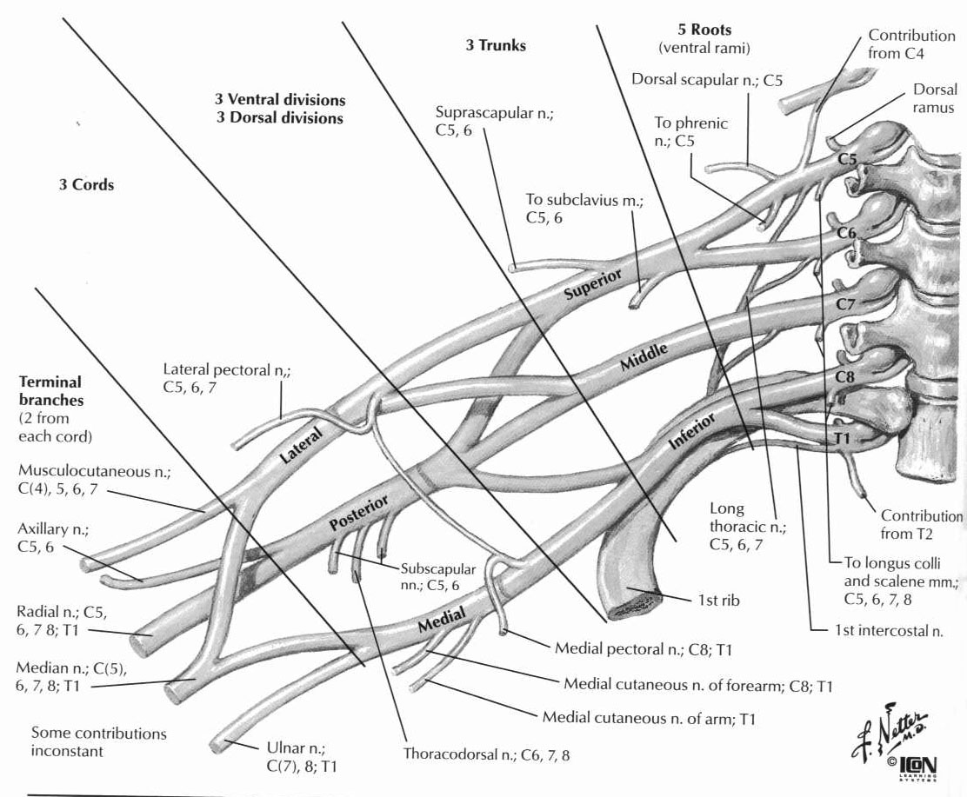
- Upper plexus injury (Erb-Duchenne palsy, often occurs at birth)
  - C5-6 – deltoid, biceps, brachioradialis, supinator, supra/infraspinatous, rhomboids
  - Arm hangs at side, internally rotated and extended at elbow
  - Movements of hand and forearm unaffected
- Lower plexus injury (Degerine-Klumpke’s palsy)
  - Traction on abducted arm, operation on axilla, tumor of lung apex, compression by cervical ribs or bands
  - Birth injury (breech)
  - Claw hand deformity
  - May have partial Horner’s syndrome
- Infraclavicular lesions of cords
  - Lateral cord – musculocutaneous nerve, lateral root of median nerve; causes weakness of flexors and pronators of forearm, intrinsic hand muscles spared
  - Medial cord – medial root of median nerve, ulnar nerve
  - Posterior cord – weak deltoid, extensors of wrist, elbows, fingers
- Brachial plexus neuropathy (Parsonage-Turner Syndrome)
  - Severe pain and weakness, sensory and reflex impairment
  - Progresses over 3-10 days, eventual recovery over 6-12 weeks
  - Mostly shoulder and upper arm
  - Loss of DTR’s
  - May be bilateral
  - Possibly associated with CMV or AIDS
  - No leukocytosis or increased ESR
- Suprascapular nerve
  - Supplies supraspinatous/infraspinatous
  - Weakness of first 15 degrees of shoulder abduction and external rotation
- Axillary nerve
  - C5-6
  - supplies teres major and deltoid
  - Weakness of shoulder abduction from 15 to 90 degrees
- Radial nerve
  - C6,7,8 (mostly C7)
  - supplies triceps, brachioradialis, supinator, extensors of wrist and fingers, abductors of thumb
  - Lesion causes brachioradialis weakness with inability to flex forearm midway between pronation and supination
- Median nerve
  - C5,6,7,T1 (mostly C6)
  - Supplies pronators of forearm, long finger flexors, abductor brevis and opponens of thumb, 1st and 2nd lumbricals
  - Lesion causes
    - inability to pronate forearm or flex hand
    - paralysis of flexion of index finger and terminal phalanx of thumb
    - weakness of opposition and abduction of thumb (abductor and flexor pollicis brevis)
- Ulnar nerve
  - C8,T1
  - Supplies ulnar flexors of wrist, ulnar flexor profundii digitorum, adductors and abductors of fingers, adductor of thumb, 3rd and 4th lumbricals, muscles of hypothenar eminence
  - Complete paralysis (elbow fracture) produces claw hand deformity
  - May see compression distal to medial epicondyle of elbow beneath aponeurosis of flexor carpi ulnaris (cubital tunnel)

Motor Neuron Disease
- Spinal Muscular Atrophy (SMA) – degeneration of anterior horn and hypoglossal nuclei, sparing of corticospinal tracts and other bulbar nuclei
  - Type 1 (infantile, Werdnig-Hoffman syndrome) – most common; onset before 6 months, death by 18 months (pneumonia), autosomal recessive (chromosome 5), worst in proximal trunk and extremities, extraocular muscles spared, no mental retardation
  - Type 2 (Wohlfart-Kugelberg-Welander) – onset childhood, death 5-10 years, M>F, autosomal recessive chromosome 5 (can also be X linked)
  - Type 3 – adult onset, usually autosomal dominant
- Amyotrophic lateral sclerosis – 35 years, death 3-6 years, upper and lower motor neurons
  - Fasciculations in all extremities, diffuse hyperreflexia, sensation preserved
  - M>F, sporadic (10% autosomal dominant chromosome 21)
  - Degeneration of motor neurons and corticospinal tract
  - Bladder not affected
  - Starts with hands, involves face and tongue
  - Antibodies to glycosides
  - Bunina bodies – intracytoplasmic, in anterior horns
  - Usually male, over 50 years old
  - Symptoms
    - Starts with awkwardness in finger movements and finger stiffness
    - Progresses to atrophic weakness of hand and forearms, slight spasticity of arms and legs, and generalized hyperreflexia, all in the absence of sensory changes
    - Complete lack of sensory changes help to differentiate from other diseases (cervical spondylosis/disc, peripheral diseases such as peroneal muscular atrophy/Charcot-Marie-Tooth)
    - Eventually the legs and thigh are affected, but often after spread to shoulder, upper arm, tongue, neck, pharynx/larynx, etc.
  - Signs
    - Course fasciculations are usually evident in weakened muscles
    - EMG shows widespread fibrillations and fasciculations
    - Motor nerve conduction only slightly slowed
  - Primary Lateral Sclerosis
    - Mostly rigidity and spasticity
    - Almost no LMN involvement (unlike ALS)
  - Wohlfart-Kugelberg-Welander Syndrome
    - Proximal limb involvement in children
    - Slowly progressive

Neuromuscular Junction
- Myasthenia gravis – antibodies to acetylcholine receptors (but IgG cannot be isolated in 10% of patients)
  - F>M; 30-40 years old; 10% of patients have thymoma – these are M>F, 50-60 years old
  - 50% have thymic hyperplasia, and 30% improve with thymectomy even if no thymoma is identified
  - symptoms start with EOM, progresses proximal to distal
    - pupils unaffected (unlike with botulism)
  - EMG is decremental (tensilon improves, aminoglycosides worsen due to effect on calcium channels)
  - Associated with hypothyroidism, rheumatoid arthritis, lupus, polymyositis
  - Treatment is AchE inhibitors followed by thymectomy, steroids, immunosuppression (azathioprine), then plasmapheresis
    - AchE inhibitors can cause cholinergic crisis (weakness, salivation, diarrhea, bradycardia, miosis, nausea, etc.) – diagnosed by giving edraphonium (if symptoms worsen, lower dose of AchE inhibitors)
- Eaton-Lambert myasthenic syndrome – antibodies to presynaptic calcium channels so less calcium enters with action potential and fewer quanta are released
  - M>F; more than half have oat cell cancer of lung
  - No ocular or bulbar findings
  - Weakness progresses proximal to distal; reflexes decreased; no fasciculations; autonomic system affected
  - Treat with plasmapharesis, steroids, immunosuppression
  - Worsened by aminoglycosides, high magnesium, low calcium (decreases acetylcholine release)
  - Incremental response to repetitive stimuli on EMG (as does botulism)

Muscle Diseases
- Types of Muscle Fibers
  - Type 1 – red – involved with myotonic dystrophy, most congenital myopathies, central core disease
  - Type 2 – white – involved with myasthenia gravis, denervation, disuse, steroids, and peripheral neuropathy
- Muscular dystrophy – differentiate from polymyositis, which has more rapid course with higher CK levels, more fibrillation, and responsiveness to steroids
  - Congenital muscular dystrophy – more common in Japan, autosomal recessive
  - Duchenne’s disease – most common muscular dystrophy
    - X-linked recessive (but 1/3 are spontaneous), M>F
    - Affects 1/3500 births; become symptomatic at 2-5 yrs, 75% dead by 25 years
    - Decreased dystophin in muscle fibers (stabilizes membranes) – see muscle fiber necrosis/regeneration
    - Atrophy worse in shoulder and pelvic girdle; calf seems to hypertrophy
    - Spares hands/face/eyes
    - Associated with mental retardation, CHF, and respiratory problems
  - Becker’s disease – milder form of Duchenne’s
    - X-linked recessive, M>F
    - Affects 1/30,000 births; becomes symptomatic at 11 years, nonambulatory by 30 years, most dead by 50 years
    - Dystrophin abnormal – no necrosis/regeneration
  - Fascioscapularhumoral dystrophy
    - Autosomal dominant on chromosome 4
    - Symptomatic 10-20 years
    - Face affected first, then shoulders and upper arm
    - Associated with sensorineural hearing loss
    - Chronic inflammatory cells seen in muscle (only MD to do this)
    - CK normal; no associated CHF or mental retardation
    - Sometimes associated with absence of a muscle
  - Limb-Girdle Syndrome
    - Autosomal recessive
    - Axial weakness
    - Sometimes associated with CHF, no mental retardation
    - 1/3 have pseudohypertrophy
  - Oculopharyngeal muscular dystrophy
    - Autosomal dominant
    - Becomes symptomatic 40-50 years
    - Weakness of eye muscles and pharynx
  - Myotonic Dystrophy – most common muscular dystrophy in adults
    - Autosomal dominant on chromosome 19
    - Affects 1/20,000 births; generally nonambulatory 20 years after first symptoms
    - Face affected first, then distal extremities
    - Weakness and myotonus (cannot relax muscle after contraction)
    - Dysrhythmia (especially with quinine, procainamide, and phenytoin which increase AV block), decreased intelligence, cataracts, endocrine dysfunction, testicular atrophy, frontal balding
- Metabolic Myopathies – usually affect proximal lower extremities; face and eye are rarely involved; CK invariably elevated
  - Glycogen storage diseases (glycogen in vacuoles)
    - Acid Maltase deficiency
      - Autosomal recessive
      - Infantile form (Pompe’s disease) symptomatic by 1 month with hepatomegaly, cardiac problems, death by 2 years
      - Glycogen accumulates in liver, heart, and muscle
    - Myophosphorylase deficiency (McArdle’s disease, type V glycogen storage disease)
      - Painful muscle cramps and decreased ability to exercise
      - Symptomatic by 15 years
      - Associated with myoglobinuria
    - Phosphofructokinase deficiency (Tarui’s disease, type VII glycogen storage disease) – similar to McArdles
      - Autosomal recessive
      - Unable to mobilize glycogen
  - Lafora’s diease – myoclonus epilepsy, autosomal recessive
    - Symptomatic age 6 to 19
    - characterized by generalized tonic-clonic seizures, resting and action myoclonus, ataxia, dementia, and classic EEG findings, including polyspike and wave discharges
    - Lafora bodies – basophilic cytoplasmic inclusion bodies present in portions of the brain, the liver, and skin, as well as the duct cells of the sweat glands
    - Death usually occurs within 10 years of onset
  - Lipid Storage Diseases
    - Carnitine deficiency – cannot use long chain fatty acids
    - Fabry’s disease – alpha-galactosidase deficiency, x-linked recessive
      - Accumulate ceramides
      - Peripheral neuropathy, anhydrosis, corneal opacities, renal insufficiency
      - Skin angiokeratomas
  - Mitochondrial disorders – often associated with ragged red fibers
  - Malignant Hyperthermia – defect in ryanodine calcium release channels – too much calcium released from SR
    - rapid onset of extremely high fever with muscle rigidity precipitated by exogenous agents (especially halothane or succinylcholine)
    - Autosomal dominant, 1/15,000 affected
    - Tachycardia, dysrhythmia, labile blood pressure, hyperkalemia, increased CK, myoglobinuria, renal failure
    - Dantroline (decreases calcium release from SR) – decreases mortality from 70% to 5%; also cool patient, hydrate, 100% oxygen, bicarb, stop anesthetics
    - Caffeine or halothane will cause muscle fibers of affected individuals to contract in vitro
  - Thyroid myopathy – with hyperthyroidism
    - Exophthalmos/ophthalmoplegia (esp IR/MR, so downgaze palsy); painful with monocyte/lipocyte infiltration
    - Thyrotoxic periodic paralysis – responds to beta-blocker
- Inflammatory myopathy
  - Bacterial myositis – staph aureus, causes fever, high white count, muscle tenderness
  - Trichinosis – affects eye, face, proximal limbs; eosinophilia present; affects both fiber types; can also happen with toxo or cysticercosis
  - Viral myopathy – 1-2 weeks after infection
    - influenza, coxsackie; causes rhabdomyolysis with ATN
    - HIV, HTLV
  - Polymyositis – most common inflammatory myopathy in adults
    - Subacute, painless, symmetric, proximal to distal, fever
    - Increased CK/myoglobinuria
    - T-cells and macrophages in muscle fibers
    - 10% associated with cancer
    - steroids help
    - most improve with time
    - Black > white, female > male, associated with cancer, responds to steroids/immunosuppressants
    - Involves proximal muscles; face spared
    - Fever, malaise, dysphagia
    - Increased ESR and CK levels
    - EMG shows small short-duration polyphasic motor units with fibrillations
    - Interstitial lung disease found in 70% of patients
    - Pathology: Cell mediated tissue destruction with T cells around muscle, also see necrosis and phagocytosis of individual muscle fibers
    - Endomysia inflammatory exudate with large number of T and B cells
  - Dermatositis
    - Maculopapular butterfly rash, heliotrope, periorbital edema
    - Angiopathy affecting skin, muscle (especially extensors/neck/shoulders), peripheral nerves, intestines
    - 10% associated with cancer
    - B-cells seen perivascularly NOT in muscle
    - Female > male, associated with cancer, responds to steroids/immunosuppressants
    - 90-95% of patients get cutaneous rash on extensor surfaces
    - systemic angiopathy and vasculitis with mucosal ulceration (sometimes GI bleeding), subcutaneous calcifications and nodules
    - interstitial lung disease in only 30%
    - Pathology: lymphocytic inflammation ; mostly B cells around blood vessels; also see perifascicular muscle atrophy
    - Incidence of malignancy 25% in patients over 55 years old
    - Etiology is immune complexes deposited in walls of arterioles and veins
    - IgG, IgM, complement, MAC deposition in small vessels
  - Inclusion body myositis – like polymyositis with inclusion bodies
    - CK normal, steroids don’t work
    - Possibly caused by virus
  - Drug induced – penicillin or tryptophan
    - CK normal, see perivascular eosinophils
- Familial periodic paralysis – genetic defect of Na, Cl, Ca channels
  - Recurrent episodes of remarkable generalized weakness
  - Autosomal dominant, M>F, improves with age
  - Brought on by cold, hyotension
  - Potassium very low
  - See vacuoles in sarcoplasm
- Neurogenic atrophy – consists of grouped atrophy, then large group similar reinnervation (instead of normal checkerboard pattern); may also see target fibers

Diagnostic Studies
- EMG
  - Motor unit potential – myopathy polyphasic – small amplitude, short duration
  - Neuropathy – large amplitude, long duration
  - Conduction velocity = distance / (distal latency - proximal latency)
  - Internodal demyelination – conduction delay
  - Segmental demyelination – loss of conduction proximally
  - Cut axon
    - loss of conduction proximally, unaffected distally immediately after injury
    - 7-10 days later – see loss of conduction distally as well due to distal Wallerian degeneration (motor 5-6 days, sensory 10-11 days)
    - proximal signal will be dispersed due to different speeds of various sized axon
    - 3 weeks – fibrillation potentials indicating denervation of muscle; but it does not give location (radicular vs. peripheral nerve injury)
    - best determination of nerve injury – EMG immediately afterwards, then in 7-10 days to determine if there is still an action potential
  - Insertional activity
    - Electrical response to mechanical damage to the muscle
    - Prolonged in acute neuropathies and active myopathies
    - Decreased with advanced myelopathy with fibrous or fatty tissue replacement
  - Spontaneous activity
    - Resting muscle has little or no activity
    - Some spontaneous mEPSP from released quanta
    - Fibrillation potential – triphasic potential 1-5 msec
      - Not visible through the skin
      - Caused by deinnervation with increased muscle sensitivity
      - Starts 3 weeks after injury
      - May display positive sharp wavs
    - Fasciculation ptential – 3-5 phases lasting 5-15 msec
      - Caused by activity in a motor unit
      - Visible through the skin
      - Associated with nerve irritability, not destruction
  - Recruitment
    - Initiation of firing of additional motor units from increase in firing rate of active units
    - Rapid in myopathy – all units recuited at low levels of force
    - Decreased in neuropathy – Total number of motor units is reduced
  - Myopathy EMGs
    - Active – fibrillations, positive waves
      - From deinnervation, inflammation (polymyositis, Duschenne MD)
    - Chronic – small EP, rapid recruitment
      - Other MDs, congenital and metabolic myopathies
  - Neuropathy EMGs
    - Active – Fasciculations
    - Chronic (reinnervation) – large EP, slow recuitment
- Nerve Conduction Velocities
  - Axonal disease – decreases wave amplitude
  - Myelin disease – increases latency (decreased velocity), signal degredation
  - M wave – direct motor response to stimulation of a motor nerve
  - F wave – caused by supramaximal stimulation of a mixed motor-sensory nerve
    - Antidromic impulse to the anterior horn followed by orthodromic impulse back
    - Forms a second, smaller action potential with greater latency than direct stimulation
    - Can be used to measure conduction in the proximal protion of the nerve
  - H reflex – elicited by submaximal stimulation of a sensory fiber
    - Sends impulse to the spinal cord that elicits a monosynaptic reflex
    - Only works in the calf (Achilles reflex)
Neurology

Cerebellum

- Horizontal segments
  - Flocculonodular lobe (arch/vestibulocerbellum) input from vestibular nuclei, function equilibrium. Lesion causes positional nystagmus and impaired equilibrium
  - Anterior lobe (Paleocerebellum) input from spinocerebellar tracts from muscle tendons, function posture and muscle tone. Lesion: hyperreflexia
  - Posterior lobe (neocerebellum) input corticopontine fibers, function: coordination. Lesion causes decreased tone, clumsiness and intention tremor (if dentate involved).
- Longitudinal segments
  - Vermis (fastigial nucleus) input vestibular nuclei, function: coordination of eyes, head, and body to account for gravity, axial posture and tone, locomotion.
  - Intermediate zone (interposed nuclei) input area 4 and spinocerebellar tract, function: posture tone and ipsilat. Limb movements. Lesion causes intention tremor.
- Lesions
  - Flocculonodular lobe- nystagmus
  - Vermis- truncal ataxia, scanning speech, and hypotonia
  - Intermediate hemisphere- appendicular ataxia and hypotonia
  - Lateral hemisphere- terminal tremor, decomposition of multijoint movements, delay in initiating movements, mild ipsilateral weakness
  - Anterior nucleus- slight hyperreflexia

Tremor

- Def: rhythmic, regular, oscillating action of agonists/antagonists.
- Physiologic tremor- awake and asleep (8-13Hz)
- Pathological tremor- only awake (except palatal and ocular myoclonus) 4-7Hz
- Parkinsons- at rest, inc with stress, persistent when walking (unlike essential tremor), treated with anticholinergic or contralateral VL thalamic lesion.
- Intention- 2-3Hz, end of movement, absent at rest, assoc with titubation (rhythmic ossic of head on the trunk). Treatment VL thalamic lesion
- Postural/action tremor:
- Physiologic- normal, inc. with fear, hyperthyroid, hypoglycemia, ETOH w/d, caffeine, steroids, pheo.
- Essential- 4-8 Hz, familial, AD inheritance, adulthood onset. Suppression with ETOH, B blocker, primidone, and VL lesion.
- Kinetic predom. Action tremor- worse with activity, slower, disabling. Treat w/ clonazepam or botox.
- Hysterical tremor- single limb w/ gross movements and persists in repose.

Myoclonus

Aphasia

Broca’s- nonfluent, effortful, poor repetition, poor naming, good comprehension. Lesion: frontal operulum (area 44,45)
Wernickes- fluent, nl sentence length, good articulation, impaired repetition, poor comprehension. Lesion: posterior-superior temporal region.
Conduction- fluent, good comprehension, paraphasic errors (assoc., with agraphia and limited reading comprehension. Lesion: left inferior parietal lobule, anterior supramarginal gyrus.
Global aphasia- poor fluency, poor comprehension, poor repetition. Lesions: both Broca’s and Wernicke’s area.

EEG
- Alpha – 8-13 Hz, symmetric, present posteriorly (occipital) with eyes closed, disappear (are blocked) with eye opening
  - Resting with eyes closed
- Beta – above 13 Hz; symmetric, present frontally; no effect with eye opening
  - Awake, eyes open
- Gamma (4-8 Hz) and Delta (less than 4 Hz) – seen in children and young adults with frontal and temporal predominance
- Theta waves – 4-7 Hz
  - Parietal and temporal areas in children
- Delta waves – 1-3 Hz
  - Deep sleep
- EEG in Sleep
  - Stage I – loss of alpha waves
  - Stage II – sleep spindles, K-complexes
  - Stage III – delta waves, some spindles
  - Stage IV – Delta waves only.
    - Sleepwalking, night terrors
  - REM – beta waves

Headache
- Nonthrobbing
  - Dissection of ICA
    - Nonthrobbing pain centered in/around eye, then ischemic symptoms, unilateral Horner’s sign; may have CN X, XI, or XII involvement
    - More common in women than men
  - Cluster headache
    - Young men, constant unilateral orbital pain, burning excruciating pain above and behind eye; deep, nonthrobbing; may have rhinorrhea, flush and edema of cheek, miosis, lacrimation, injected conjuntivum; may also have ptosis, partial Horner’s syndrome
    - Paryoxysmal, short duration (20-30 minutes), occur at same time of day (usu 1-2 hrs after dark) for weeks
    - NO ischemic signs associated with it
- Throbbing – usually associated with vascular etiology
  - Migraine – usually unilateral; may be classic 10% (aura) or common (no aura), familial, pulsatile, femal predominance
  - Glossopharyngeal Neuralgia
    - intense paroxysmal pain originates in throat, provoked by swallowing or talking, chewing, yawning, laughing
    - pain may be localized in ear
    - may be accompanied by bradycardia or syncope

Abnormal Eye Movements
- Optokinetic Nystagmus
  - Toward involved (lesioned) hemisphere is lost
  - Right parietal lesion causes impared smooth tracking to right
- Vertical eye movements
  - Under bilateral control of cortex and upper brainstem
  - Pretectal fibers of midbrain tegmentum, involve fibers of posterior commissure near superior colliculus
    - Rostral MLF at junction of midbrain and thalamus
    - Medial cells serve upgaze; lateral cells serve downgaze (initially are medial and commingle with upgaze fibers)
  - Lesion of both medial RiMLF causes complete vertical gaze palsy
  - Lateral lesion causes isolated downgaze palsy (rare)
- Saccades – fast conjugate eye movements, voluntary
  - Generalized in contralateral frontal lobe (area 8)
- Smooth Pursuit – slow involuntary movement generated in ipsilateral occipital lobe (area 18 and 19)
- Hypermetria (overshooting) – midline cerebellar lesion
- Inability to initiate voluntary movements (vertically or horizontally)
  - May be congenital (Cogan syndrome, ataxia-telangiectasia)
- Impaired Smooth Pursuit with slow, hypotonic saccades – caused by Parkinson’s, Huntington’s, Progressive Supranuclear Palsy
- Midbrain lesion or in region of posterior commissure – interfere with conjugate movements in vertical plane (seen in Nieman-Pick)
  - Parinaud’s syndrome – vertical gaze palsy (usually upgaze)
    - Mydriasis; loss of convergence and papillary light reflexes
    - Refractory nystagmus or lid retraction (Collier’s sign)
- Congenital Ocular Motor Apraxia (Cogan’s Syndrome)
  - Abnormal eye and head movements during attempts to change position of eyes
- Effects of Lesions
  - Right cerebral lesion produces right eye deviation, left hemiparesis
  - Right PPRF lesion produces left eye deviation, left hemiparesis, left CN VI/VII palsies
  - CN III lesion produces ipsilateral CN III palsy (down and out)
  - CN III + Red nucleus lesion also produces contralateral tremor (Benedikt’s syndrome)
  - CN III + pyramid lesion produces contralateral hemiparesis (Weber’s syndrome)
  - CN VI+VII + pyramid lesion produces cranial nerve deficits and contralateral hemiparesis (Millard-Gubler syndrome)
  - Cavernous lesions
    - Retrocaverous compressive lesions(infraclinoid extradural aneurysms/tumor) – involve V1, V2, V3, III, IV, VI
    - Posterior cavernous sinus – V1, V2, III, IV, VI
    - Anterior cavernous sinus – VI, III, VI, VI
  - CN IV lesion – difficulty with downward gaze, especially with adduction
    - Paralyzed eye tends to look up and in (opposite of CN III lesion)
    - Bielchowski’s sign – head tilt to opposite shoulder because of paralyzed intortion
    - Inferior oblique intorts abducted eye, depresses adducted eye
- Spasmus Mutans – pendular nysyagmus of infancy
  - Any direction, one eye predominates, worse when head immobilized
- Vertical Nystagmus
  - Upbeat – can be demyelinating; caused by vascular, tumors
  - Downbeat – always central; caused by Wenickes, syringobulbia, Chiari, basilar invagination
- Course Horizontal Nystagmus – can be caused by CP angle tumors
- Convergence Nystagmus – after accompanied by nystagmus retractorius in Parinaud syndrome
  - Usually lesion of upper midbrain tegmentum or pinealoma
- Seesaw Nystagmus – torsional-vertical oscillation; caused by sella or parasellar masses
- Palatal Nystagmus – lesion of central tegmental tract
- Oscillopsia – illusionary movement of environment
  - Associated with lesion of labyrinth (such as aminoglycoside toxicity)
- Opsoclonus – rapid, conjugate oscillations of eyes in all positions
  - Childhood form associated with ataxia, myoclonus; responds to ACTH

Autonomic Disorders
- Anhidrosis, orthostatic hypotension, increased or decreased blood pressure, cardiovascular changes, adynamic ileus and atonic bladder
- Seen in amyloid, small fiber polyneuropathy, diabetes, pure autonomic polyneuropathy and Shy-Drager syndrome, GBS
- Primary Autonomic Failure (Idiopathic Orthostatic Hypotension)
  - Presents as anhydrosis, impotence, bladder atonicity
  - Two possible etiologies:
    - (1) Lesion of postganglionic sympathetic neurons (spinal parasympathetic and CNS); associated with denervation sensitivity to plasma infusion of norepinephrine
    - (2) Lesion of preganglionic lateral horn neurons of thoracic spinal cord; produces later cerebellar or basal ganglia signs (Shy-Drager)
- Diabetic Neuropathy – impotence, constipation, or diarrhea; hypotonia of bladder, gastroparesis, orthostasis, sensory polyneuropathy, small pupils
- Autonomic Dysreflexia – occurs in quadriplegics with high cervical lesions (central control of sympathetics is abolished)
  - flexors spasms of legs, involuntary emptying of bladder associated with increased blood pressure, bradycardia, sweating and pilomotor reactions, dilated pupils
- Sjogren’s syndrome – Autoantibodies Ro and La; associated with peripheral neuropathy
- Myasthenic syndrome – Treat with guanidine (blocks reuptake of calcium into mitochondria) or diaminopyradine (increases acetylcholine by blocking potassium channels)
- Hypothalamic lesion – anterior produces hyperthermia, posterior produces hypothermia (poikilothermia), suprachiasmatic produces alteration of circadium rhythm of temperature
- Wernicke’s encephalopathy – hypothermia
- Shapiro’s syndrome (agenesis of corpus callosum) – episodic hypothermia and hyperhidrosis
- Riley-Day syndrome (hereditary sensory-autonomic neuropathy type II) – defective synthesis of norepinephrine; autosomal recessive, orthostasis, faulty regulation of temperature, decreased hearing, hyperhidrosis, denervation sensitivity
  - Autosomal recessive, decreased lacrimation, hyperhidrosis, labile blood pressure, GI dysfunction with vomiting, decreased pain and temperature with Charcot joints and acral mutilation, areflexia, poor feeding and aspiration, scoliosis, corneal abrasions
- Fabry’s disease – alpha-galactosidase deficiency with buildup of ceremide trihexosidase in dorsal root and peripheral autonomic ganglia
- MEN 2b – mucosal neuromas, medullary thyroid cancer, pheochromocytoma, ganglioneuromatosis, bony deformities, hypotonia, marfanoid appearance
- Porphyria – persistent tachycardia, labile hypertension due to vagus denervation, catecholamine release
- Multiple System Atrophy (Shy-Drager Disease) – autonomic dysfunction, orthostatic hypotension, Parkinson’s symptoms (akinesia/rigidity) due to cell loss in substantia nigra and putamen (no Lewy bodies), anhidrosis, urinary incontinence, extrapyramidal symptoms
  - Shy Drager – parkinsonism + dysautonomia
  - Olivopontocerebellar Atrophy – parkinsonism + cerebellar signs
  - Striatonigral degeneration – parkinsonism + pyramidal signs and laryngeal stridor
- Acromegaly
  - Diagnosis
    - Clinical features (acral growth, prognathism, visceromegaly, headache, diabetes, hypermetabolism)
    - Elevated growth hormone (above 10 ng/ml)
    - Failure of growth hormone levels to rise in response to TRH or glucose
  - Late complications:
    - Carpal tunnel syndrome
    - Myopathy (proximal muscle weakness and atrophy)
    - Polyneuropathy (paresthesia, decreased DTRs, distal muscle atrophy, sometimes enlargement of nerves)

Metabolism
- Osm = 2 (Na + K) + BUN/28 + glucose/18
- Oxygen-Hemoglobin Dissociation Curve
  - Shifted to the right (higher PO₂ required) by:
    - Increased temperature
    - Low pH
    - Increased PCO2
    - Increased DPG
  - Shifted to the left (lower PO₂ required)
    - CO poisoning

Anesthetic agents
- Increase CBF
  - All inhaled agents and ketamine
  - Enflurane – lowers seizure threshold)
  - Nitrous oxide – Least increase in CBF, no vasodilation
  - Isoflurane – small increase in CBF
- Decrease CBF
  - All IV agents except ketamine
  - Thiopental – cardiodepressant
  - Etomidate – suppresses adrenal response to stress
- Cerebral metabolism changes with CBF

