LSU Health Sciences Center - Abbreviated Diabetes Foot Screen

Name (Last, First, MI) _____________________________________________ ID # ______________

Date: _____/_____/_____ DOB: _____/_____/_____

Mark the level of sensation in the circles:
+ = Can feel the 5.07 filament
— = Can't feel the 5.07 filament

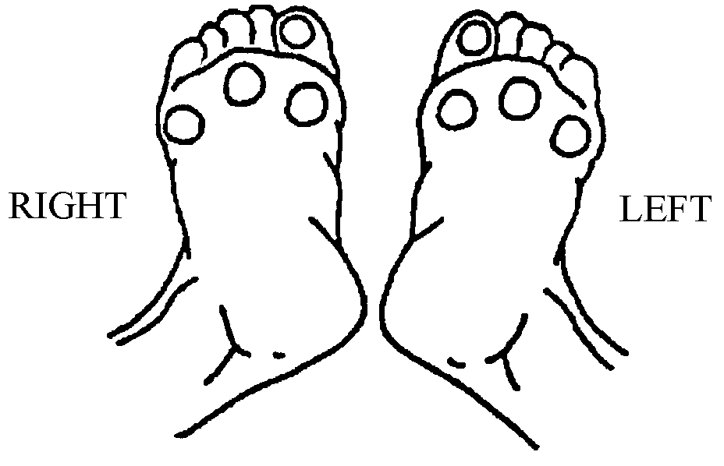

Check the appropriate Risk Category based on the following findings:

Is there a history of foot ulceration or Charcot fracture? If yes then check Risk 3

Can the patient feel the 10 gram filament at all four sites on the foot?
If yes then check Risk 0

If the patient can not feel the 10 gram filament at any of the four sites
But there is no focal callus, deformity or absent pulses then check Risk 1.

If the patient can not feel the 10 gram filament at any of the four sites
and there is focal callus, deformity or absent pulses then check Risk 2.

Foot Injury Risk
0 - No loss of protective sensation
1 - Loss of protective sensation
2 - Loss of protective sensation with either
high pressure (callus or deformity)
or poor circulation
3 - History of foot ulcer or Charcot fracture

