LSU Health Sciences Center - Diabetes Foot Screen

Name (Last, First, MI) _____________________________ Date: _____/_____/_____

Fill in the following blanks with a "Y" or "N" to indicate findings in the right or left foot.

R L
Is there a history of a foot ulcer? _______ _______
Is there a foot ulcer now? _______ _______
Is there a claw toe deformity? _______ _______
Is there swelling or an abnormal foot shape? _______ _______
Is there elevated skin temperature? _______ _______
Is there limited ankle dorsiflexion _______ _______
Are the toenails long, thick or ingrown? _______ _______
Is there heavy callous build-up? _______ _______
Is there foot or ankle muscle weakness? _______ _______
Is there an absent pedal pulse? _______ _______
Can the patient see the bottom of their feet? _______ _______
Are the shoes appropriate in style and fit? _______ _______

Note the level of sensation in the circles:
+ = Can feel the 5.07 filament — = Can't feel the 5.07 filament

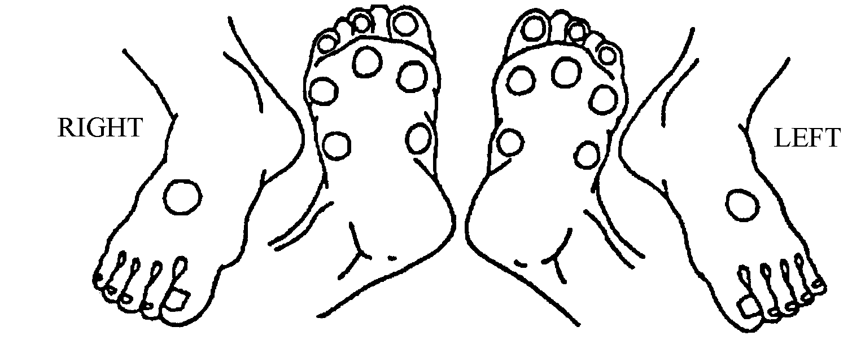
Skin Conditions on the Foot or Between the Toes:
Draw in: Callous , Pre-ulcer , Ulcer (note length and width in cm)
Label with: R - redness, M - maceration, D - dryness, T - Tinea

RISK CATEGORY:
____ 0 No loss of protective sensation.
____ 1 Loss of protective sensation
____ 2 Loss of protective sensation with either high pressure (callous/deformity), or poor circulation.
____ 3 History of plantar ulceration, neuropathic fracture (Charcot foot) or amputation.

