Summary of Benefits – Faculty

January 1 – December 31, 2025

Below is a generalized overview of the benefit programs available to faculty members at LSU Health Sciences Center.

**Retirement:** All new faculty members working 50% effort or greater are required to participate in either the Teachers’ Retirement System of Louisiana (TRSL), or the

Optional Retirement Plan (ORP). Employees contribute 8% of their base pay and receive a 6.2% employer match. Employee contributions are on a pre-tax basis.

* TRSL is a defined benefit plan with retirement benefits computed on a formula based on years of service. Five years of service are required to vest into the retirement benefit.
* ORP is a defined contribution plan. Benefits are determined by the value of the account at retirement. ORP provides immediate vesting and was created to provide faculty and unclassified staff with a portable retirement plan. Participants have a choice of three carriers to select from: TIAA, Corebridge and VOYA.

**Supplemental Retirement Plans:** LSU offers multiple options to help employees save for the future. The supplemental retirement program includes 403(b) and 457(b) plans. Eligible individuals may make paycheck contributions before and/or after taxes and enrollment can take place at any time throughout the year.

* Choice of vendor: TIAA, Corebridge and Fidelity o 403(b) plan allows employees to defer a pre- tax portion of earnings into a supplemental retirement account.
  + Roth 403(b) allows employees to make contributions on an after-tax basis under the Roth option



* Louisiana Deferred Compensation: Administered by Empower Retirement o 457(b) plan allows employees to defer a pre- tax portion of earnings into a supplemental retirement account.
  + Roth 457(b) allows employees to make contributions on an after-tax basis under the Roth option

The contribution limits for the 403(b) and 457(b) for calendar year 2025 are $23,500 (under age 50), $31,000 (age 50 and over), and $34,750 (age 60 – 63). Limits are independent of each other (you can maximum your savings by participating in both) and contributions towards mandatory state retirement plans do not count towards these limits.

**Social Security:** The University does not participate in the Federal Social Security Retirement Program; however, all new employees are subject to the 1.45% Medicare portion of the FICA tax.

**Vacation & Sick Leave:**

* Choice of two Annual Leave Plans:
  + The University annual leave plan allows for an accrual at the (full time) rate of fourteen (14) hours per month of annual leave with a maximum accumulation limited to 176 hours during the first ten years of employment. After 10 years the accrual cap is lifted.
  + Faculty may elect the Civil Service annual leave accrual plan that allows for lower accruals, (8) hours per month for the first 3 years of service, of annual leave but does not have the 176-hour cap.
  + Election of an annual leave accrual plan is irrevocable and must be made within the first 30 days of employment. The University schedule is the default plan.
* Sick leave is accrued based on years of full-time service. During the first three years of service, sick leave is accrued at the (full time) rate of one day (8 hours) per month.

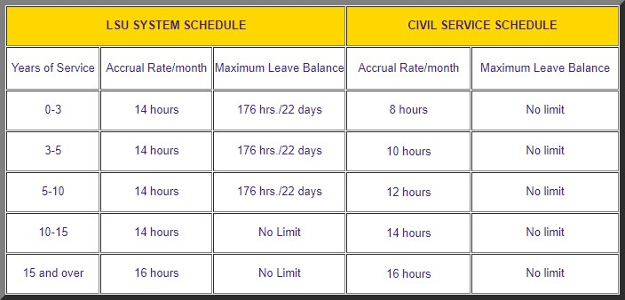

**Holidays are set by LSU which authorizes 14 paid holidays per year to eligible faculty and staff**

**Health Insurance:** Faculty members working at 75% or greater have a choice of health plans that include LSU First, Magnolia Local, Magnolia Local Plus, Magnolia Open Access, Pelican HRA 1000, and Pelican HSA775. The effective date of coverage is the first day of the month following one full calendar month of employment. A faculty member appointed on any day other than the first day of the month must be employed for the remainder of the month appointed, plus one full calendar month, before the health insurance would be effective.

**Dental Insurance:** Faculty members working at 75% or greater have a choice to enroll in our dental plans. LSU partners with Humana to provide you and your family a choice between a basic or enhanced plan dependent on your family’s needs.

**Vision Benefit:** Employees working at 75% or greater are eligible to enroll in our EyeMed vision benefits.

**Flexible Spending Accounts:** Employees working at 75% or greater are eligible to participate in an FSA to cover eligible medical (dental, vision, hearing, and prescription drugs) expenses that are not reimbursed by an insurance plan or eligible dependent care expenses. You may not have a Healthcare FSA and be enrolled in the Pelican HSA 775 health plan.

**Miscellaneous Insurance Plans:** A variety of employee paid plans are available. They include several financial protection and long-term care plan.

**Dependent Verification Requirement:** If you elect to cover a spouse and/or child(ren) for health insurance the following documents must be presented with enrollment as proof of legal dependent status:

* Social Security Cards for all
* Spouse – Certified marriage certificate
* Children – Certified birth certificate, adoption papers, court copy of judgment granting guardianship or custody

**New Employee Orientation:** All newly appointed faculty members who qualify for medical and/or retirement benefits are invited to attend the LSU Health New Employee Orientation by Human Resource Management. This orientation provides detailed information regarding your individual benefit choices available.

Benefit options are subject to change due to changes in legislation or in contractual arrangements with the State, the University or LSUHSC.

Should you have any questions or need more specific information regarding benefits, please visit the [Benefits Section](https://www.lsuhsc.edu/administration/hrm/benefits.aspx) of HRM’s website, email nohrmbenefits@lsuhsc.edu or call 504-568-7780.

**Early Learning Center:** Onsite, high quality, inclusive early care and education for infants and toddlers. Highly qualified teachers, 4:1 teacher to child ratio, small group classes, and research-based curriculum. The LSU Health Early Learning Center operates under the direction of the Human Development Center and enrolls children between the ages of 6 weeks and 36 months. Faculty and staff of LSU Health New Orleans are given priority enrollment.

**Wellness Center:** Our onsite Wellness Center is free to faculty, staff, residents, and students and extends to spouses and children above the age of 16. The facility is equipped with a functional training group exercise room, free weights, cardio, and a multi-use selectorized room.

**Campus Assistance Program (CAP):** The Campus

Assistance Program is a free service provided by LSU Health New Orleans to assist faculty, staff, residents and students and their immediate family members in resolving personal, academic, or work-related programs.

**Discounted Downtown Parking:** Parking privileges are regarded as an optional benefit associated with employment or student registration at the LSU Health

Sciences Center