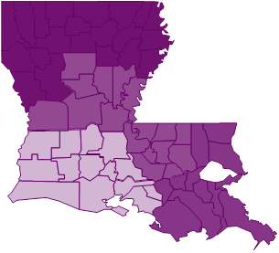
NLAHEC

CLAHEC

SWLAHEC
SELAHEC

