Research Guide for Medical Students
Welcome to the Research Guide for Medical Students. This document was developed to provide an easy and all-encompassing approach to begin and complete research in the Department of Orthopedics. Please see below and follow the steps in numerical order. If a heading doesn’t apply to you, then you may skip it and proceed.
- GETTING STARTED: TRAINING & ACCESS TO MEDICAL RECORDS AND OTHER OBSTACLES (MUST BE COMPLETED FIRST)
  - First, you will need CITI training if you are conducting any clinical research. This training is good for 3 to 5 years (depending on the module), so it's a good time to complete them now before you do your clinical rotations.
- CITI Training Instructions (you can do these modules without an LSUHSC ID):
  - Go to https://about.citiprogram.org/
  - Click Register and select 'Louisiana State University Health Sciences Center - New Orleans' as your Organization Affiliation.
  - Provide contact information, including your mentor's LSU department. The 'Which course do you plan to take?' and 'Role in human subjects research' pull-downs are for our information only, and do not determine your Learner Groups.
  - Complete online CITI training if you are doing clinical research (e.g., chart reviews, clinical samples):
      - Biomedical Research - Basic Refresher module OR the Social and Behavioral Research module (only one is required)
      - One Good Clinical Practices (GCP) module below must be completed:
        - GCP- Drug Development
        - GCP- Device Development OR
        - GCP- Social and Behavioral Research Best Practices for Clinical Research
- Make sure you are up to date on your online Knowledge Delivery System (KDS) training modules.
  - How to get KDS trainings added to your account
    - Send request to: nocompliance@lsuhsc.edu
      - Email Template:
        - “Good afternoon, I am requesting modules pertaining to research compliance be added to my KDS account.
          - Name:
          - Username:
          - Student Requested Training: Conflict of Interest in Research Training; HIPAA Privacy – Research
        - Thank you!”

- Once you have done all your CITI and KDS training, you can contact your PI. Let them know that you do not have Epic access and then once you get approved to be on a project, you can reach out to Mrs. Andante Hebert to get your EPIC access. She will send you the UMC credentialing application which requires documentation listed below. After this, UMC will process your application and notify you when you have been approved.
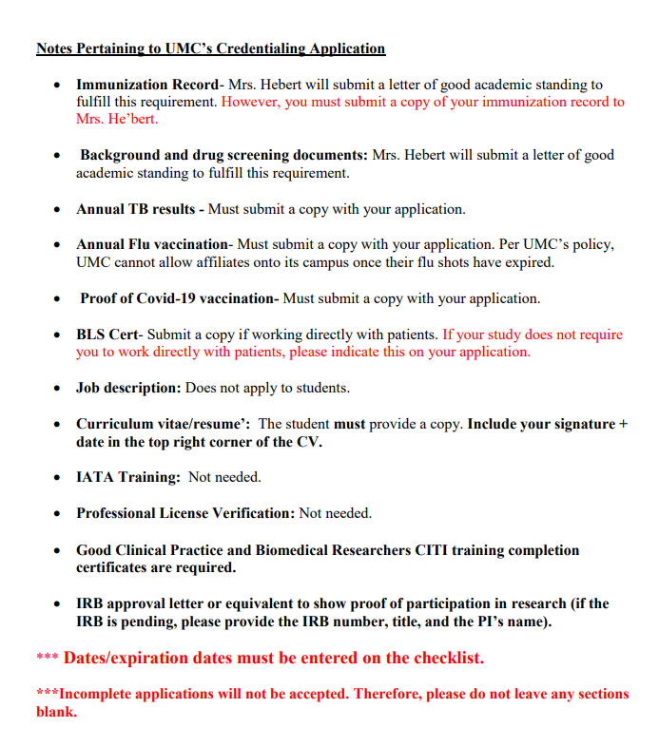
  - Joining the LSUHSC-NO IRB ListServ, so that the IRB staff can more effectively communicate new information concerning the IRB process and updates
    - *Must be on campus or connected through Citrix*
    - Go to http://www.listserv.lsuhsc.edu/scripts/wa.exe?INDEX
    - Join IRB_UPDATES_AND_ANNOUNCEMENTS
  - For OCHSNER EPIC ACCESS please email the chair-elect.

- Picking a Project
When selecting a project, realize there are multiple routes (a-d):
  - Starting your own project based on a Physician’s idea
    - Reach out to the chair-elect for an updated and comprehensive list of research ideas in our database. After choosing an idea, please inform the chair-elect of your choice.
    - Perform a brief review of literature on the subject via PubMed, and ask research coordinator, Elaine Hicks, to search the literature for you. If you have an article that interests you, send it to her with your request.
      - PubMed Tip: There are 35M+ articles published on PubMed, so when you use that link make sure that you type in keywords to narrow down your search. After that you can filter the smaller pool of publications for what you need.
        - Keywords example: Inflammatory Markers and Total Knee Arthroplasty
    - Contact the faculty associated with the project to set up a meeting with them to discuss the idea (CC: Chairman, chair-elect, and senior advisor to the chair on the email).
      - FYI: just discussing the idea does not require you to complete the project.
    - When choosing a study, it is required that you work with 2 other classmates: ideally have 2 L1/2s, 1 L3/4, and 1 Resident on the study.
      - This ensures a good distribution of the workload and provides the L1/2s with upper levels students and residents as a point of contact to help guide them through the research process.
      - Of Note: If you don’t know any L3/4s to add, contact your Chair-Elect and they will help find someone. Ideally a resident would not be added until IRB is ready to submit since most of the legwork is to be done by the students, unless you know a resident that would like to be added before this point then go ahead and add them.
    - SEE 3. FOR FURTHER INSTRUCTIONS
  - Staring your own project based on your OWN idea
    - The idea is to build on what is known. If you have your own idea, work with Ms. Hicks to find some literature in the general area of your interest. Having some literature will facilitate better communication with a faculty member.
    - Email the students on the committee to gather an idea of which faculty will be willing to start a study with you in that field of orthopedics.
    - Email that faculty member (while cc’ing the students on the committee) to see if they are willing to discuss that idea.
      - If the faculty agrees to work with you on that study, ask them if they can help you fill out a “Faculty Research Proposal”
      - Once completed, send to students on committee and begin working on Routing Form (seen below in section 3.)
  - Joining an on-going project
    - Your best bet to find an ongoing study that needs help ASAP is to email the chair elect.
    - Once a study is found, email the resident or project leader to determine what the project is about and if there truly are availabilities (CC: Chairman, chair-elect, and senior advisor to the chair on the email).
    - Inquire about joining the project.
    - If approval is received, ask the project member to add you to the Kuali protocol.
***Note the difference between a., b., & c. is that by starting your own project, you will for sure be an author on the project (max of 6 which includes at least physician and statistician), and if you are asked about it in a residency interview, you may have more to say about it. But if you put in enough work with b. or c., you will likely still be an author and will be able to speak to the extent of you contribution and knowledge of the project in an interview.

    - Dr. Claudia Leonardi (cleon1@lsuhsc.edu) will put your name in the system. Then by searching “redcap” on the LSUHSC web page, you can access the webpage using your LSUHSC ID & password
    - For EPIC access, each area hospital (UMC, LSU Healthcare Network, Ochsner) has their own version of EPIC, the medical record system. Instructions about the LSU HealthCare Network EPIC is in the document, How to Conduct Research and Access EPIC for Research at LSU Healthcare Network v12.22.2022
- The following Steps are also for a New project.
*Download the Resident Student Research Proposal and Routing Form which is required to fill out as you move along.
  - REMEMBER: Need at least 3 student members on research team to distribute workload as indicated previously.
  - Meet/discuss with Faculty member you will be working with to discuss if project is possible via email (Cc: students on research committee)
    - ENSURE YOU ARE FAMILIAR WITH WHAT IS REQUIRED ON ROUTING FORM BEFORE MEETING - SO TIME IS NOT WASTED.
    - Make sure to bring the Faculty Project Proposal form if completed for the idea.
    - Would recommend skimming the rest of this document prior to meeting to familiarize yourself with research process.
  - Go to the MSK research committee webpage to access Routing form if not already accessed and follow instructions given at the top of the form.
  - After doing a literature review of relevant information regarding your topic, write a 2-3 page introduction/lit review as seen in the EXAMPLES given on the student webpage.
    - Save relevant articles in a citation manager. The Ische Library provides RefWorks. Create an account and save all relevant articles in it. Use the Create a Bibliography function to download the citations to a Word document. Annotate each citation in a brief paragraph. Or, create a summary and reference the citations using the Write and Cite feature. This will become the Background section of any paper written about the study-and factor into the abstract.
    - Zotero is also a good, free citation manager option with a chrome extension and desktop app available.
      - When finding new citations, the chrome extension will automatically add the journal to your Zotero library (after clicking).
      - You can use the Zotero tab plugin in word to insert citations and a bibliography that automatically updates as well as sync your citations to an account.
  - Then summarize this information into a 300-word abstract that will be placed in the PROJECT ABSTRACT portion of the Routing Form.
    - DO NOT feel overwhelmed by all this.
    - The INTRODUCTION/LIT REVIEW is just to show Dr. Dasa that you have an idea about what the project plan is and that you have researched the topic.
  - After Routing form is completed, click the link at the top of the routing form to fill out the electronic routing form to be submitted to Dr. Leonardi for review by herself and faculty on the committee.
  - Once the routing form is approved, you will get the go-ahead for writing an IRB Protocol
    - Refer to writing a protocol using Protocol Builder or Dr. Rivera's retrospective study template
    - Create a protocol in Kuali (ask Ms. Hicks)
  - ***REFER TO THE MEDICAL STUDENTS WEBPAGE ON THE ORTHO RESEARCH WEBSITE FOR EXAMPLES ON INTRO/LIT REVIEW, IRB, IBC
  - data is collected, submit to statistician for data analysis
  - Begin manuscript preparation (introduction, materials/methods)
    - Find a journal that will accept your paper. Consult the Where to Publish (Journal Metrics) box on the Open Access and Scholarly Communication libguide. A popular product is the Journal/Author Name Estimator (JANE) Journal / Author Name Estimator (biosemantics.org) .
    - For each journal, find the Authorship section. It will tell you exactly how to format your paper.
    - Use the write and cite Refworks feature or Zotero throughout this process.
  - Meet with statistician to review findings of data analysis
  - Begin results and discussion section of manuscript based on data analysis
  - Submit abstract for meeting (podium/poster)
    - INFORMATION ABOUT TRAVEL POLICY FOUND ON MAIN RESEARCH WEBSITE UNDER: “Resident/Student Travel Policy”
      - Make sure to get approval before purchasing anything via email to Dr. Dasa and faculty on study (provide proposed cost in email)
      - Your contact is Edwina Jackson (ejack9@lsuhsc.edu) for reimbursement and coordination of travel
    - If POSTER accepted use poster template on department website
      - The library provides very good instruction about poster design and prints posters for free. https://libguides.lsuhsc.edu/posterprinting.
    - If PODIUM acceptance
      - Use dept PPT template on dept research website
      - Submit to faculty for review
  - Submit manuscript to faculty for review
  - Submit rough draft for final manuscript editing to dept editor
  - Submit final manuscript for publication
    - A PDF of orthopedic journals that are ranked in order of impact factor to submit to, are listed on the orthopedic research website.

- Contacts
  - Dr. Vinod Dasa (Orthopedics Research Chairmen) vdasa@lsuhsc.edu)
  - Ms. Elaine Hicks, MS/LIS, MPH, MCHES (Orthopedics Research Coordinator) ehick1@lsuhsc.edu
  - Ms. Edwina Jackson (Administrative Assistant) ejack9@lsuhsc.edu
  - Ankur Khanna (Senior Advisor to the Chair) akhann@lsuhsc.edu
  - Tara Korbal (Committee Chairman) tmakar@lsuhsc.edu
  - Robby Branstetter (Chair-Elect) rbran5@lsuhsc.edu
  - Dr. Claudia Leonardi (Faculty Statistician) cleon1@lsuhsc.edu

***If you have an issue please let us know

