Office of Diversity Community Engagement, School of Medicine
Visiting Diversity Clerkship
Scholarship Program, 2020

As a joint venture between the Office of Diversity & Community Engagement and the LSU Clinical Departments of Pediatrics, Orthopedic Surgery and Neurosurgery, we are pleased to sponsor a fourth year senior medical student who plans a career in one of the respective disciplines, and wishes to experience a rotation in our academic medical center. Students must self-identify as an under-represented minority (URM) and display genuine interest in exploring issues of social determinants of health, population medicine, access to care, and social justice.
The LSU Health Sciences Center, New Orleans historically serves a large, metropolitan community, with many under-resourced neighborhoods, challenged by the social determinants of health, and are affected by health disparities. Our historic mission of our training institution – to care for every member of our community, regardless of station or situation. Academic partnership with LSU Health Sciences Center and other local health professions schools seeks to provide an educational framework as well as opportunities to impact teaching on issues of cultural competency and diversity to the next generation of learners and practitioners.

Students selected for the program will receive:
- $500 in travel assistance to New Orleans
- Housing in student residential facility in Downtown New Orleans, adjacent to med school and hospital facilities
- A resident and faculty mentor who will meet with the student during their rotation, to provide career and professional guidance as well as a personal connection to the community
Students will participate in advanced clinical electives along with our LSU students completing traditional 4-week rotations for senior students planning to match in the specialty of interest. Students will also be required to write a brief case study of a patient they encountered during their rotations, focusing on the social determinants of health that impacted that patient’s care, barriers to optimal outcomes, and proposed strategies that were or could have been employed to overcome these challenges and improve overall health care delivery.
Requirements:
- Students must be entering their final year of medical school at an accredited, U.S. institution, and must have completed all of their required core rotations (Medicine, Pediatrics, OB, Surgery, Psychiatry) prior to beginning the clerkship.
- Student must include with this application a brief (no more than 500 words) essay describing their interest in LSU, New Orleans and the selected clinical specialty discipline, and answer brief questions related to their interest in their selected specialty area (see below).
- Current CV
- Application form (below)
- Submission of formal LSU Pediatrics, Neurosurgery or Orthopedic Surgery visiting clerkship application on VSLO, with all institutional requirements (immunization forms, malpractice, etc) met.
Applications must be received by Monday May 4th. Awards will be made by May 29th, 2020. The number of students selected for visiting rotations in a clinical specialty, will be strictly determined by each department. Students considered as finalists for the visiting clerkship may receive additional opportunity for residency program interview consideration, but this is not guaranteed.
Please submitted completed application via email to:
Pediatrics; Chelsey Sandlin, MD: Assistant Professor Clinical Pediatrics,
Residence Program Director, Ctyler@lsuhsc.edu

Neurosurgery; Jason Wilson, MD, MS, FAANS: Assoc. Prof., Clinical Neurosurgery
Program Director, Jwils8@lsuhsc.edu

Orthopedic Surgery; Linda Flot, Residency Coordinator
Department of Orthopaedic Surgery, Lflot@lsuhsc.edu

Program questions may also be forwarded to:
Robert Maupin Jr., MD, FACOG, Assoc. Dean, Diversity & Community Engagement
LSUHSC School of Medicine, Rmaupi@lsuhsc.edu , Office Phone: 504-568-8501

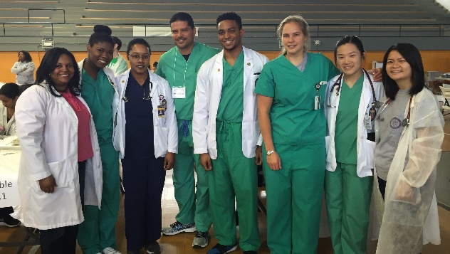

VISITING EM CLERKSHIP PROGRAM APPLICATION

NAME:

STREET ADDRESS:

CITY: STATE: ZIP:

MEDICAL SCHOOL:

ENTRANCE DATE: EXPECTED GRADUATION DATE:

GENDER: ☐ Male ☐ Female
RACE/ETHNICITY*: ☐ African-American ☐ Hispanic ☐ Native American ☐ Caucasian ☐ Pacific Islander ☐ Alaska Native
☐ Other:
*check all that apply
USMLE Step 1 Score:
USMLE Step 2 CK Score (if applicable):
I am applying to Pediatric Medicine, Orthopedic Surgery or Neurosurgery Residency Programs (Circle One Specialty : ☐ Yes ☐
NoHow did you become interested in your selected specialty? What is your specific interest in LSU Health Sciences Center and training in the city of New Orleans?

What strengths do you possess that you feel will make you a strong resident in your chosen clinical specialty and as a future physician leader? What do you wish to work on/develop more fully?

How do you think the social determinants of health impact patients in the specialty area that you are choosing to pursue?

