Department of Orthopaedic Surgery

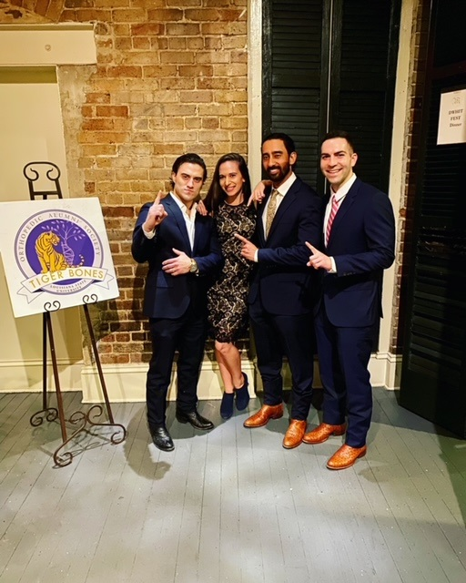
19th Annual Robert D. D’Ambrosia Lectureship & Research Day
(L-R) Stuart Schexnayder, MD; Rocio Crabb, MD; Patrik Suwak, DO and Scott A. Barnett, MD

Friday, June 23, 2023

LSUHSC School of Medicine
Medical Education Building – Lecture Room B
1901 Perdido Street | New Orleans, LA 70112

The Lectureship and Research is named in honor of

Robert D. D’Ambrosia, M.D.

This annual lecture and department chairmanship has been established to honor Dr. D’Ambrosia’s service to the LSU Health Department of Orthopaedic Surgery. In his 30+-year as the Department Chair, he exemplified leadership and humanity while training and mentoring more than 100 graduates. We are very grateful for Dr. D’s contributions to LSU and to the department. Now in its 19th year, we continue to honor his legacy through the annual Robert D. D’Ambrosia Lectureship & Research Day.
ROBERT D’AMBROSIA LECTURESHIP & RESEARCH DAY AGENDA

AGENDA
8:00 am – 8:30 am BREAKFAST
Posters will be displayed outside the lecture hall near the food service

8:30 am – 8:45 am Introduction: Vinod Dasa, MD, Director of Orthopaedic Research

8:45 am – 9:45 am Resident Presentations

8:45 am – 9:00 am Patrik Suwak, DO

Assessing Vertebral Body Rotation in Minimally Invasive Spine Surgery

9:00 am – 9:15 am Scott A. Barnett MD

Endoscopic Proximal Median Nerve Decompression: An Alternative Treatment for Pronator Syndrome

9:15 am – 9:30 am Rocio Crabb, MD

A Case of Heterotopic Ossification in the Adductor Longus following Pubic Symphysis ORIF

9:30 am – 9:45 am Stuart Schexnayder, MD

Factors Associated with Loss to Follow-up During the First Year After Total Knee Arthroplasty

9:45 am – 10:15 am Faculty Speaker: Anna Cohen Rosenblum, MD., M.Sc.

The 2022 Hip Society-British Hip Society Travelling Fellowship: My Experiences

10:15 am – 10:30 am MEET OUR EXHIBITORS

10:30 am – 11:00 am Student and Fellow Presentations

10:20 am – 10:30 am Leland Vandeventer, L4
Effective Orthopaedic Care Delivery Models In Low- And Middle- Income Countries

10:30 am – 10:40 am Morgan McCoy, L3
Total Joint Arthroplasty Patient Demographics Pre-and Post-COVID-19 Surgery Restrictions

10:40 am – 10:50 am Jonathan Williard, Medical Student Research Fellow
Effectiveness of an Evidence-Based Protocol on Antibiotic Stewardship, Infection Rate and Incidence of Drug-Induced Complications in Type III Open Fractures

10:50 am – 11:00 am Gregory Galvin, DO
Increased E&M Levels in a Pediatric Orthopaedic Department through a Single Didactic

11:00 am – 11:15 am Outcome Research Opportunity: Strength training in a simulated gym for AIS patients: Andrew King, MD, MB.ChB, FRACS, FACS

11:15 am – 12 pm Keynote Presentation: Adam J. Starr, M.D
The Parkland Trauma Index of Mortality and Post Traumatic Stress Disorder
Hansjorg Wyss Distinguished Professor, Orthopaedic Trauama, University of Texas Southwestern Medical Center and Medical Director, Parkland Memorial Hospital, Dallas, TX
Dr. Starr is the Hansjörg Wyss Distinguished Professor in Orthopaedic Trauma at UT Southwestern Medical Center (UTSWMC) in Dallas, TX, Medical Director for Orthopaedic Surgery at Parkland Hospital and has been recognized as a Texas Monthly Super Doctor and a D Magazine Best Doctor.
He is a pioneer in minimally invasive percutaneous treatments for fractures of the pelvis, especially the acetabulum. His many achievements include inventing the Starr Frame with colleague Charles Reinert, M.D., a device that helps surgeons align the pieces of a broken pelvis using very small incisions. He is an internationally-invited lecturer and textbook author who reviews and contributes to more than a dozen texts and several orthopaedic journals. He is a member of the American Academy of Orthopaedic Surgeons, the Orthopaedic Trauma Association and is certified by the American Board of Orthopaedic Surgeons.
Dr. Starr has been affiliated with UTSWMC for more than 26 years as a faculty member, fellow in orthopaedic trauma, resident in orthopaedic surgery and medical student.
Starr AJ, Julka M, Nethi A, Watkins JD, Fairchild RW, Rinehart D, Park C, Dumas RP, Box HN, Cripps MW. Parkland Trauma Index of Mortality: Real-Time Predictive Model for Trauma Patients. J Orthop Trauma. 2022 Jun 1;36(6):280-286. doi: 10.1097/BOT.0000000000002290. PMID: 34653106.
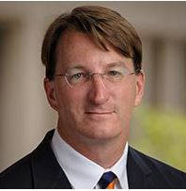

Adam J. Starr, M.D. 1

Congratulations On Your Fellowships, Chiefs!

Endoscopic Proximal Median Nerve Decompression: An Alternative Treatment for
Pronator Syndrome

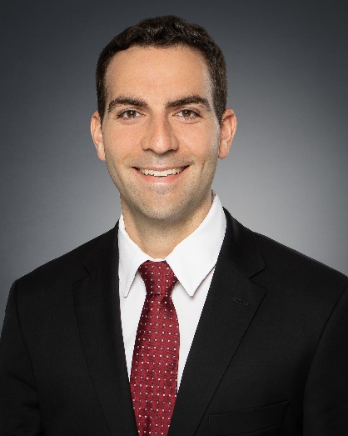
Proximal forearm median nerve compressive neuropathy, termed pronator syndrome, is difficult to diagnose and often overlooked. Its symptoms include vague proximal volar forearm pain that may be associated with paresthesia and numbness in the median nerve distribution. Weakness is typically not present. The treatment of pronator syndrome is largely nonsurgical, consisting of activity modification, anti-inflammatory medication, corticosteroid injections, stretching, and periods of splinting. Surgery is indicated when conservative therapy fails; however, there is no consensus on the treatment approach or technique. Most decompressions are performed using an open technique through a variety of incisions. Recently, endoscopic approaches have drawn an interest. This article describes a technique for endoscopic proximal median nerve decompression that enables the complete decompression of the median nerve in the distal aspect of the arm and proximal aspect of the forearm through a small incision, potentially minimizing surgical morbidity and reducing healing time.
Scott Barnett, M.D.

Endoscopic Proximal Median Nerve Decompression: An Alternative Treatment for Pronator Syndrome. Barnett SA, Shah SA, Ahmad RI - J Hand Surg Glob Online - July 1, 2021; 3 (4); 210-214

Assessing Vertebral Body Rotation in Minimally Invasive Spine Surgery
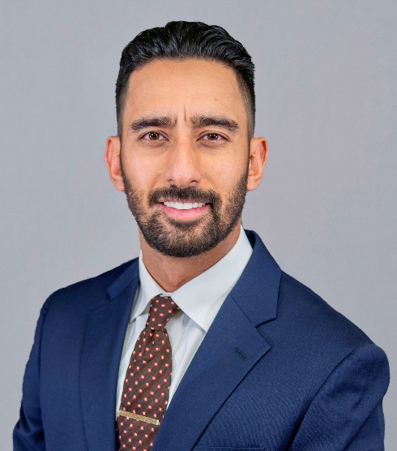
Background
Minimally invasive spine surgery relies on fluoroscopic imaging as bony landmarks used for instrumentation are not exposed. The precision of techniques used to determine vertebral body rotation intraoperatively may be confounded by anatomic variation or pathology. Here, we investigate the physiologic variation in different anatomic structures of the lumbar spine used for percutaneous pedicle screw placement.
Objective: The aim of this study is to evaluate the incidence and magnitude of pedicle asymmetry as well as spinous process deviation in the healthy lumbar spine.
Patrik Suwak, DO
Methods: 100 normal lumbar CT scans, without evidence of acute deformity, significant spondylosis, scoliosis, or spondylolisthesis were reviewed to assess for pedicle height, width and spinous process angle (SPA) to compare symmetry between right and left-sided pedicles for each vertebral body. Spinous process deviation of ≥5° in the axial plane was considered a relevant finding and the magnitude of offset from midline was calculated using the deviation angle and spinous process length.
Results: Analysis of CT scans found that 17.5% of lumbar spinous processes had an average angular variation ≥5°. This calculates to a clinically significant 3.53 mm average offset of spinous processes from midline in 17.5% of lumbar vertebrae. Pedicle height and width measurements did not show statistically or clinically significant variation when comparing right to left lumbar pedicles.
Conclusion: These results suggest that using the spinous process as a fluoroscopic landmark during intraoperative imaging to determine neutral rotation of lumbar vertebrae can be an unreliable technique. Rotational alignment can be determined more reliably by comparing left to right pedicle symmetry. These findings should be considered when selecting an operative technique to assess neutral vertebral alignment during percutaneous pedicle screw instrumentation.
Patrik Suwak, DO; Kirby Bonvillain, MD; Peter D’Amore, MD; Claudia Leonardi, PhD.; Abhishek Kumar, MD.

A Case of Heterotopic Ossification in the Adductor Longus following Pubic Symphysis ORIF

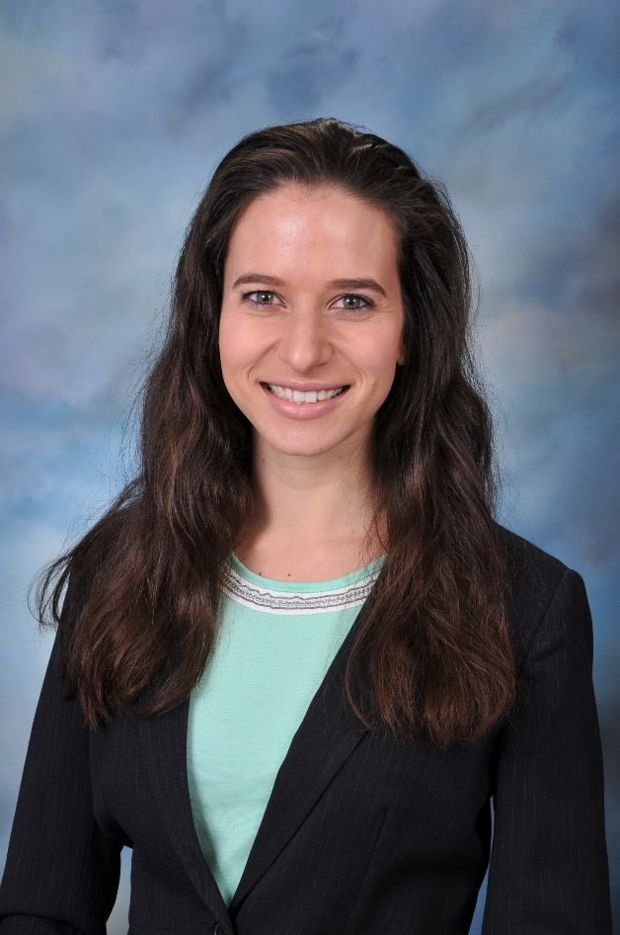
Case Description: The patient is a 37-year-old male that presented as a trauma activation after a motorcycle accident. He was GCS 3 in the field and intubated en route. Injuries included an open APC III pelvic injury with left zone 2 sacral fracture, as well as multiple facial fractures, SAH and multiple intra-abdominal injuries requiring massive transfusion protocol and ex-lap. He underwent initial I&D and ex-fix of his pelvis with later ORIF pubic symphysis and SI screw placement during his initial hospital stay. He recovered well from all his injuries, however at his 3-month post-op visit he was found to have developed clinically painful and ultimately restrictive heterotopic ossification (HO) of the right proximal thigh. After maturation, the decision was made to surgically remove the prominent HO. A 12.5cm x 5.5cm osseous mass was found to originate from the inferior pubic body and was successfully dissected out of the adductor longus muscle. Post-operative prophylactic indomethacin was prescribed. Post-operatively the patient had resolution of symptoms and has had no local recurrence to date.
Rocio Crabb, MD
Discussion: Heterotopic ossification is the pathological formation of bone in soft tissues. Risk factors include fractures, ORIF, joint replacement, specific extensile approaches to the hip or elbow, as well as associated TBI. In this case, our patient had multiple risk factors including local trauma, pelvic fixation, and TBI, with resultant HO that formed in the adductor compartment of the thigh.
Conclusion: Heterotopic ossification can be severely impacting to a patient’s life causing pain and movement restrictions requiring activity modification. This was a case of HO in a patient with a multitude of known risk factors and development within a unique location who was ultimately successfully treated with surgical excision

Factors Associated With Loss to Follow-up During the First Year After Total Knee Arthroplasty
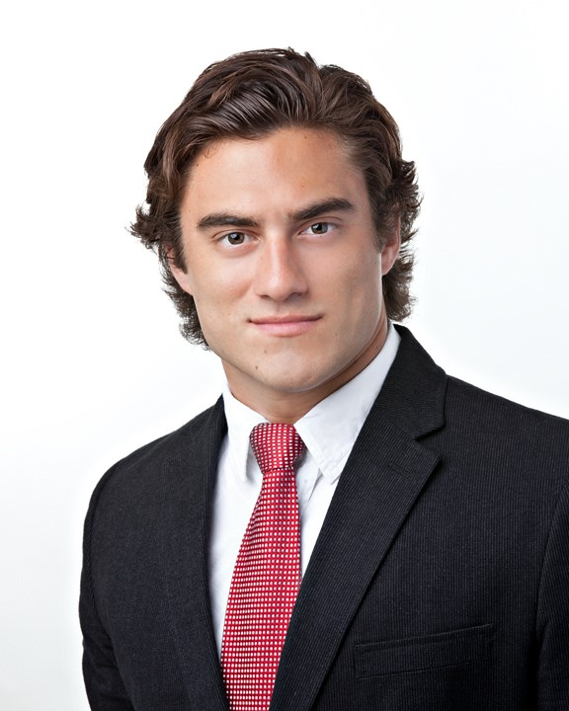
Despite increased pressure to capture patient-reported outcome measures for at least 1 year following total joint arthroplasty (TJA), follow-up rates during the first year after TJA are typically lower than desired and may result in biased findings if data are not missing at random. We conducted a retrospective review of medical records of primary total knee arthroplasty patients treated by a single surgeon at an urban academic private hospital. Main measures were demographics (sex, age, race, and insurance), body mass index, travel distance to clinic, and the Knee Injury and Osteoarthritis Outcome Score (KOOS). Multivariable regression analyses were performed to identify patient characteristics associated with attendance at follow-up visits and predictors of attendance at 6-month follow-up. Among the 205 study patients, follow-up visit attendance declined from a high of 95.7% at day 14 to lows of 69.2% at 6 months and 64.4% at 1 year. Attendance at the previously scheduled follow-up visit was a statistically significant predictor of attendance at 3-month (P=.0015), 6-month (P=.0002), and 1-year (P<.0001) follow-up visits, and travel distance was significantly associated with attending the 1-year follow-up visit (P=.042). Patients with the most favorable KOOS Symptom, Pain, and Function in daily living subscale scores at 3-month follow-up were significantly less likely to attend the 6-month follow-up visit than patients with the least favorable KOOS scores. Prospective studies are needed to identify the full range of factors that may contribute to high rates of loss to follow-up after TJA, which should be of concern to researchers, clinicians, and hospitals.
Stuart Schexnayder, MD

Stuart Schnexayder, MD

Student Presentations

Total joint arthroplasty patient demographics before and after COVID-19 surgery restrictions

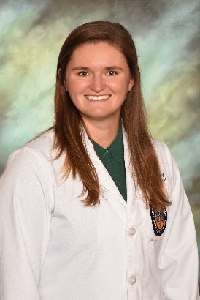
Background:
Total joint arthroplasty (TJA) includes total hip (THA) and total knee arthroplasty (TKA). Non-emergent TJA operations were paused between mid-March and April, 2020, due to Coronavirus disease 2019 (COVID-19). This study analyzed potential disparities in access to care due to pandemic restrictions.

Methods:
Three tests were used to analyze TJA patient demographics from the period of May-December 2019 (pre-COVID-19) and May-December 2020 (post-COVID-19 restrictions). Fisher’s exact tests measured and compared categorical covariates by reporting counts and percentages. Two-sample t-tests measured continuous covariates by reporting means and standard deviations. A test of proportions measured equality of TJA counts by year.
Morgan McCoy, L3

Results:
Comparing the post to the pre-COVID period:
- Increases:
    - Number of TJAs (1151 vs. 882, p<.001)
    - Percentage of TJAs (p<.001)
    - Relative percentage of THAs vs. TKAs (26.9% vs 18.8%, p<.001)
    - Medicaid patients
- Decreases
- Private insurance patients (p=.043)
- Average length of hospital stay
- No differences
- Patient sex, race, BMI, smoking status, or age

Conclusions:
These trends may reflect pandemic-related changes in insurance status as well as the growing shift to same-day discharge.

Effective Orthopaedic Care Delivery in Low- and Middle- Income Countries

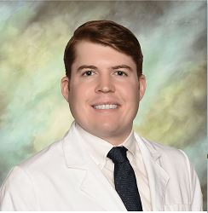
Background:
The global burden of musculoskeletal injuries is high. Trauma kills more people than HIV/AIDS, malaria, and tuberculosis combined. Road traffic injuries are the leading cause of death among ages 5-29. Non-governmental organizations (NGOs) have developed a wide spectrum of orthopaedic care delivery models in low-and-middle income countries (LMICs), e.g. specialized implants and postoperative rehabilitation. This study defines and compares 15 predominant models of care: the combination or services provided by an organization in its mission to deliver orthopaedic care.
Leland Vandeventer, L4

Methods:
A literature review and Internet investigation was conducted which identified 409 orthopaedic care models. Of those,15 were selected for this study. Publicly available financial information and clinical data was reviewed for the years 2018-2020.

Results:
The mean number of years in operation was 27.5. Most organizations trained local MDs and ancillary medical staff. (Table 2) The majority had a non-profit status, did not have a religious affiliation, and reported some research activity. (Table 3) The predominant orthopaedic care activities include facilitating visits by foreign surgeons; educating local providers; supplying implants; conducting research; performing surgeries and creating cost-sharing for-profit payment models. Total expenses and the percent spent on medical operations per surgery completed were analyzed. The majority of costs were medical operation expenses expressed as a mean (84%), followed by non-medical related activities (9%) and fund raising (7%). The number of annual surgeries performed or facilitated ranged from 123 to 117,600. The cost of the least expensive model, SIGN, averaged $23.00 per surgery.

Conclusions:
These findings suggest that combining various models of care is the most efficient means of delivering orthopaedic care appropriate for the population.

Effectiveness of an Evidence-Based Protocol on Antibiotic Stewardship, Infection Rate and Incidence of Drug-Induced Complications in Type III Open Fractures

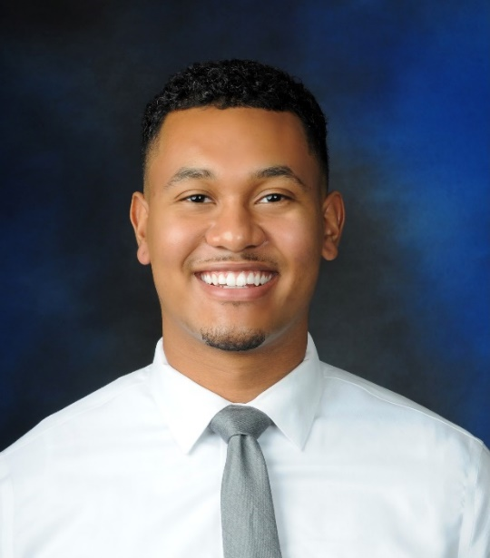
Background
An open fracture is defined as fracture fragments in communication with the environment through a skin break. It is associated with high-impact trauma and poses a higher susceptibility to infection and soft tissue complications. The Gustillo and Anderson classification describes the severity of these fractures based on contamination, size of the laceration, degree of soft tissue injury, and presence of vascular compromise. Open fractures are categorized as Grade I, II, or III with the degree of severity increasing in numerical order (I-III). Risk of infection and limb loss correlates with the Gustilo type. Antibiotic prophylaxis is an important adjunct in preventing infections in open lower extremity fractures, with broader coverage recommended in higher-severity fractures. Duration and choice of antibiotic therapy continue to be an ongoing area of clinical research that remains variable between institutions. Appropriate antibiotic prophylaxis regimen is controversial, and many trauma centers use broad-spectrum antibiotic therapies for coverage of Grade III fractures. There is substantial morbidity associated with commonly used broad-spectrum antibiotics in the open fracture population including antimicrobial resistance and potential AKI with aminoglycoside and glycopeptide use. Recent studies have shown that the implementation of an evidence-based antibiotic prophylaxis protocol for open fractures results in significantly decreased use of aminoglycoside and glycopeptide antibiotics without an increase in skin and soft tissue infection rates. The primary objective of this study is to examine infection rates before and after implementing an evidence-based antibiotic prophylaxis protocol for open fractures at our institution. Secondary objectives include assessing the number of dose drug administrations, cost differences and incidence of AKI before and after protocol implementation. The hypothesis of this study is that the infection rate after implementation of an evidence-based protocol would be non-inferior to a broad-spectrum protocol with decreases in dose drug administration, cost and incidence of AKI.
Jonathan Willard, Medical Student Research Fellow

Methods
This is single-center retrospective study which identifies patients who were admitted for open long fractures of lower extremities including femur and tibia/fibula fractures from 06/01/2014 through 06/01/2022. It includes all patients who were diagnosed with Type III open lower extremity fracture in age group 18+. A retrospective chart review will identify all adults (age 18+) with Grade III open femur and open tibia/fibula fractures and will be conducted by querying the institution trauma database and Epic Slicer Dicer. A preliminary list of patients who meet the criteria will be abstracted and compared based on respective antibiotic groups for presentation.

Results and Conclusions Pending

QSVI: Increased E&M Levels in a Pediatric Orthopaedic Department through a Single Didactic

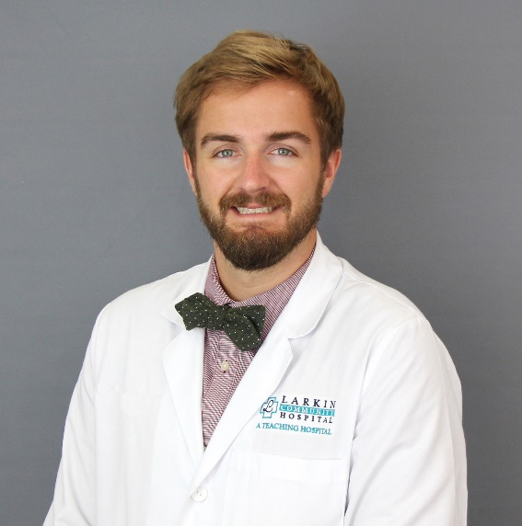
Introduction:
Evaluation and management (E&M) coding is a system used to represent clinical services provided by practitioners for billing purposes. Beginning in January 2021, Current Procedural Terminology (CPT) guidelines changed for office visit E&M codes in an effort to reduce unnecessary documentation and administrative burden. Other notable changes include reductions in the work relative value units (wRVU) per E&M level and the reimbursement per wRVU, with the E&M guidelines allowing the average orthopedic clinic visit to be billed at a higher level than under the previous system. Due to these important differences, education on the newly adopted system is critical. This study investigates the effect of a single quality improvement didactic session on the utilized E&M levels billed in our pediatric orthopaedic surgery department.
Greg Galvin, D.O., Fellow

Methods:
Physicians and advanced practice providers (APP: PA’s and NP’s) in the pediatric orthopaedic department took part in a single interactive didactic session on appropriate billing practices and the 2021 changes to the E&M CPT coding system. E&M coding data for a 6 month period before and after the didactic session were obtained. Primary outcome was to observe changes in E&M CPT utilization for level 3 (ie. 99203/99213) and level 4 (ie. 99204/99214) codes. Secondary outcome was observed changes in E&M CPT utilization between providers who received training and those who did not participate in the didactic session.

Results:
A total of 7 physicians and 6 advanced practice providers were included. Total number of RVU codes utilized prior and after the single didactic session were analyzed, with focus on level 3 and level 4 CPT coding. There was a significant increase over time in level 4 coding (ie.99204/99214) after the didactic session (85 vs. 158 average incidence of these codes over 6 months, p = 0.031). There was also an observed decrease over time in level 3 coding (ie. 99203/99213), but significance was not obtained (199 vs. 181, p = 0.568). When trained providers were compared to those providers who did not receive any formal training, both level 4 and level 3 coding did not show any significant differences (level 4, p = 0.966; level 3, p = 0.278).

Conclusion:
Through our single interactive didactic session that reviewed the E&M levels in our department, we were able to significantly increase the utilization of E&M level 4 coding. We recommend providing similar sessions to better understand the critical nuances of the E&M coding system to remain in compliance with legal requirements and to ensure fair reimbursement.

Student Poster Presentations

Treatment of Infected THA with Pelvic Discontinuity: A Case Report

Leland vanDeventer (L4)

Comparison of Outcomes for Operative and Nonoperative Management of GSW Humerus Fractures

Samuel Baum (L3)

Minimally Invasive Versus Open Posterior Cervical Fusion: Fusion Rates and Perioperative Parameters

Kaleb Derouen (L3)

Relationship of Vitamin D Levels and Back Pain in Adolescent Idiopathic Scoliosis

Tara Korbal (L3)

Pediatric Occult Ankle Fractures: Predictive Risk Factors

Christian Kerut (L3)

Orthopaedic Infections: A Primer

Gregory Laborde (L3)

Evaluating the Paracrine Release of Myokines Relative to Myopenia and Fibrosis in Osteoarthritis

Davis Martin (L3)

Historic Analysis of TJA Recipient Insurance Status

Morgan McCoy (L3)

Oral Small Molecule IL-11 Inhibitors Targeting Osteoarthritis

Ryan Schroeder (L3)

Review of Clinical Models in Limb Lengthening and Reconstruction Clinics

Megan Vasterling (L3)

Frailty and Increasing Body Mass Index Have a Combined Effect on 30-day Mortality: A Comprehensive Analysis of an International Database with the Risk Analysis Index Demonstrating Outstanding Discrimination

Robert Branstetter (L2)

Comparing ACDF Outcomes by Cervical Spine Level: A Single Center Retrospective Study

Cliff Daigle (L2)

Targeting Arthralgia in Knee Osteoarthritis via Non-Psychoactive Cannabinoid Mechanisms

Collin Toups (L2)
- Total Knee Arthroplasty After Ipsilateral Below-Knee Amputation
Jonathan Williard (Medical Student Research Fellow)
- Musculoskeletal Complications Following Stroke
Helen P. Neil, PhD Candidate, RN, MSN - HCSM, CLNC, FCN (Faculty, LSUHSC School of Nursing)

Department of Orthopaedic Surgery

2021 Perdido Street, 7th Floor • New Orleans, Louisiana 70112

Office 504-568-4680 • Fax 504-568-4466

www.medschool.lsuhsc.edu/orthopaedics

A very special thank you to our sponsors

Bioventus, Inc. | Megan Quirk, Territory Manager II – New Orleans
Bonesupport, Inc. | Kevin Allen, Regional Manager – Delta Region
Capitol Imaging Services | Michael Holmes, Chief Marketing Officer with  Jeff Beach, Regional Sales Director and  Diagnostic Imaging Specialists Joyce Sergi and Tiffany Plaisance
Heraeus Medical, LLC. | Territory Specialists Brennan Mello, Eddie Lanier  and Steve Vallette
Medacta | Michael Paternostro, Sales
Orthofix | Liz Cline, Distributor Principal and  Billy Davis, Distributor Representative
Pacira Biosciences, Inc | Scot Poucher, BSN, RN, Account Manager
Stryker | Trauma Sales Representatives Kyle Aucoin, Daniel Duke and Robert Belmont with  Jr. Sales Representative Nathan DeBord, and  Associate Sales Representative Megan Haydel
Zimmer Biomet | Mike Luckoski or JT Jackson

