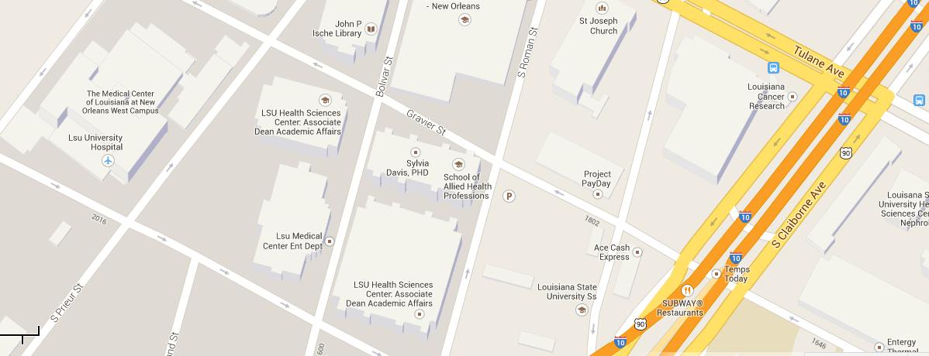
1.
1.
- Enter Medical Education Building through this door [corner of Perdido and S Roman St].
- Turn immediate right to the back corner.
- Find the Folders Table.
- Look up Nguyen, Thu Ha.
- Insert your form and check (signed to LSUMS Student Council).
- Thank you very much!

